How to Figure Out If Your Phone Has Malware
Has your phone been acting up? Here's how to check if malware is to blame, and what to do if it is.


By Jason Cohen
December 13, 2021
Your smartphone is like a mini computer that fits in your pocket, so—just like your laptop—it's also vulnerable to malware, which can take the form of spyware, adware, or ransomware.
Unfortunately, it can sometimes be difficult to determine if your device has been infected. This is by design, since those behind the malware don't want you to find their software and remove it, so it's up to you to look out for signs of troubling activity.

iOS vs. Android: Which OS Is More Vulnerable?

Android is an open ecosystem by design, which has its benefits but also makes the OS more vulnerable to malicious apps than Apple's iOS. Google has made progress here; a recent report noted that bad actors have had to get more creative in order to get their malware-laden apps onto Android devices. But that same report found that Trojan dropper apps netted over 300,000 downloads on Google Play recently in order to scoop up people's banking details.
If you have an iPhone, you may be thinking that none of this applies to you. After all, the idea that Macs don't get viruses certainly extends to all other Apple devices, right? Wrong. While it's true that iPhones are less likely to get infected with malware than Android phones thanks to Apple's rigorous approval process, it doesn't mean the smartphones are immune to infection.
So regardless of what mobile OS you're running, it's important to stay alert. You never know when a seemingly innocuous app holds a nefarious payload.

Signs Your Phone May Be Infected
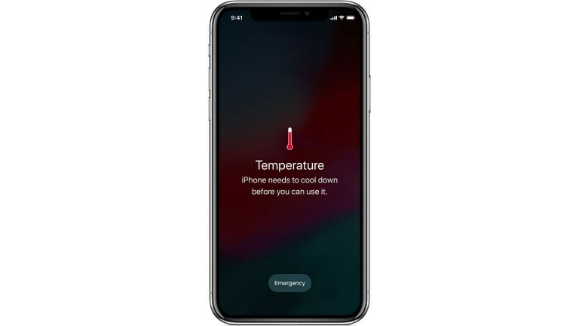
Is your phone infected with malware? Here are some things to watch out for:

Pop-Up Ads That Won't Go Away
If you're suddenly seeing a lot of ads in a specific app or even when no apps are open, you may be infected with adware. These annoying pop-ups can generate money from ad clicks, try to infect you with worse malware, or link to scam offers. Whatever you do, don't click!

Unexplained Fees on Your Bill
Take a look at your phone bill or credit card statements and make sure you can account for every charge. If not, there is a chance you may be the victim of a scam that adds unwanted services to your phone and charges to your phone bill, also known as cramming. Wireless carriers have been accused of looking the other way in some cases in order to pocket a percentage of the monthly rate, so the onus is on you to be diligent and catch any bogus charges.

Your Battery Drains Faster Than Expected
While batteries do degrade naturally over time, you shouldn't see a sudden shift in battery life with normal wear and tear. Malware may be hijacking your phone's components in order to perform background tasks, resulting in the battery needing a recharge faster than expected.

Your Phone Is Overheating
Under normal circumstances, your phone should never be hot to the touch, but certain malware can overwork the internal CPU or charging mechanism. If your phone is overheating, we recommend unplugging it from any power sources and turning it off. Left unattended, a hot phone can cause fires and even explode.

Your Phone Is Slower Than Normal
Just like a computer, your smartphone contains a processor that is used to perform certain computational tasks. If your device has been hijacked, the malware may be overworking the components inside your phone and causing simple tasks to take longer than they should. If your phone is suffering from a sudden slowdown, and even crashing, malware could be the reason.

Dropped Calls and Poor Connections
If your phone has been infected with malware, an outgoing connection to a foreign server can interfere in your phone's ability to maintain a stable Wi-Fi or cellular connection, resulting in poor connection quality and frequent dropped calls. If other devices on the same Wi-Fi connection are working properly, and those in your household are not experiencing dropped calls, malware may be the culprit on your phone.

An Unexpected App Appears
Sometimes an app you download can be loaded with malware that installs additional programs. Take a look at your app list and make sure you recognize and want everything on the phone. If you find something unexpected, do not open the app.

Enter Safe Mode on Android
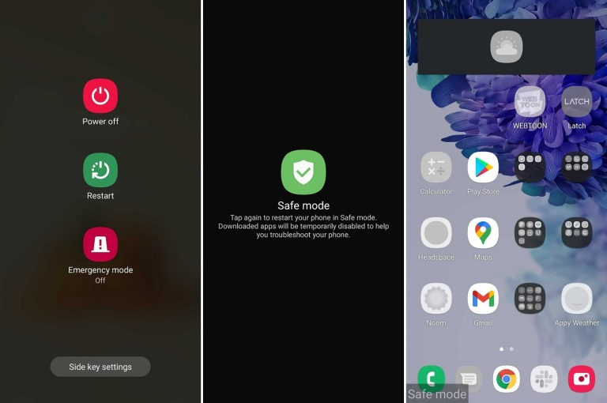
You've examined your phone and found something suspicious, or you have one or more symptoms of malware. Now what? If you're on an Android phone, try safe mode.
The process may vary depending on your phone maker, but most new devices require you to hold down the Power button, and then long-press Power Off until you get the option to enter safe mode. This disables third-party apps on your phone so you can safely inspect anything out of the ordinary, remove any apps you think may be infected, and then return to normal mode and see if the problem has been fixed.

