The Best Windows 11 Tips and Tricks
Windows 11 gives Microsoft's venerable OS a new look and adds a few features you'll want to tweak or customize.


By Jason Cohen
October 26, 2021 Windows 11, the latest iteration of Microsoft's long-running operating system, is here—at least for those with supported PCs. If you take the leap, you'll notice a slick redesign, with a Chrome OS-like centered taskbar and rounded corners on apps. Under the hood, it's largely the same OS, but there are some new features you should know how to use. These tips will help ease the transition from Windows 10 to Windows 11.

Realign the Start Button
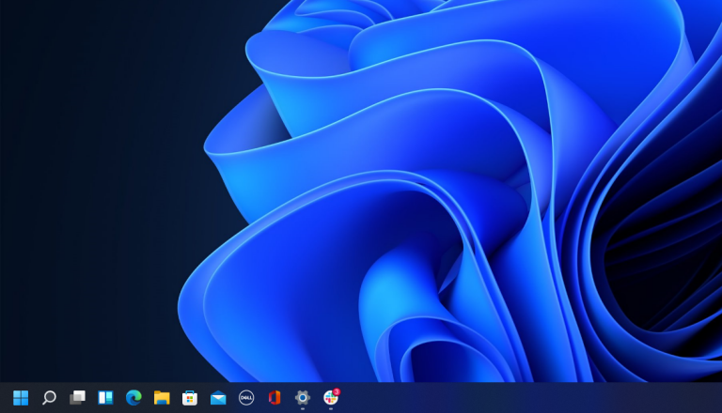
The first thing that will jump out at you is the placement of the Start button. Long located in the lower-left corner of the screen, it's now centered with the rest of the icons on the taskbar. But don't worry, you can change it back. Right-click the taskbar and open Taskbar Settings. Select the Taskbar behaviors drop-down and change Taskbar alignment to Left. This will move all your taskbar icons to the left and put the Start button back where it belongs. For more on personalizing the Windows 11 taskbar, check out our guide.

A Simplified Right-Click Menu
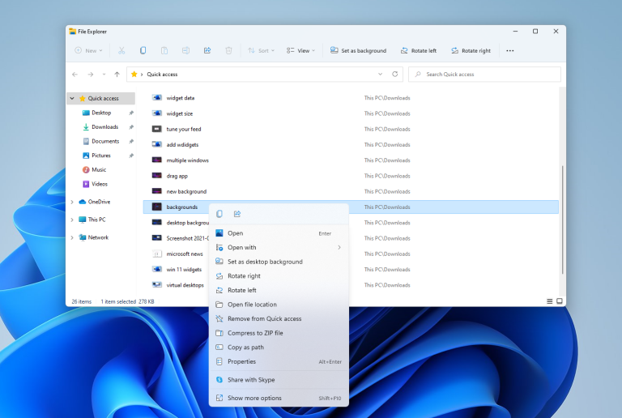
The right-click menu now focuses only on the most important settings. Should you need more settings—print, set a new background, or view the full file location, for instance—select Show more options to open a spill-over menu.

Customize the Quicks Setting Panel
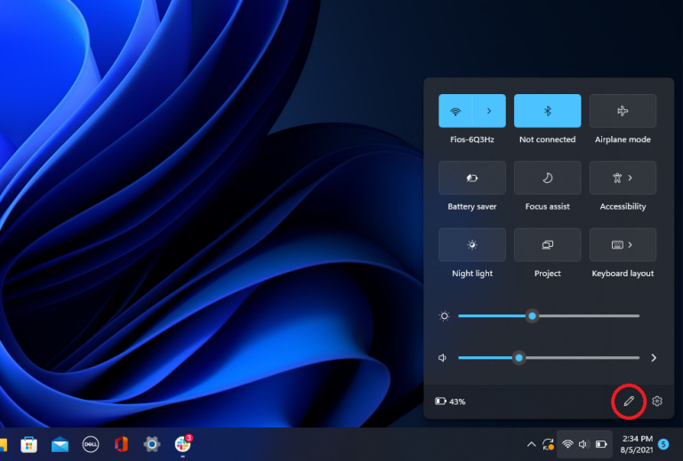
Windows 11 separates the Quick Settings that appear in the Action Center in Windows 10 from that panel's notifications. Click the area of the taskbar that has Wi-Fi, speaker, and, battery icons to open a settings menu that lets you control Wi-Fi, Bluetooth, airplane mode, battery saver mode, and more. To add or remove settings buttons here, click the pencil-shaped Edit quick settings button. Unpin what you don't want or click Add to make new features accessible from the Quick Settings menu.

Easier Desktop Management
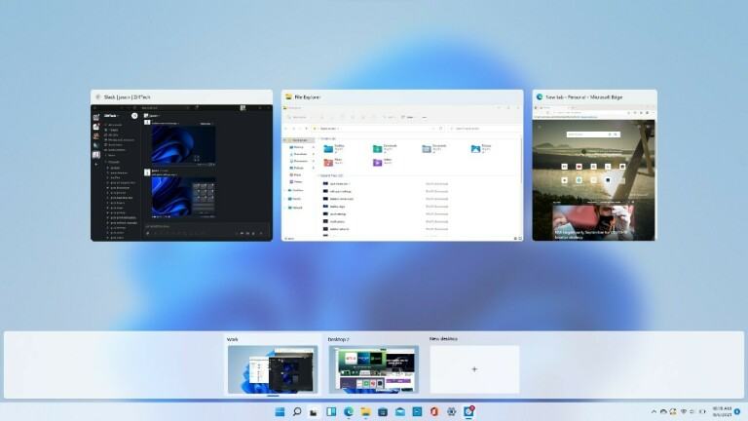
Microsoft replaces the old Task View button with a redesigned icon on the taskbar, which makes it easier to create and manage multiple desktops. Just hover over the icon to see any open virtual desktops or create a new desktop. These desktops can then be rearranged as needed, and apps that are in one desktop can be dragged into another.

Gather Your Widgets
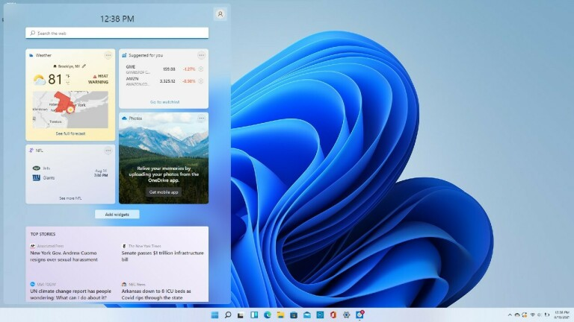
While Windows 10 dabbled in widgets, Windows 11 goes all in. If you want to check the weather, look up sports scores, track stock prices, watch nearby traffic, manage your Outlook calendar, cross tasks off your to-do list, or read the latest news, a new Widgets icon on the taskbar has you covered. You can customize the widgets to suit your needs, rearrange them on the page, and manage your newsfeed preferences through Microsoft News.

More Multitask Layouts
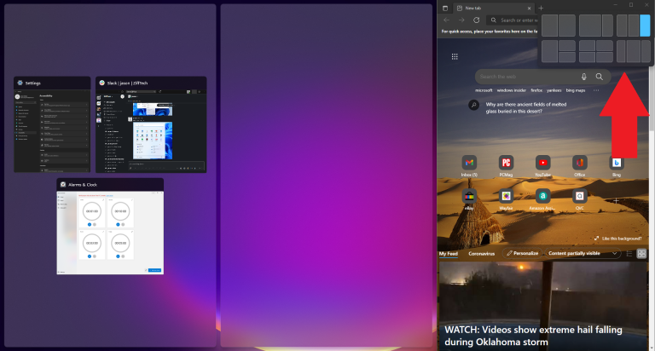
Microsoft has supported the snap and resize feature since Windows 7, but it gets a boost in Windows 11 with Snap Layouts. You can still drag and drop windows into place, but in Windows 11, you can also hover over the Maximize button on supported apps to see a menu of layout options—one large window on the left and two on top of each other on the right, or three in a row, for example. Click to select your preferred formation and then move your apps into place.

Chat With Teams
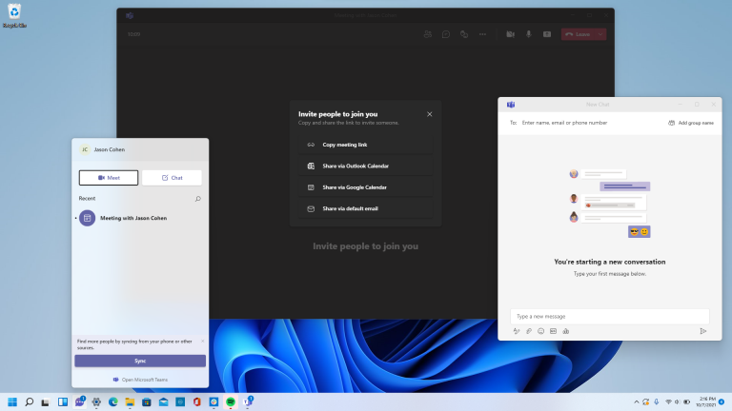
Microsoft Teams—the company's free messaging, calling, and videoconferencing app—is built into Windows 11. Launch video calls and start chats from a new Chat icon on the taskbar; no need to open the Microsoft Teams app. You can sync your contacts through the Teams mobile app, but if your contacts don't use Teams, send invites via email or text. You can also have SMS conversations with contacts even if they don't sign up for Teams, and they can join a video chat from a web link.

Get Things Done With Focus Sessions
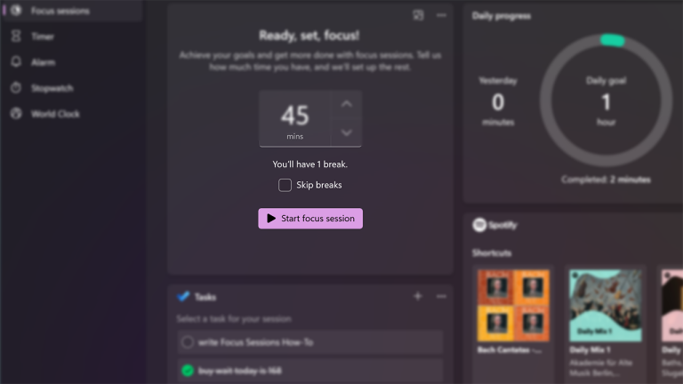
With messages and video chats popping up throughout the work day, it's easy to get distracted as the work piles up. Focus Sessions in Windows 11 encourages you to set aside time for work that requires uninterrupted, deep focus. It's currently available in the new Alarms & Clock app, and offers a quick way to get at least 30 minutes of distraction-free work time. If you go beyond 45 minutes, the app automatically schedules a five-minute break about midway through your session. Here’s a step-by-step guide on setting it up for your PC.

Streamlined File Explorer Menu
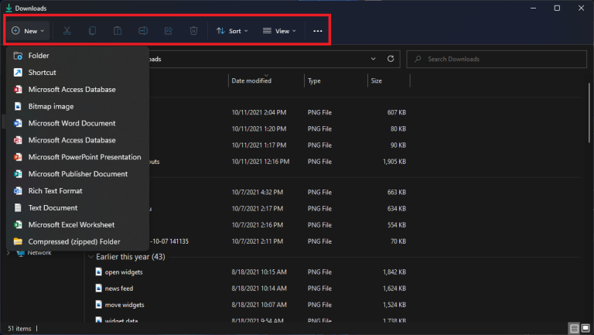
With Windows 11, Microsoft streamlines the ribbon at the top of the File Explorer menu. Now only cut, copy, share, sort, and view options are visible; no need to wade through multiple tabs and settings you'll never use. Windows 11 also adds a New button for creating new folders and shortcuts, as well as documents based on the programs you have installed.

Pair Input/Output Devices
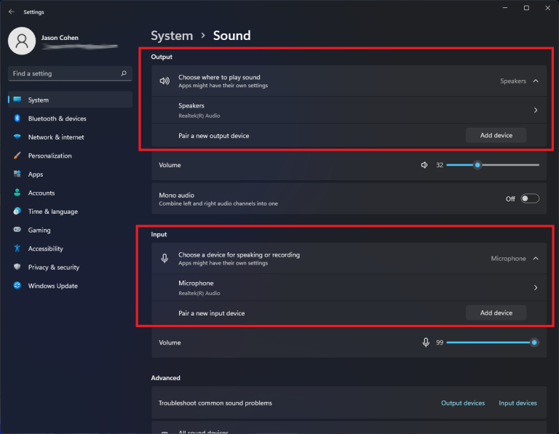
Windows 11 gets a full-featured Sound menu with the ability to pair new input and output devices. Open Settings > System > Sound and click Add device under the Output section to link external speakers or other devices. Or click Add device under Input to connect an external microphone. You will then be given the choice to connect via Bluetooth, wireless docks, and more. Scroll down to the Advanced section and click All sound devices to view a full list of all input and output devices that have been connected to your PC.

New Sound Modes
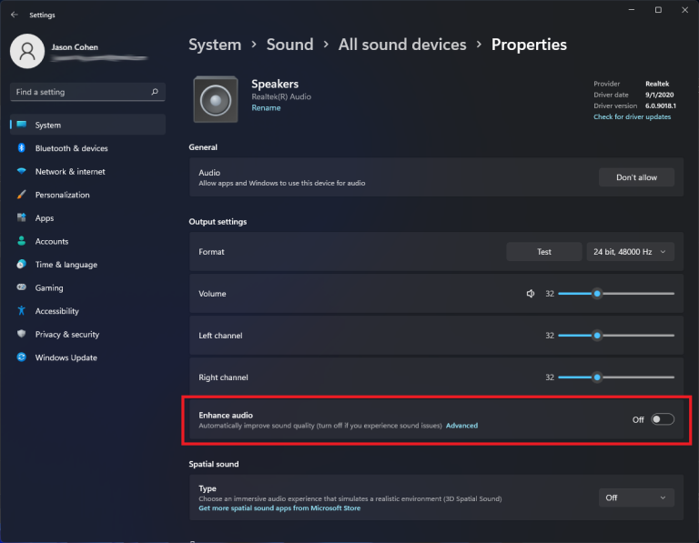
You get extra control over your audio output in Windows 11, including mono audio and enhanced audio modes. To go mono, open Settings > System > Sound, then enable Mono audio to combine the left and right audio channels. For enhanced audio—which includes bass boost, virtual surround, room correction, and loudness equalization—click All sound devices under the Advanced section of the Sound menu, choose a device to access the Properties menu, and enable Enhance audio.

View the App List
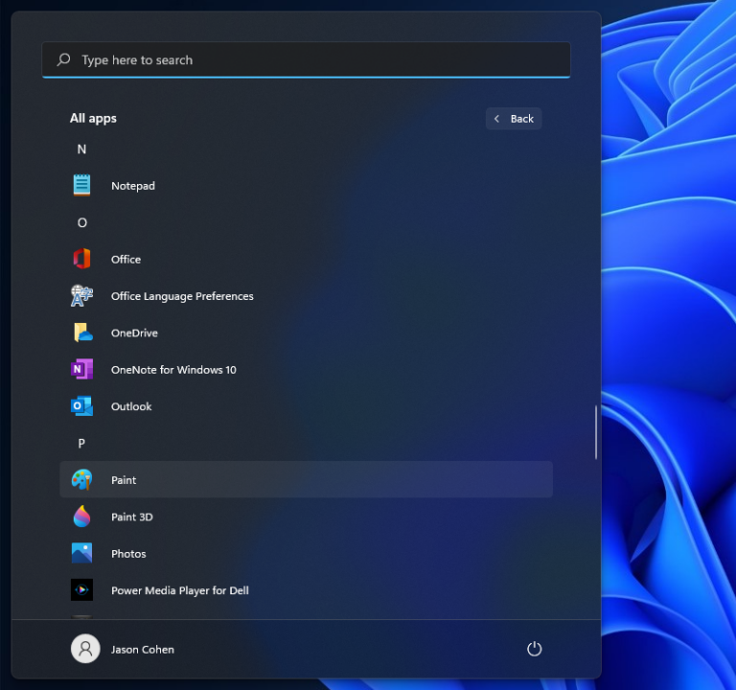
Windows 11 adds an extra step to view your full list of installed apps. Instead of opening the Start menu and immediately seeing the App List next to your live tiles, you have to click the All Apps button in the Pinned section of the Start menu. You will then be able to browse the list or search for a specific app.

Pins Apps to the Start Menu
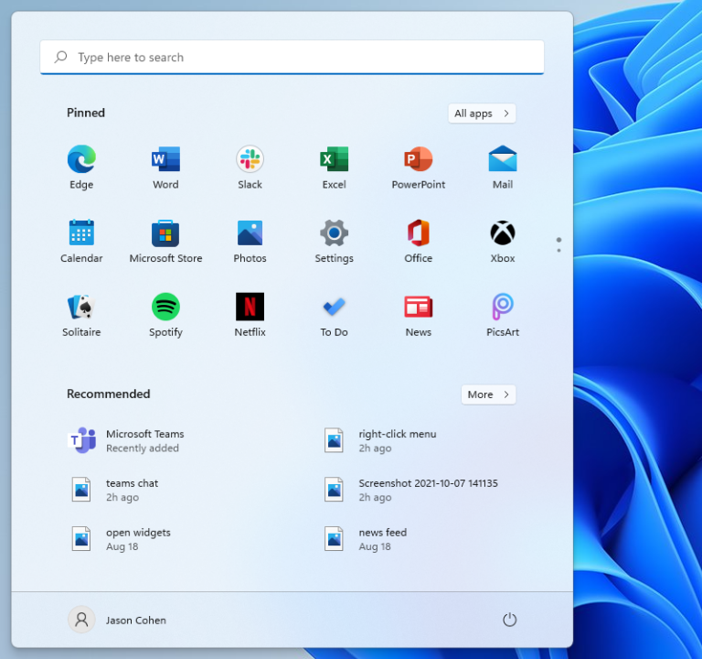
Speaking of live tiles, they're finally gone in Windows 11. In their place is a more simplistic Start menu where you can pin apps for easy access. Open the App List, right-click on an app, and select Pin to Start to move it to the Pinned section. You can then drag the app into your preferred position. To remove apps, right-click and choose Unpin from Start.

Customize the Start Menu
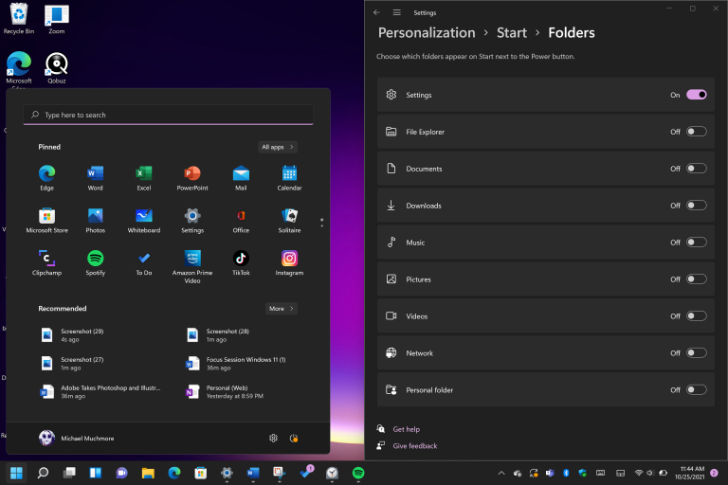
In Windows 10, the Settings button appears above the Start button when you tap it. Not so in Windows 11, but you can add it back via Settings > Personalization > Start > Folders. Here, you can also add File Explorer, other common folders, and Network icons.

Get Better Recommendations
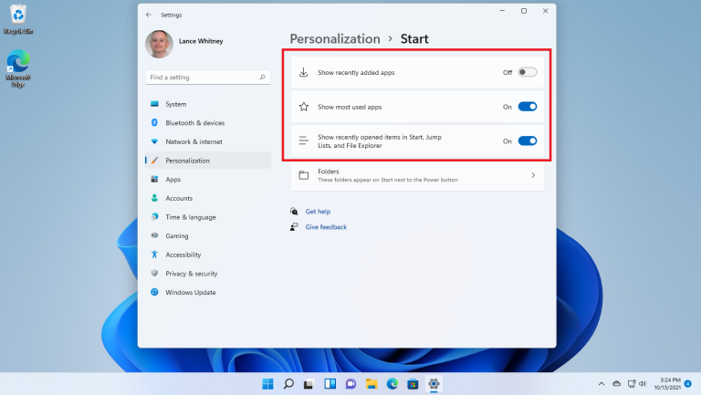
The new Start menu has a Recommended section for recent files and frequently used apps. To customize what appears here, open Settings > Personalization > Start so you can tell Windows to stop showing recently installed apps, frequently used apps, or recently opened items in the Start menu, App List, and elsewhere.

Change Default Apps
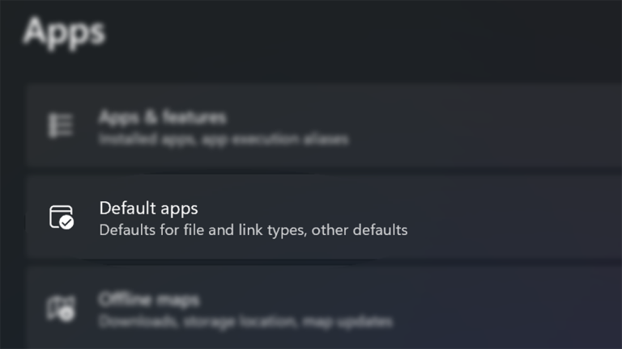
In Windows 10, it’s easy to choose a default app, but with Windows 11, the process is more complicated, as you need to specify a default app for every file type. Open the Settings app and tap on the Apps section in the left-hand menu. Choose Default apps, click on the app you want to set as the default for a file type, and you’ll see a list of all file types it’s capable of handling. Click on the file type you want, and select an app from the menu that pops up. For a full rundown of the process, check out our guide.

Choose Your Theme
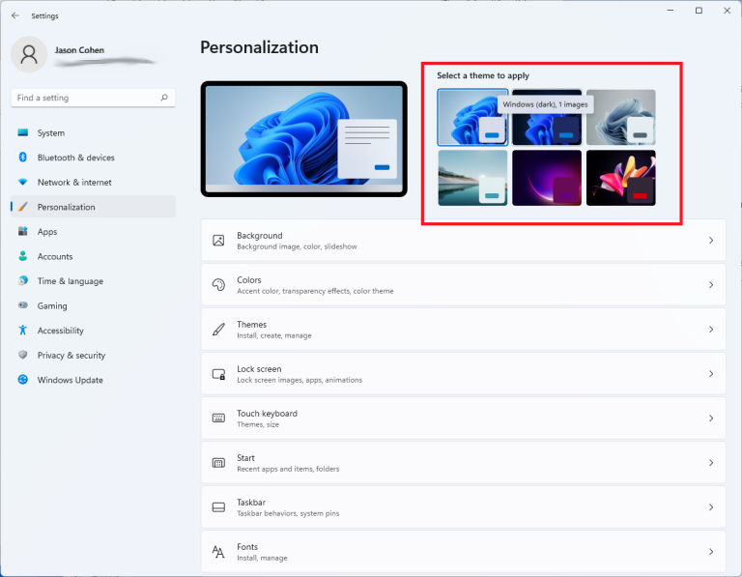
Themes make a return in Windows 11, but this time they work hand-in-hand with dark mode. Open Settings > Personalization and select one of the default themes to change the background image, sounds, cursor, accent color, and color theme all at once. Open Themes to edit current themes, add new themes from the Microsoft Store, or create your own.

Better Battery Visualization
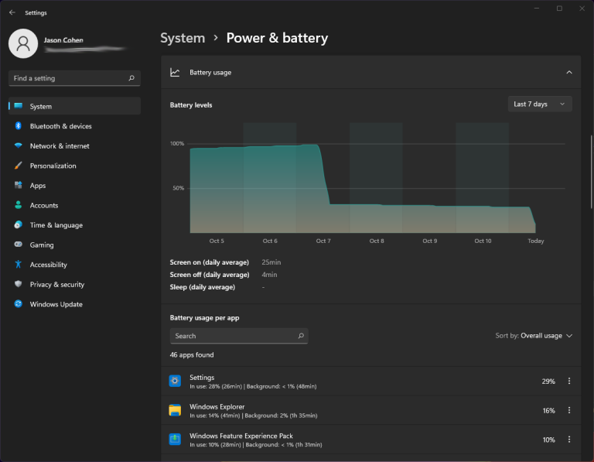
Windows 11 does a better job than its predecessor of helping you visualize your battery usage data. Go to Settings > System > Power & battery, then open the Battery usage tab. Here you will find a chart that shows how much power you have used over the last few days or hours. A list of apps below that show power usage by individual app. If you find a program that may be using too much power, you can shut down background usage and put it to sleep, just like iPhones and Android devices allow you to do.

Get Used to the New Touch Gestures
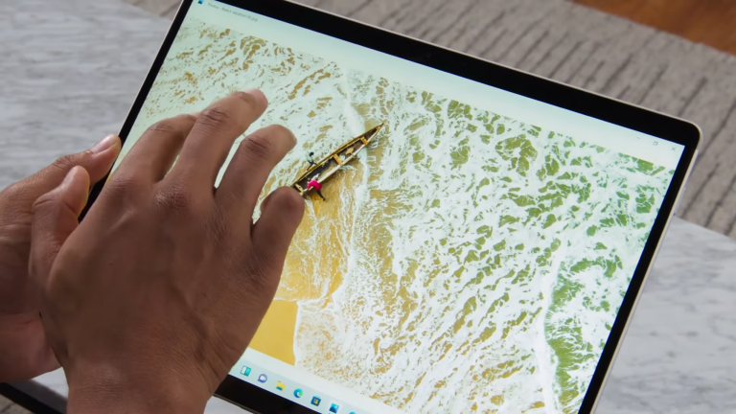
(Microsoft)
If you’re using a touch-screen PC convertible or tablet, like the stunning new Surface Pro 8, you have to get used to a whole new set of touch gestures, many of which involve using multiple fingers. Swiping in from the left side no longer opens task switching mode, but rather the Widgets panel of news and information. To show the Task View, you now have to swipe up on the screen (anywhere) with four fingers. Swiping in from the right still thankfully opens notifications. Swiping down from the top no longer closes an app, but you can swipe down in an app window with three fingers to minimize an app and show the desktop. Swiping three fingers up opens all running windows.

Run Android Apps (in Beta)
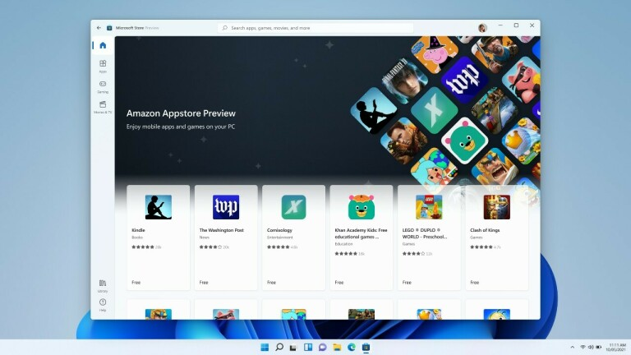
If you're a Windows Insider, you have early access to Android apps in the Microsoft Store. It's currently limited to 50 Amazon Appstore apps, but more are on their way. Here's how to download the Windows Subsystem for Android, install the Appstore, and play around with Android apps on your Windows 11 PC.
Michael Muchmore contributed to this story.

