Turning on TPM. I have an ASUS Motherboard.
Two days ago when I typed tpm.msc in the RUN command box this negative message came up.:
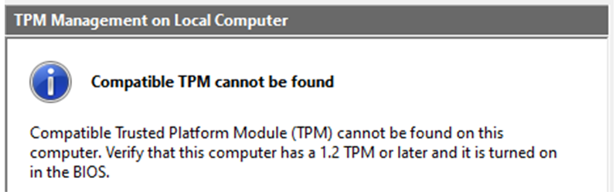
Then I entered the BIOS and did a search for TPM and eventually found under Advanced an option for Discrete or Firmware TMP so I changed my to Firmware TPM and was successful when again using the RUN command prompt. (see below –STATUS –The TPM is ready to use).



