How to Manage and Share Your Photos With Amazon Photos
New storage rules for Google Photos may mean you need a new way to back up an unlimited number of photos online. If you're a Prime member, Amazon Photos is the way to go.


By Lance Whitney
June 19, 2021
Google Photos has killed free unlimited storage, so you may be looking for a different service to house all your images. Amazon Photos is one option worth considering, especially if you’re already an Amazon Prime subscriber.
With Amazon Photos, you can back up and share your photos in the cloud, view photos by people and places, create albums, and play slideshows. Prime members also get unlimited full-resolution photo storage for free. The service can be accessed on the web, through the desktop app, or on your phone or tablet via the mobile app.
Though Amazon Photos makes the most sense for Prime members, non-subscribers can tap into the service as well, but it will cost you. Storage plans start at $1.99 per month for 100GB ($19.99 per year), move to $6.99 per month for 1TB ($59.99 annually), and continue on up from there. You can pay for storage as you go and cancel your plan at any time.

Upload and View Images
To get started, open your desktop browser to the Amazon Photos website and sign in with your Amazon account. Assuming you haven’t yet uploaded or synced photos with your account, the page will prompt you to drag and drop photos or browse and select them from your computer. Upload the photos you want to store on Amazon Photos.
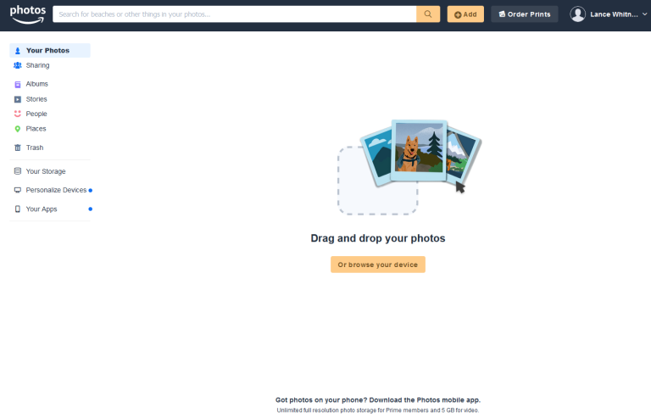
After you’ve uploaded an array of photos, you can view them in different ways. Click one of the four small grid icons on the right to change the layout of your photos to use different numbers of rows and columns.
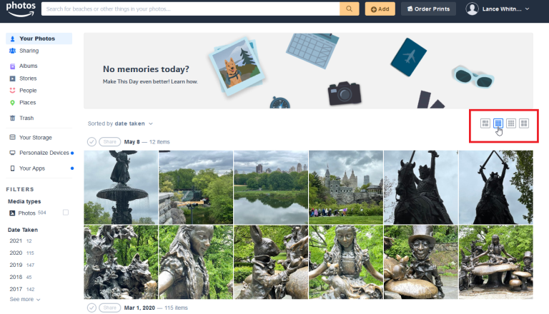
From the left pane, you can filter the photos you see based on media type (photos or videos), the year taken, the types of things in the photos, and the people identified. Check one or more criteria to narrow down your selection, then uncheck the boxes to view all your photos again.
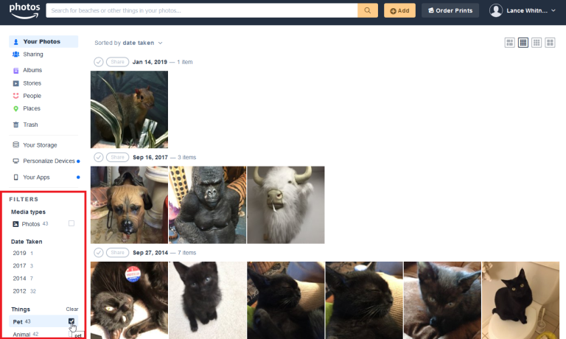
Click a photo to view it up close. From here, you can share the photo, tag it as a favorite, zoom in and out, view it in slideshow format, or move it to the trash.
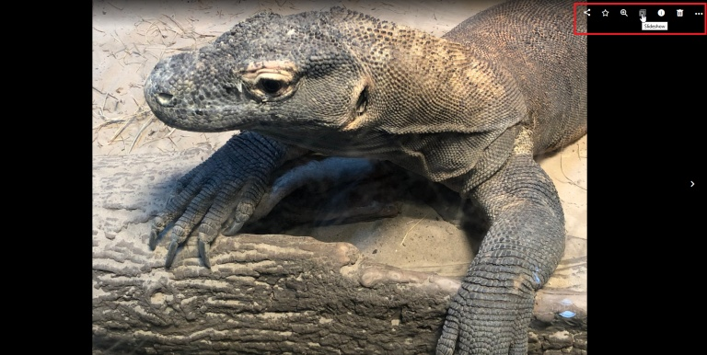
Want to edit your photos? Click the ellipsis icon and select Edit photo. At the editing window, you can rotate the photo, apply different filters, adjust the brightness and contrast, add text, and tweak the focus.
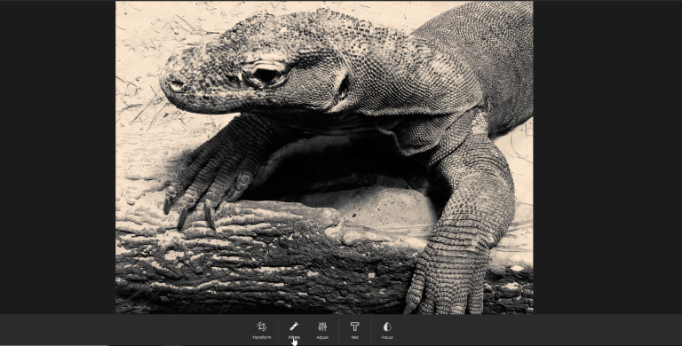
At the top left, click the Stories category. If you’ve taken at least 20 photos with the location enabled, Amazon Photos will create a story based on those photos.
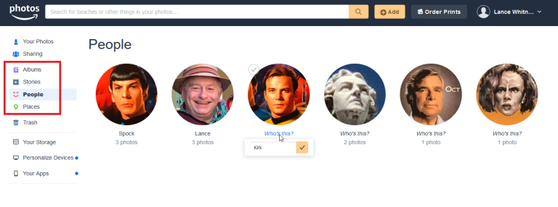
Click the People category to see photos based on identified people. Here, click the phrase Who’s this? for a specific person and type their name. Click the Places category to see photos based on identified locations.

Create Albums
You can create albums to arrange your photos. Click the Albums category and then click the Create new album button.
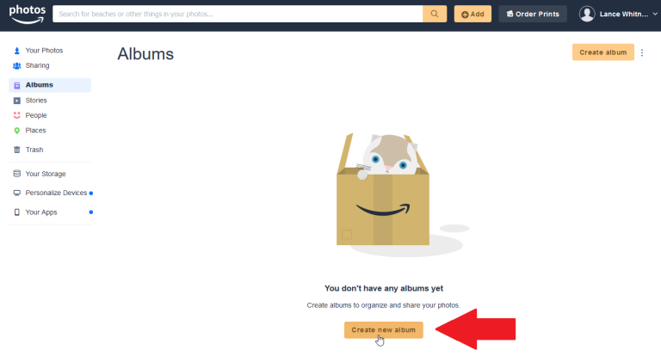
You can select individual photos you want to include in the new album or bulk upload. To select an entire group of photos by a specific date, click the circle in front of the date. Then click the button at the top to Create album.
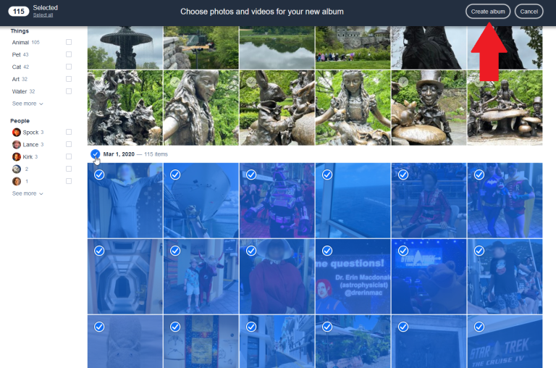
At the album page, type the name you wish to give the album. All the photos you selected appear in your new album. Finally, click the Save Album button at the top. To create additional albums, click the Album category on the left and select Create Album.
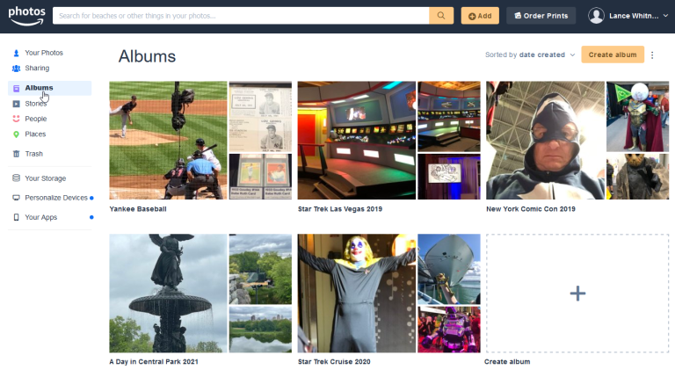

Share Photos
You can share photos by creating special sharing groups within Amazon Photos. Click the Sharing category and then click the Create Group button.
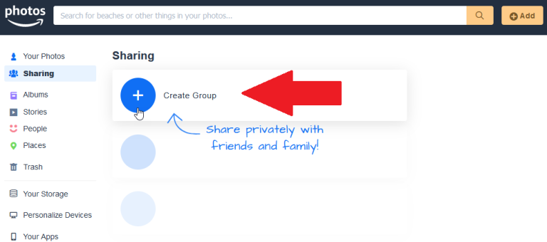
Name the group and click the Add photos button. You can opt to add photos from your computer or from Amazon Photos. Once the photos have been selected, click the Share button
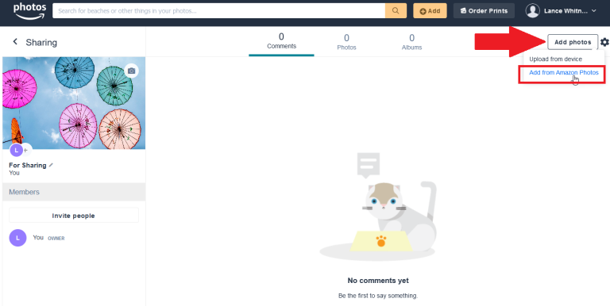
Now click the Invite people button to add users to the group. Your recipients will need an Amazon account for this to work. You can send the link to your shared album via a link, your Amazon contacts list, an email, or Facebook. Choose your preferred method.
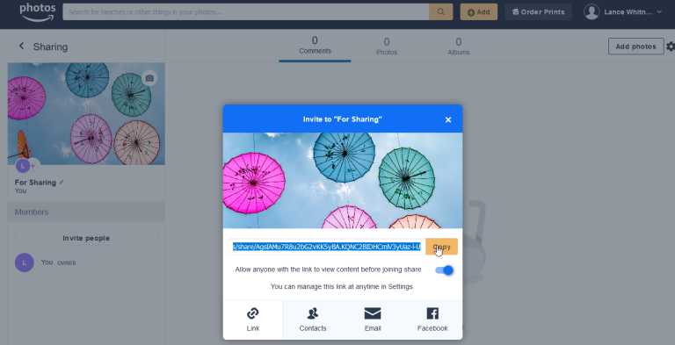
After your recipients accept the invitation, they can access this album. You can also update the shared album by adding or removing photos.
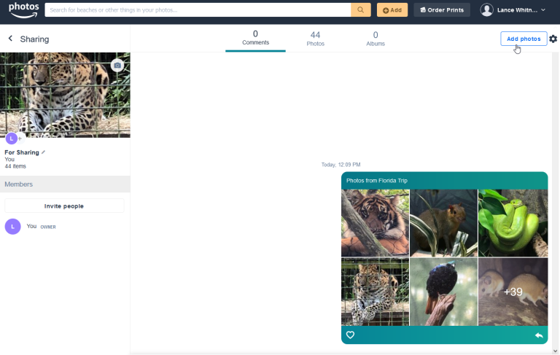

Additional Options
There is much more you can do with your photos. If you select one or more images, several options appear at the top of the screen to let you share or download your photos, add them to an album, or order printed photos.
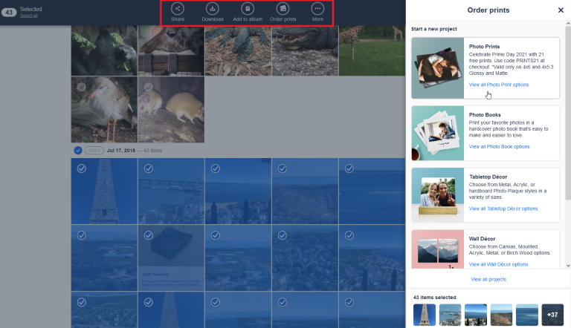
Click the More icon to see additional commands for your Family Vault, to hide the selected photos from view, edit their date and time, or move them to the trash.
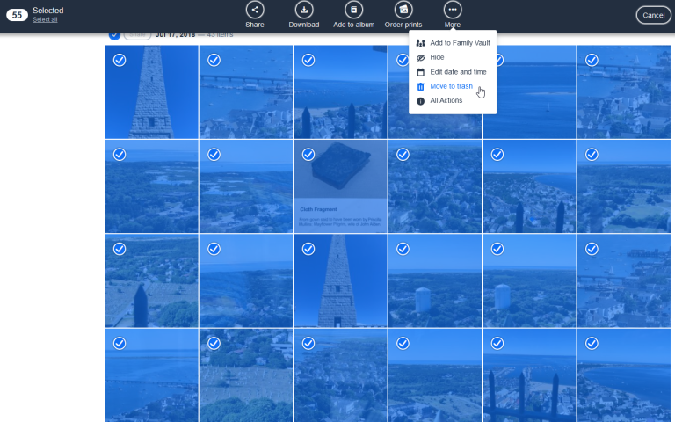
Click Add to Family Vault to add photos that only certain people can see. Once this is set up, you can click the down arrow next to your name and select Family Vault to view and manage the photos.
Select All Actions to view all the available commands on one page, including Share, Download, Add to album, Order prints, Add to Family Vault, Hide, Edit date and time, and Move to trash.
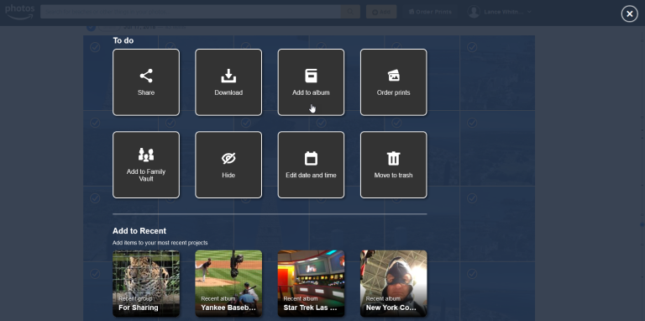

Amazon Photos Desktop
Amazon Photos is also available through a desktop app that works similarly to the website. Head to the Amazon Photos Apps and click the Download now button to grab the desktop app. Open the app and sign in with your Amazon account.
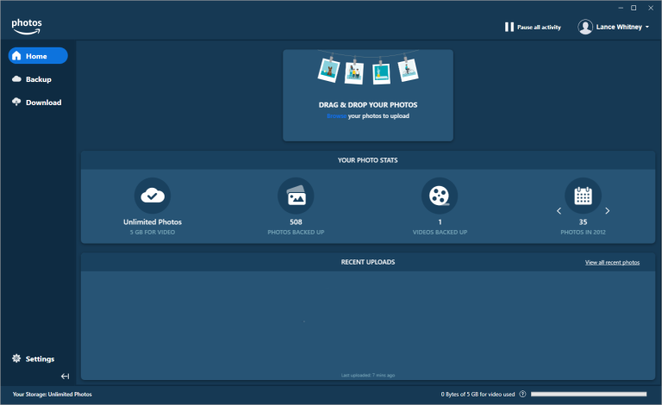
Click Backup, and choose a folder of images on your computer to back up to Amazon Photos.
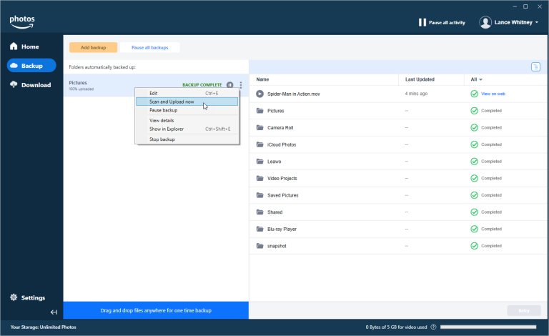
Click Download to download specific folders and albums from Amazon Photos to your PC.
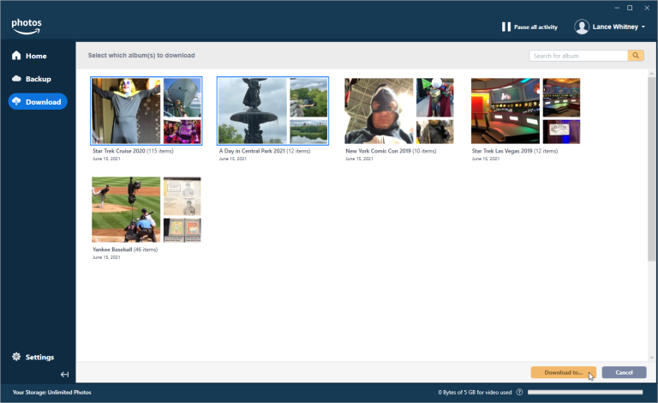

Auto-Save on Mobile
The Amazon Photos app for iOS/iPadOS and Android have many of the same features as the web version. You can view and manage your photos, arrange them into albums, and share them with other people.
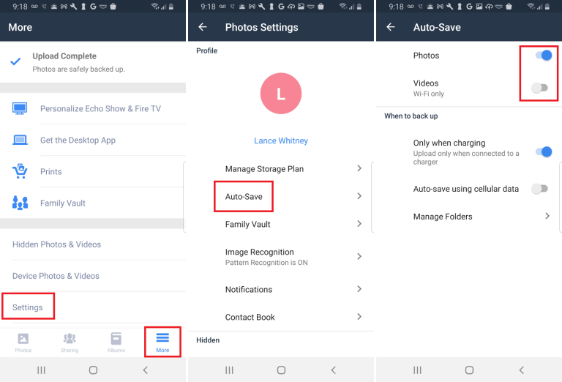
One handy option you may want to enable in the mobile app is to automatically upload photos you snap on your device. Set this up by tapping More > Settings > Uploads > Auto-Save on your iPhone or iPad. You can also include or exclude videos and choose whether to auto save photos using cellular data.
Android users can go to More > Settings > Auto-Save, then turn on the switch for Photos and Videos. You can opt to upload photos only when charging your device and choose whether or not to upload when you're using cellular data.

