**April 2018 SLO Bytes Notes by Ralph Sutter**

Financial Report – Bob Styerwalt [www.slobytes.org/financial](http://www.slobytes.org/financial)

New resource: The Tech Enthusiasts’ Hour: <https://tehpodcast.com/episodes/>

<https://techboomers.com/amazon-alternatives>

Ask Leo Links; Leo Notenboom; <https://askleo.com/>

<http://ask-leo.com/whats_the_difference_between_a_router_a_wireless_router_and_a_wireless_access_point.html>

<https://askleo.com/whats_the_difference_between_a_hub_a_switch_and_a_router/>   
(The end of this article defines common terms)

How Should I Back Up My Computer Before an Operating System Upgrade or Reinstall?

<https://askleo.com/how-should-i-back-up-my-computer-before-an-operating-system-upgrade/?awt_l=BHGrQ&awt_m=Isdcj4Rg63dfbL&utm_source=newsletter&utm_campaign=20180320&utm_medium=email&utm_content=featured>

Actual URL is <https://askleo.com/how-should-i-back-up-my-computer-before-an-operating-system-upgrade/>

[broadband](https://askleo.com/glossary/broadband/), [IP address](https://askleo.com/glossary/ip-address/), [switch](https://askleo.com/glossary/switch/), [router](https://askleo.com/glossary/router/), [network](https://askleo.com/glossary/network/), [protocol](https://askleo.com/glossary/protocol/), [packet](https://askleo.com/glossary/packet/), [firewall](https://askleo.com/glossary/firewall/), [malware](https://askleo.com/glossary/malware/), [hub](https://askleo.com/glossary/hub/), [port](https://askleo.com/glossary/port/), [DHCP](https://askleo.com/glossary/dhcp/), [NAT](https://askleo.com/glossary/nat/), [ISP](https://askleo.com/glossary/isp/)

For a more comprehensive list, see <https://askleo.com/glossary/>

**Tree Size**; free program that displays the size of all folders  
<https://www.jam-software.com/treesize_free/download.shtml>

Delete system files from C using Windows’ **Disk Cleanup**   
(Candidates for deletion; **Windows.old** and **Windows10Upgrade)**  
<https://answers.microsoft.com/en-us/windows/forum/windows_10/how-to-free-up-disk-space-in-windows/2458cc31-bd19-482f-ace5-7e3bd9da8098>

E-mail ostensibly from my credit card company: What to do?

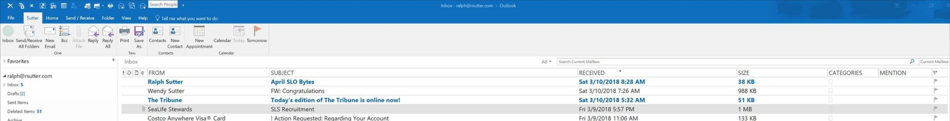

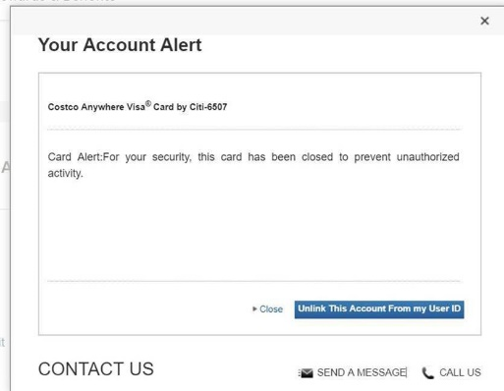

Alexa Laugh: <https://www.theverge.com/circuitbreaker/2018/3/7/17092334/amazon-alexa-devices-strange-laughter> (John Waller)

Mention Meetup; [www.meetup.com](http://www.meetup.com)

Plug Central Coast Home Roasting Coffee March 22 at 7:00 pm

Mention SLO Bytes unsecure via Google

Micro USB to Lightning adapter   
<https://www.amazon.com/gp/product/B06ZYN9DGL/ref=oh_aui_detailpage_o00_s00?ie=UTF8&psc=1>

Adobe Reader for PDF Viewer: Limitations

Show how to save rotated .pdf file using a free pdf viewer, **pdf-xchange editor**

Install **PortableApps;** <https://portableapps.com/>

Download a portable version at <https://portableapps.com/apps/office/pdf-xchange-editor-portable>

(The PDF Exchange Editor web site didn’t link to a freeware version directly) The portable version can be run without PortableApps but you lose the convenience of update notifications.

Rotate image with PDF Xchange Editor

Print to **Microsoft Print to PDF** instead of an actual printer  
Open the resulting .pdf file with any .pdf reader/editor and it will show the rotated version.

When the pdf file contains more information than required, use Microsoft Print to PDF to triage the unwanted pages

Example Porter Cable Drill Press.pdf

SCaLE Link Alan and Ralph’s reports: <http://www.slolug.com/scale2018.html>

SCaLE Videos <https://www.youtube.com/user/socallinuxexpo>

SCaLE clip: <http://www.slolug.com/videos/102.mp4> (Very slow and problematic download; must be restarted many times)  
The problem is with Alan’s host, GoDaddy, not with the actual file

I copied Alan’s file to my account on [Dropbox](http://www.dropbox.com) and was then able to download the file in 3 minutes versus more than one hour on GoDaddy  
My site: <https://www.dropbox.com/s/aqjm3fux2cvfcok/Alan%20at%20SCaLE.mp4?dl=0>