SLO Bytes HardCopy
A publication of the San Luis Obispo PC Users’ Group
Vol. 36 No.10 October 2020
September 6th, 2020 First Session Notes by Alan Raul
Clipboard in Windows 10
https://support.microsoft.com/en-us/help/4028529/windows-10-clipboard
https://www.tenforums.com/tutorials/109799-turn-off-clipboard-history-windows-10-a.html
A freeware program that I use in lieu of Logitech's SetPoint is X Mouse Button Control at https://www.highrez.co.uk/downloads/XMouseButtonControl.htm
I use it to set up the scroll button to paste the contents of the clipboard whenever I press down on it. While Logitech offers this configuration, it repeatedly forgets the setting. (Ralph Sutter)
O&O ShutUp10: Free antispy tool for Windows 10
https://www.oo-software.com/en/shutup10
O&O AppBuster: Bust Apps you do not want!
https://www.oo-software.com/en/ooappbuster
Macrium Reflect 7 Free Edition
https://www.macrium.com/reflectfree
Acronis True Image 2021
https://www.acronis.com/en-us/personal/computer-backup/
Four different ways to produce a rescue USB flash drive:
Simple
Advanced-WinPE-based media-Windows Recovery Environment
Advanced-WinPE-based media-ADK
Linux based media
What's new in Acronis True Image 2021 for Windows?
https://www.acronis.com/en-us/support/updates/changes.html?p=42226
Acronis True Image 2021 Knowledge Base
https://kb.acronis.com/acronis-true-image-2021
Acronis True Image 2021 Forum
https://forum.acronis.com/forum/acronis-true-image-discussions/acronis-true-image-2021-forum
Where to purchase Acronis True Image 2021
http://ugr7.com/true-image-perpetual.html
Wilders Security Forum
https://www.wilderssecurity.com/threads/acronis-true-image-2021.431803/
Intel: 10nm Tiger Lake CPUs will be in 50 new laptops coming this fall
https://venturebeat.com/2020/09/02/intel-10-nanometer-tiger-lake-cpus-will-be-in-50-new-laptops-coming-this-fall/
https://www.zdnet.com/article/intel-unveils-entirely-new-platform-brand-intel-evo-based-on-tiger-lake/ https://appuals.com/intel-11th-gen-evo-platform-cpus-based-on-10nm-tiger-lake-for-thin-n-light-laptops-launched/
Champion Portable Generators
https://www.championpowerequipment.com/products/generators/portable-generators/
Example: Champion (76533) 3800-Watt Dual Fuel Generator
https://www.championpowerequipment.com/product/76533-3800-watt-dual-fuel-generator/
https://www.amazon.com/dp/B00VFDJGCE
Tesla Powerwall
https://www.tesla.com/powerwall
BACK-UP Home Medical Equipment with a Tesla Powerwall
https://www.sempersolaris.com/cpap/
PocketKnife Peek is an Outlook add-in for screening your e-mail as plain text before opening it in Outlook. The add-in can be used to view all Outlook message formats, but is aimed particularly at averting the threats lurking in HTML mail.
http://www.xintercept.com/peek/pkpeek.htm
The Ultimate Windows 10 Information Hub: Everything you need in one place
https://www.zdnet.com/article/free-how-to-help-windows-10-ed-botts-tech-support-troubleshooting-guide/
Here's how you can still get a free Windows 10 upgrade
https://www.zdnet.com/article/heres-how-you-can-still-get-a-free-windows-10-upgrade/
▫▫▫▫▫▫▫▫▫▫▫▫▫▫▫▫▫▫▫▫▫▫▫
October 4th Program by Ralph Sutter
The First ZOOM Session in August will feature Alan Raul offering a Questions and Answers program from 12:45-2:00 p.m.
Usual topics include security issues, recent changes in Windows operating systems, tablets and smart phones as well as demos of software and hardware. We always encourage questions and observations from the audience.
There will be a break from 2:00-2:30 pm allowing the audience to sip a beverage, pet the dog or stretch
During the Second Session, Alan Raul will demonstrate and discuss “Good Computing Practices.” This will include general good computing practices and tips that apply to most people who use a computer such as a VPN (Virtual Private Network), password manager and more.
To be part of the virtual meeting via Zoom, please refer to the e-mail that will be sent to you twice shortly before the meeting with the credentials necessary to join the Zoom session. If you are asked for a Meeting ID or a Password, copy it from the announcement and paste it into the appropriate box.
View Zoom tutorials at https://www.youtube.com/playlist?list=PLKpRxBfeD1kEM_I1lId3N_Xl77fKDzSXe If you have any questions, please contact Ralph Sutter at ralph@rsutter.com
Ralph Sutter
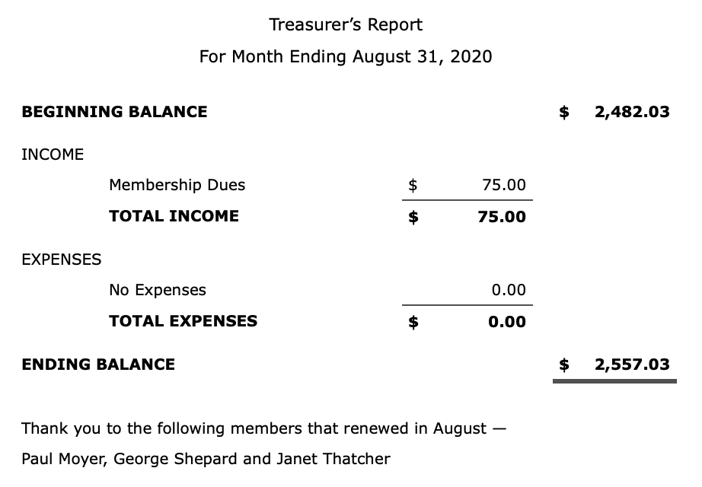
Kaye Raul, Treasurer
▫▫▫▫▫▫▫▫▫▫▫▫▫▫▫▫▫▫▫▫▫▫▫
Photo Group Report by Ralph Sutter
Notes from the Meeting of 09/13/2020
TOPIC: Artistic Growth-Phase Three; Learn a new skill for use inside or outside the camera and present it to the group.
The meeting took place via Zoom
Ralph Sutter opened the meeting, calling attention to the Links Page of the Photography web site. Two articles were added for the September meeting. They are
Open HEIC Files in Windows 10 and
Wi-Fi Photo Transfer; download images from an iPhone to a PC wirelessly
Program suggested by Alan Raul, tutorial by Ralph Sutter
Also on YouTube at https://youtu.be/lIKo3PzThTw
Next Sutter shared a series of images featuring blossoms of fruits and vegetables. Ralph explained that he used Irfanview to insert titles. He controlled the order in which Irfanview displayed the images by opening an image in that program and then clicking on File/Thumbnails/Options/Sort Thumbnails/By name (natural/logic order).

Alan Raul showed his results of "long exposures" of running water at Waller Park in Santa Maria. A typical exposure for these shots were ISO 64, 10 seconds at f/22. He used a "Variable ND (Neutral Density) filter with his 35mm f/2.8 Sony lens to get the desired effect. He use the following web site as a guide on how to set up his Sony mirrorless camera.
https://alphauniverse.com/stories/set-up-your-camera-for-long-exposures/
Stanford Brown followed introducing CopyTrans HEIC for Windows - https://www.copytrans.net/copytransheic/
John Waller demonstrated a new tool in Adobe Photoshop, the Object Selection Tool, useful for quickly selecting part of an image for further manipulation. John then showed the results of his low light tests with varying speed and aperture settings and different lenses.
Kaye Raul used Aurora HD https://skylum.com/aurorahdr with .raw files to improve shadow detail in images taken at Waller Park.
NEXT MEETING: Sunday, October 11th, 2020@ 2:00 pm
The topic is Images Dominated by a Single Color. The meeting will take place via Zoom

A Zoom invitation will be e-mailed to Photo Group members shortly before the meeting.
The meeting schedule for the remainder of 2020 is as follows
November 8th
December 13th

See the Links page for tutorials and other resources

Ralph Sutter
▫▫▫▫▫▫▫▫▫▫▫▫▫▫▫▫▫▫▫▫▫▫▫
Push Library
Look at the PUSH archives, http://www.slobytes.org/push/. This is a repository of articles where you will find tips, product reviews, and personal recommendations contributed by computer clubs across the country.
They are provided courtesy of the Association of Computer User Groups, APCUG, the national organization with which SLO Bytes is affiliated.
The actual PUSH articles are hyperlinked from the index located at
http://www.slobytes.org/push/index.html (All articles on one long page)
http://www.slobytes.org/push/push-condensed.html (Links to PUSH articles by month received)
You can view additional APCUG publications here: http://www.slobytes.org/apcug/index.html
SLO Bytes Bulletin Board
Everyone can read the SLO Bytes Bulletin Board at http://slobytes.org/smf/index.php?board=1.0 but only subscribers can post comments or respond to the posts of others. Despite the usual connotation of subscribe, it costs nothing to join the bulletin board. It is free to all current SLO Bytes members. However, to guard against cyber-mischief by spammers and other ne’er-do-wells, I have disabled self-registration. If you want to be added to the bulletin board, please send your request to me at ralph@rsutter.com.
If you are currently registered with the SLO Bytes Bulletin Board and wish to change your password, you will find a video screen capture of how to do so at
http://www.slobytes.org/documents/change-bb-password.mp4
▫▫▫▫▫▫▫▫▫▫▫▫▫▫▫▫▫▫▫▫▫▫▫
Club Information and Meeting Times
SLO Bytes, a PC Users Group dedicated to educating its members in the use of personal computers, digital devices and software, meets on the first Sunday of each month via Zoom. Zoom credentials are sent to members twice shortly before each meeting. If you are a SLO Bytes member and don’t receive this e-mail, please contact ralph@rsutter.com.
All meetings are open to the public at no cost. A general interest and Q&A session occurs from 12:45 PM to 2:00 PM and guest speaker presentations begin at 2:30 PM. Contact Ralph Sutter (ralph@rsutter.com) or visit slobytes.org for additional information about SLO Bytes and the scheduled presentation. All ideas for speakers or presentation subjects are welcome.
HardCopy is a monthly publication of SLO Bytes PC Users' Group located in San Luis Obispo, California. Information in this newsletter is derived from both our own membership and other PC user group newsletters.
The purpose of this publication is to inform our members of meetings and provide information related to the use of PCs and various operating systems.
Membership dues are $25 per year. Membership entitles you to our monthly newsletter via e-mail, technical assistance comradeship and a voice in the affairs of the club.
Outside Special Interest Groups (SIGs)
The Linux Group normally meets via Zoom at 6:30 PM on the first Thursday of the month.
View the web site at www.slolug.com. Contact Alan@alanraul.com for credentials to join the Zoom Session.
The Photography Group normally meets via Zoom at 2:00 PM on the second Sunday of each month. Contact ralph@rsutter.com for credentials to join the Zoom Session.
Visit the website at www.slobytes.org/digital
▫▫▫▫▫▫▫▫▫▫▫▫▫▫▫▫▫▫▫▫▫▫▫
SLO Bytes Officers/Volunteers
Officers
Earl Kaplan – President: earlkaplan@gmail.com
John Waller - Vice President; Programs Chair/Publicity: johnlwaller@sbcglobal.net
Kaye Raul – Treasurer; Membership: kaye@kayeraul.com
Ralph Sutter – Secretary, Webmaster/HardCopy Editor, Photo SIG Leader: ralph@rsutter.com
Alan Raul – Training Officer/Linux Group Leader: alan@alanraul.com
Other Volunteers
Peter Stonehewer – Refreshments
▫▫▫▫▫▫▫▫▫▫▫▫▫▫▫▫▫▫▫▫▫▫▫
Disclaimer: Neither SLO Bytes PC Users' Group, its officers, editors, or contributors to this newsletter assume liability for damages arising out of this publication of any article, including but not limited to the listing of programming code, batch
files and other helpful hints. Articles from this newsletter may be reprinted by other user groups if credit is given to both
the author and newsletter from which it was taken. Reproduction of articles with a specific copyright notice is prohibited without prior permission from the original author.
SLO Bytes Website: slobytes.org

