SLO Bytes HardCopy
A publication of the San Luis Obispo PC Users’ Group
Vol. 34 No. 9 September 2018
August 5th, 2018 First Session Notes by Alan Raul
Google made the Titan Key to toughen up your online security
https://www.cnet.com/news/google-made-the-titan-key-to-toughen-up-your-online-security/
Google pledges to foil phishing attacks with new Titan Security Key
https://www.zdnet.com/article/google-pledges-to-foil-phishing-attacks-with-new-titan-security-key/
Google Product Forums
https://productforums.google.com/forum/#!home
5 ways to protect your privacy while using Amazon products and services
https://www.usatoday.com/story/tech/2018/07/27/5-obscure-settings-amazon-update-your-privacy/827840002/
The Race to a Trillion
https://www.aboveavalon.com/notes/2018/7/11/the-race-to-a-trillion
How to create a bootable USB drive for Windows 10
https://mspoweruser.com/how-to-create-a-bootable-usb-drive-for-windows-10/
Rufus - Create bootable USB drives the easy way
https://rufus.akeo.ie/
Alan Raul
▫▫▫▫▫▫▫▫▫▫▫▫▫▫▫▫▫▫▫▫▫▫▫
August 5th, 2018 Second Session Notes by Ralph Sutter
View slide shows of the BBQ taken by photographers Alan Raul and Bob Styerwalt at www.slobytes.org/photos/2018bbq/

News Sources and Objectivity Presentation – 08/05/18 Second Session
What I use
AP News: https://www.apnews.com/ (My first choice for on-line news)
The Skimm: https://theskimm.com/recent (light weight irreverent sampling of news)
Telegram Tribune: http://digital.olivesoftware.com/Olive/ODN/SanLuisObispo/default.aspx? (Easier to read on line than walk to my rural mailbox; Online app is free to subscribers of the printed version)
How to Detect Bias in News:
https://fair.org/take-action-now/media-activism-kit/how-to-detect-bias-in-news-media/
Reviews of News Services for Windows 10:
https://www.windowscentral.com/best-news-apps-windows-10
Microsoft Store: News and Weather:
https://www.microsoft.com/en-us/store/top-free/apps/pc?category=news+%26+weather%5Cnews
Reviews of News Services for Smart Phones: https://www.digitaltrends.com/mobile/best-news-apps/
Alternative News: Moon Landing Faked;
Wikipedia: https://en.wikipedia.org/wiki/Moon_landing_conspiracy_theories
Fox News Documentary; https://www.youtube.com/watch?v=MIy8ZqqK5G8
Flat Earth Theory: http://freedom-articles.toolsforfreedom.com/2nd-biggest-conspiracy-flat-earth/
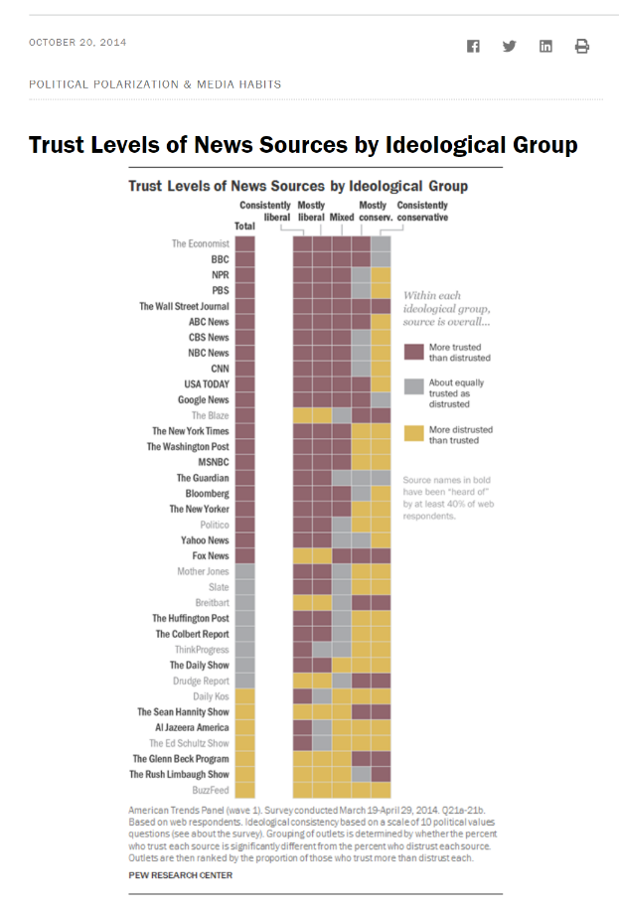

Source: http://www.journalism.org/2014/10/21/political-polarization-media-habits/pj_14-10-21_mediapolarization-01/

Pew Report - Political Polarization and Media Habits Final Report 7/27/15
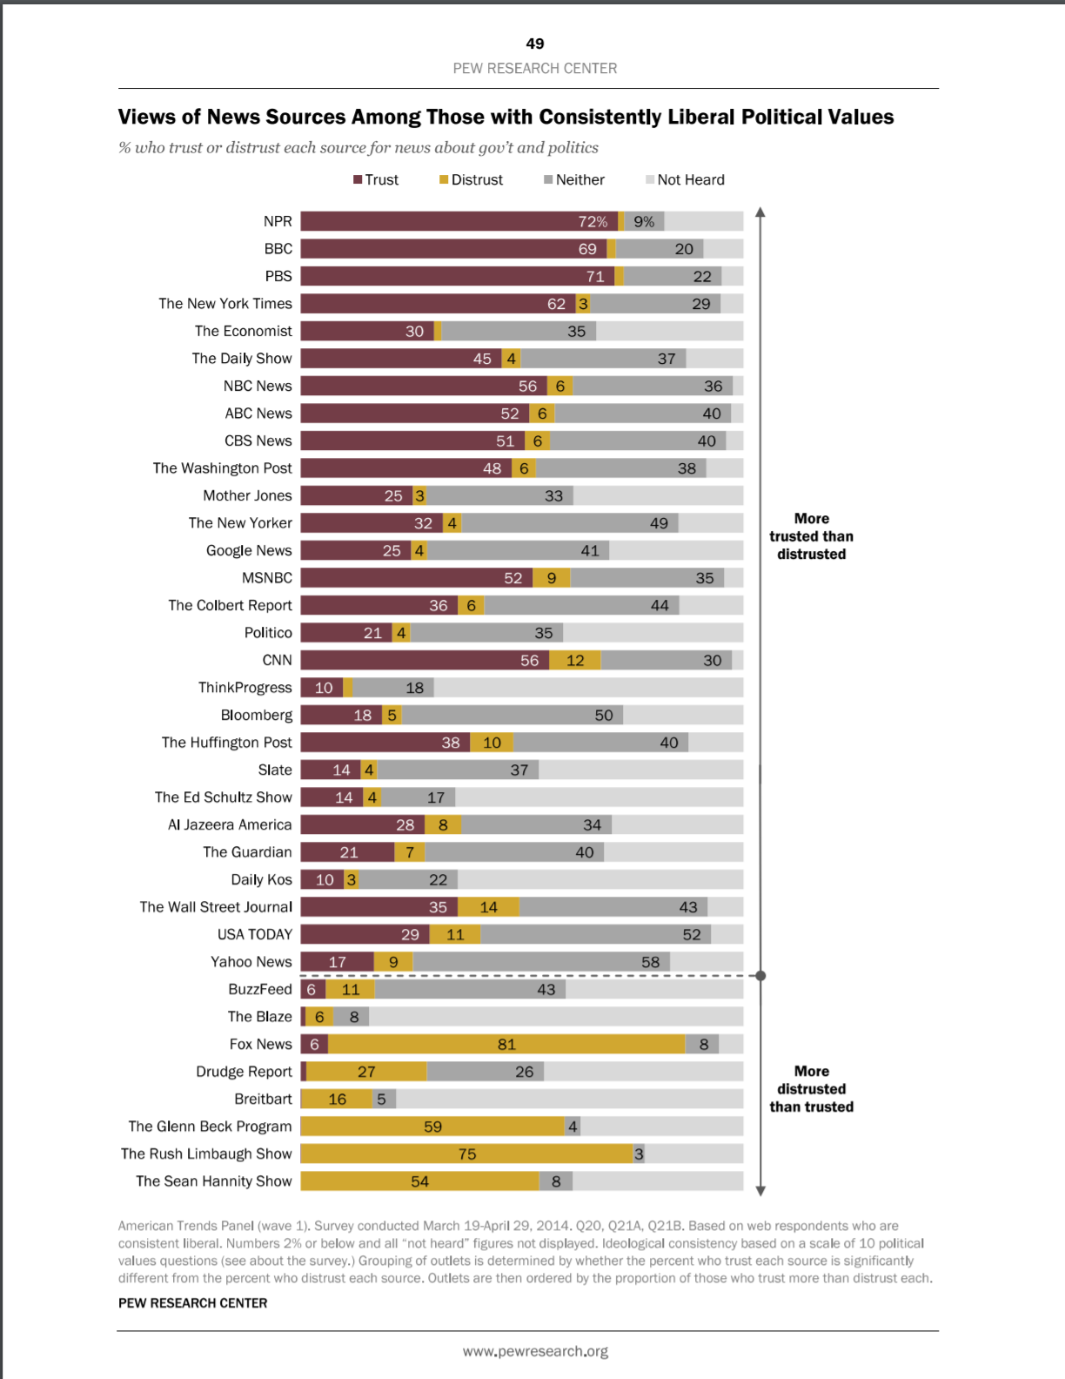 | 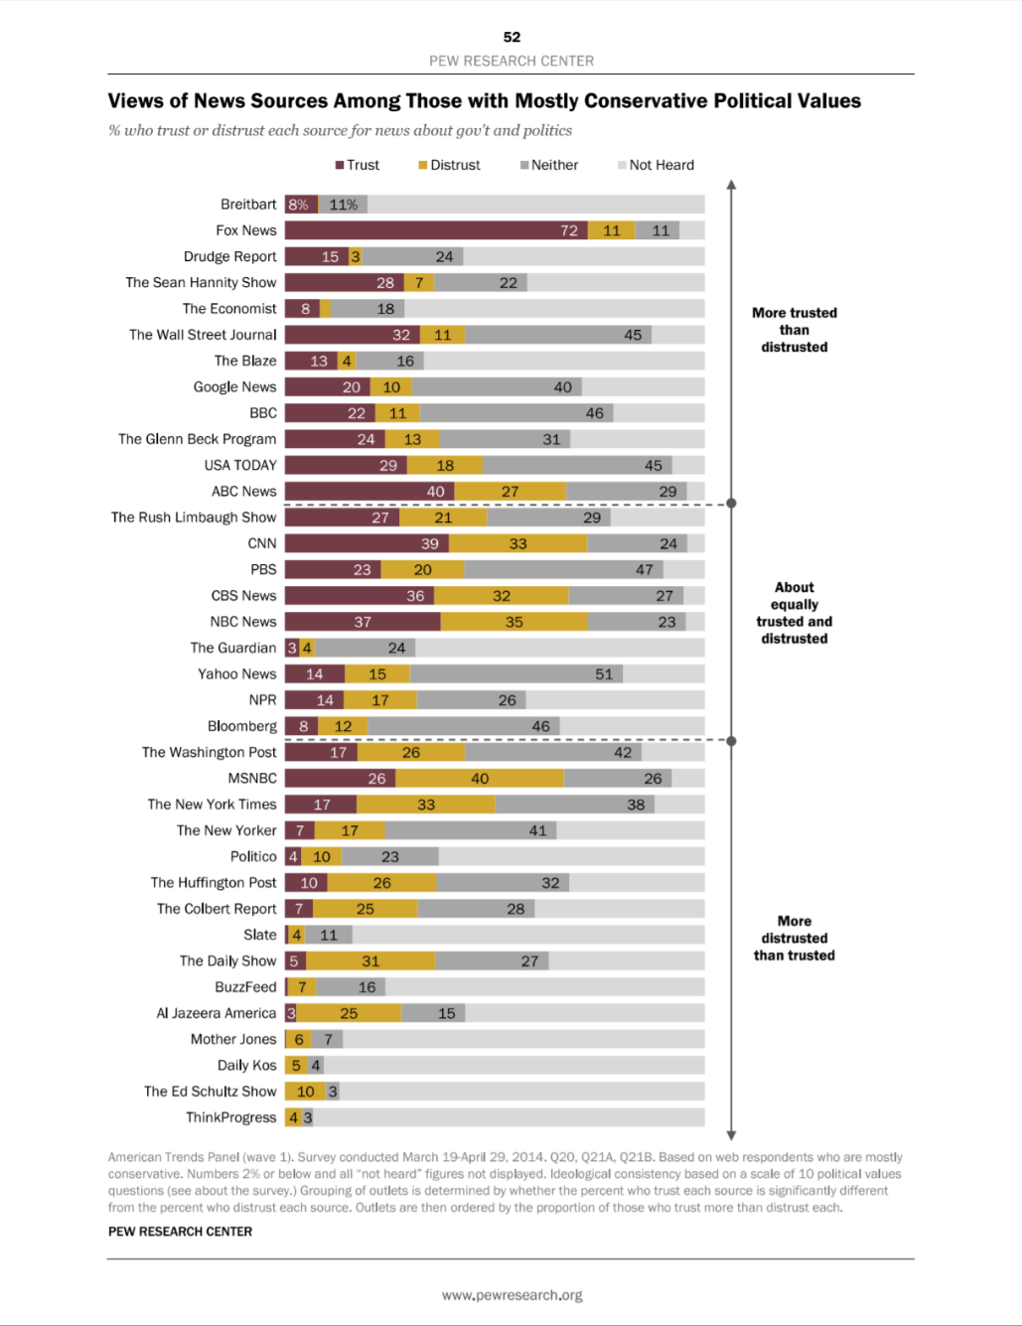
Source:
http://assets.pewresearch.org/wp-content/uploads/sites/13/2014/10/Political-Polarization-and-Media-Habits-FINAL-REPORT-7-27-15.pdf

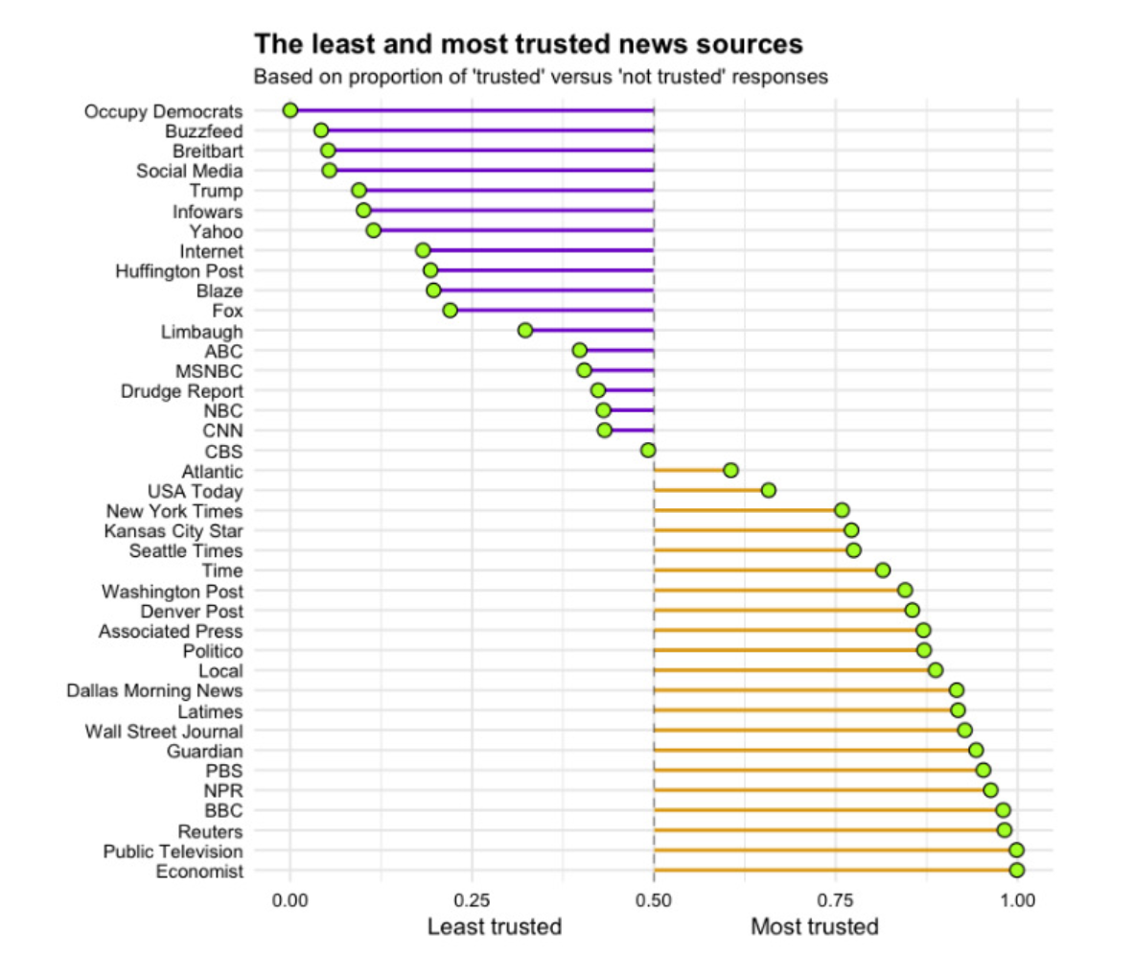
Source: http://www.visualcapitalist.com/least-most-trusted-news-sources/

13 Most Trusted News Sites that You Should Bookmark
Source: https://www.makeuseof.com/tag/trust-news-sites/

Associated Press News
BBC
Brief.news
The Bureau of Investigative Journalism
The Christian Science Monitor
The Economist
NPR
ProPublica
Reuters
USA Today
The Wall Street Journal
FAIR

Smartphone Alerts
Source: https://www.makeuseof.com/tag/4-ways-to-keep-up-with-breaking-news-online/

One of the easiest ways to keep up with breaking news online is to have it pushed directly to your phone. There are a ton of apps out there that make that easier than ever. No matter your preferred news source, you’re likely to find a native app that delivers breaking news updates as push notifications to your phone. Below is just a sample list of the most prominent mobile apps (Android, iPhone, Windows and Blackberry) that deliver news updates as push notifications:
AP Mobile
CNN
Breaking News
Fox News
Reuters
BBC News
Some news services also provide news alerts via text message, including CNN, BBC, Al Jazeera, Sky News and NBC News. The service’s availability might vary according to the country you live in.
USA Today
CNN
Fox News
If you don’t want to limit yourself to one news service, you can always create custom breaking news alerts on any topic of your choice using Google or Yahoo Alerts — that way you’re ensuring that you’re getting lots of different angles to one story, rather than sticking to one,

PLEX Newsfeed

https://app.plex.tv/desktop#!/provider/tv.plex.provider.news
Off line link to above; http://www.slobytes.org/presentations/sutter-0818/plex.mp4

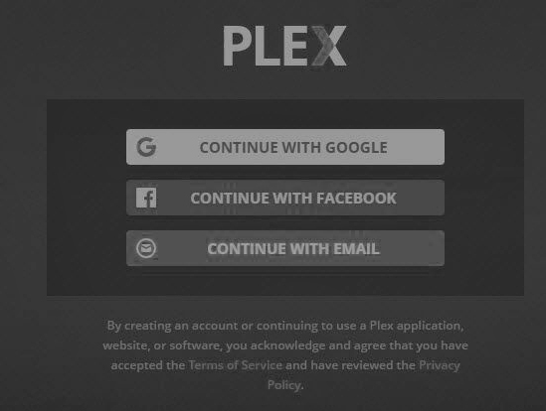
PLEX Sign-up Agreement

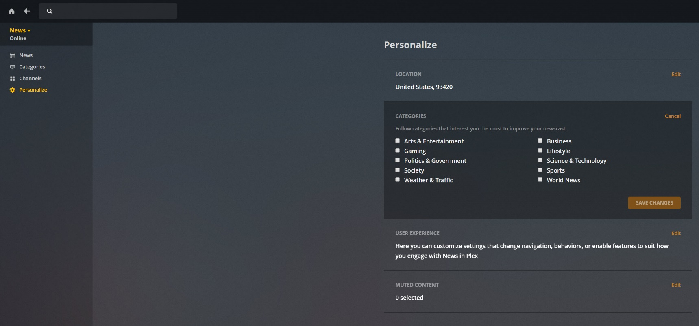
Personalization Options

PLEX Channels
https://app.plex.tv/desktop#!/provider/tv.plex.provider.news?key=%2Flibrary%2Fsections%2Fchannels&context=content.channels
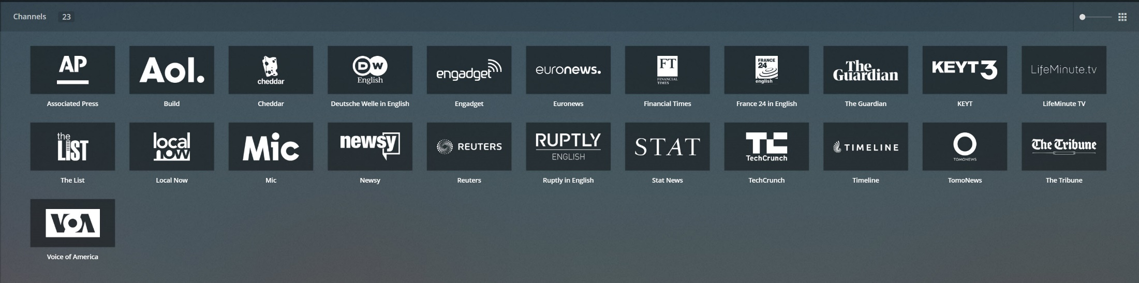

Ralph Sutter
▫▫▫▫▫▫▫▫▫▫▫▫▫▫▫▫▫▫▫▫▫▫▫
September 2nd Programming Schedule by Alan Raul
The First Session will feature Alan Raul moderating a Questions and Answers program from 12:45-2:00 p.m. Usual topics include security issues, recent changes in Windows operating systems, tablets and smart phones as well as demos of software and hardware. Alan always encourages questions and observations from the audience.
During the break, from 2:00-2:30 pm, coffee and cookies will be offered as well as a chance for you to chat with other club members.
In the Second Session, beginning at 2:30 pm, Alan Raul will demonstrate two Linux distributions, Ubuntu Mate 18.04.1 and Linux Mint 19. His goal is not to convert anyone to Linux so much as to inform the audience of the state of Linux. Both these Linux distributions are the latest and just recently updated. Alan will also demonstrate how you can use a bootable USB flash drive with Linux on it to diagnose hardware, networking (Wi-Fi) issues and of course Windows 10 system problems. A lot of our members do not go out at night anymore, so this will keep them in the Linux loop.
Contact Alan at alan at alanraul.com for more information
Alan Raul
▫▫▫▫▫▫▫▫▫▫▫▫▫▫▫▫▫▫▫▫▫▫▫
Treasurer’s Report for July 2018 by Bob Styerwalt
Income July 2, 2018 thru August 5, 2018
 | Renewing Members | $175.00
 | New Members
 | Refreshments donations | $15.00
 | General donations | $130.00
Expenses:
 | Refreshments reimbursement | $94.18
 | Hall Rent | $65.00
 | New Projector | $499.00
Bank Statement ending 07/31/2018
 | Checking account balance | $2,459.73
 | Interest paid this period | $0.00
 | Deposits | $275.00
 | Withdrawals | $564.00
Renewing Members: Four members renewed during this period, Earl Kaplan, Alan Raul, George Shephard and Janet Thatcher. Note: Alan is very optimistic about our club; he renewed his membership for four years. Hooray! Thanks to all for your continuing interest and support. Two SLO Bytes members and one SLOLUG attendee made generous donations to the club budget. Thank you!
I continue to believe that we have a friendly group that can provide useful information to any computer user. Please encourage your friends, neighbors, kids, parents and strangers to check us out.
Bob Styerwalt
Photo Group Report by Ralph Sutter
Notes from the August 12th Session; TOPIC: Symbols
The session opened with Ralph Sutter showing a series of images of trees growing in difficult places. View them at http://www.slobytes.org/digital/images/trees.docx
He then updated the group on member Bob Grover's biography. An edition with full-color photos is available in the Kindle format at https://www.amazon.com/Always-Quest-Norma-Elise-Wäälen-ebook/dp/B07DPGN7M2/ref=sr_1_1_twi_kin_2
Purchasing the Kindle version, those with Amazon's Alexa can have the book read aloud by saying to Alexa, "Alexa, tell Kindle to read Always a Quest".
Next, Ralph presented a slide show featuring company logos past and present as well as personal symbols.
Connie Sutter followed with shots of familiar icons taken from local signs and structures. They included traffic control, religious symbols and flags.
Bob Styerwalt offered a collage of automobile nameplates and public works signs.
John Waller broke his images down into those with and those without text. Like other members, John showed nameplates and public signs.
At the close of the meeting, Ralph demonstrated how he downloaded an on-line article, saved it off-line and used Photoshop Elements to remove selected content.
The group couldn't decide on a topic for the September meeting, deciding to e-mail suggestions to Ralph at ralph@rsutter.com . He will have members vote on the most popular option
Here is the meeting schedule for 2018
September 16 (One week later than usual)
October (The October meeting date has not been determined yet)
November 11
December 9
NEXT MEETING Sunday, September 16th, 2018 @ 2:00 pm
LOCATION:
Home of Connie and Ralph Sutter
498 Hansen Hill Road
Arroyo Grande, CA
Map at www.slobytes.org/digital/sutter-map.html
Ralph Sutter
▫▫▫▫▫▫▫▫▫▫▫▫▫▫▫▫▫▫▫▫▫▫▫
Push Library
Look at the PUSH archives, http://www.slobytes.org/push/. This is a repository of articles where you will find tips, product reviews, and personal recommendations contributed by computer clubs across the country.

They are provided courtesy of the Association of Computer User Groups, APCUG, the national organization with which SLO Bytes is affiliated.
The actual PUSH articles are hyperlinked from the index located at
http://www.slobytes.org/push/index.html (All articles on one long page)
http://www.slobytes.org/push/push-condensed.html (Links to PUSH articles by month received)
You can view additional APCUG publications here: http://www.slobytes.org/apcug/index.html
▫▫▫▫▫▫▫▫▫▫▫▫▫▫▫▫▫▫▫▫▫▫▫
SLO Bytes Bulletin Board
Everyone can read the SLO Bytes Bulletin Board at http://slobytes.org/smf/index.php?board=1.0 but only subscribers can post comments or respond to the posts of others. Despite the usual connotation of subscribe, it costs nothing to join the bulletin board. It is free to all current SLO Bytes members. However, to guard against cyber-mischief by spammers and
other ne’er-do-wells, I have disabled self-registration. If you want to be added to the bulletin board, please send your request to me at ralph@rsutter.com.
If you are currently registered with the SLO Bytes Bulletin Board and wish to change your password, you will find a video screen capture of how to do so at http://www.slobytes.org/documents/change-bb-password.mp4
▫▫▫▫▫▫▫▫▫▫▫▫▫▫▫▫▫▫▫▫▫▫▫

Club Information and Meeting Times
SLO Bytes, a PC Users Group dedicated to educating its members in the use of personal computers, digital devices and software, meets on the first Sunday of each month at the San Luis Obispo Guild Hall at 2880 Broad Street, San Luis Obispo. There is a map available at http://www.slobytes.org/slo-guild-map.html.
All meetings are open to the public at no cost. A general interest and Q&A session occurs from 12:45 PM to 2:00 PM and guest speaker presentations begin at 2:30 PM. Contact John Waller (johnlwaller at sbcglobal.net) or visit slobytes.org for
additional information about SLO Bytes and the scheduled presentation.
All ideas for speakers or presentation subjects are welcome.
HardCopy is a monthly publication of SLO Bytes PC Users' Group located in San Luis Obispo, California. Information in this newsletter is derived from both our own membership and other PC user group newsletters. The purpose of this
publication is to inform our members of meetings and provide information related to the use of PCs and various operating systems.
Membership dues are $25 per year. Membership entitles you to our monthly newsletter via e-mail, technical assistance, eligibility for raffle gifts when drawings are held, a voice in the affairs of the club, and comradeship.
▫▫▫▫▫▫▫▫▫▫▫▫▫▫▫▫▫▫▫▫▫▫▫
Outside Special Interest Groups (SIGs)
Linux SIG normally meets at 6:30 PM on the Thursday following our Sunday's General Meeting at the KCBX.NET Training Center, 4100 Vachell Lane, San Luis Obispo. View the web site at www.slolug.com.
Photography SIG normally meets at 2:00 PM on the second Sunday of each month at Ralph Sutter’s home in Arroyo Grande. Call Ralph at 478-0826 for directions. Visit the website at www.slobytes.org/digital
▫▫▫▫▫▫▫▫▫▫▫▫▫▫▫▫▫▫▫▫▫▫▫

SLO Bytes Officers/Volunteers
Officers
Earl Kaplan – President: earlkaplan at gmail.com
John Waller - Vice President; Programs Chair/Publicity: johnlwaller at sbcglobal.net
Bob Styerwalt – Treasurer; Membership: rstyerwalt at gmail.com
Ralph Sutter – Secretary, Webmaster/HardCopy Editor, Photo SIG Leader: ralph at rsutter.com
Alan Raul – Training Officer: alan at alanraul.com
Other Volunteers
Nancy Vrooman – Refreshments
Peter Stonehewer – Refreshments
Ken Stilts – Set-up/Clean-up
▫▫▫▫▫▫▫▫▫▫▫▫▫▫▫▫▫▫▫▫▫▫▫
Disclaimer: Neither SLO Bytes PC Users' Group, its officers, editors, or contributors to this newsletter assume liability for damages arising out of this publication of any article, including but not limited to the listing of programming code, batch
files and other helpful hints. Articles from this newsletter may be reprinted by other user groups if credit is given to both the author and newsletter from which it was taken. Reproduction of articles with a specific Copyright notice is prohibited without prior permission from the original author.
SLO Bytes Website: slobytes.org

