SLO Bytes HardCopy
A publication of the San Luis Obispo PC Users’ Group
Vol. 37 No.6 June 2021
May 2nd 2021 First Session Notes by Alan Raul
The world's first and only rollable TV has arrived
https://www.lg.com/global/lg-signature/rollable-oled-tv-r
Lume Cube Broadcast Lighting Kit
https://lumecube.com/products/broadcast-lighting-kit
Serve The Home
https://www.servethehome.com/
Notebook Check
https://www.notebookcheck.net/
Nobody is flying to join Google’s FLoC; FLoC (Federated Learning of Cohorts)
https://www.theverge.com/2021/4/16/22387492/google-floc-ad-tech-privacy-browsers-brave-vivaldi-edge-mozilla-chrome-safari
DuckDuckGo Unwraps Google FLoC Blocker
https://www.technewsworld.com/story/87102.html
Apple rolls out iOS 14.5 with controversial privacy feature
* The ability to unlock your iPhone with Face ID while wearing a mask
* Stop apps from tracking you for advertising purposes
* Choose from four Siri voices
https://www.zdnet.com/article/ios-14-5-arrives-with-controversial-privacy-feature-face-id-improvements-and-new-voices-for-siri /
AirTags vs. Tile and Apple's Antitrust Future
https://www.technewsworld.com/story/87106.html
Alan Raul
▫▫▫▫▫▫▫▫▫▫▫▫▫▫▫▫▫▫▫▫▫▫▫
June 6th, 2021 Program by Ralph Sutter
The First ZOOM Session will feature Alan Raul offering a Questions and Answers program from 12:45-2:00 p.m.
To be part of the virtual meeting via Zoom, please refer to the e-mail that will be sent to you twice shortly before the meeting with the credentials necessary to join the Zoom session. If you are asked for a Meeting ID or a Password, copy it from the announcement and paste it into the appropriate box
Usual topics include security issues, recent changes in Windows operating systems, tablets and smart phones as well as demos of software and hardware. We always encourage questions and observations from the audience.
There will be a break from 2:00-2:30 pm allowing the audience to sip a beverage, pet the dog or stretch
The Second Session will continue with the format begun recently but tweaked slightly. Some members will speak. Afterwards, the audience is invited to pose computer issues that they face and/or solutions to them. We will call this segment Potpourri.

Contact Ralph at ralph@rsutter.com for more information
View Zoom tutorials at https://www.youtube.com/playlist?list=PLKpRxBfeD1kEM_I1lId3N_Xl77fKDzSXe If you have any questions, please contact ralph@rsutter.com
Ralph Sutter
▫▫▫▫▫▫▫▫▫▫▫▫▫▫▫▫▫▫▫▫▫▫▫
Treasury Report by Kaye Raul
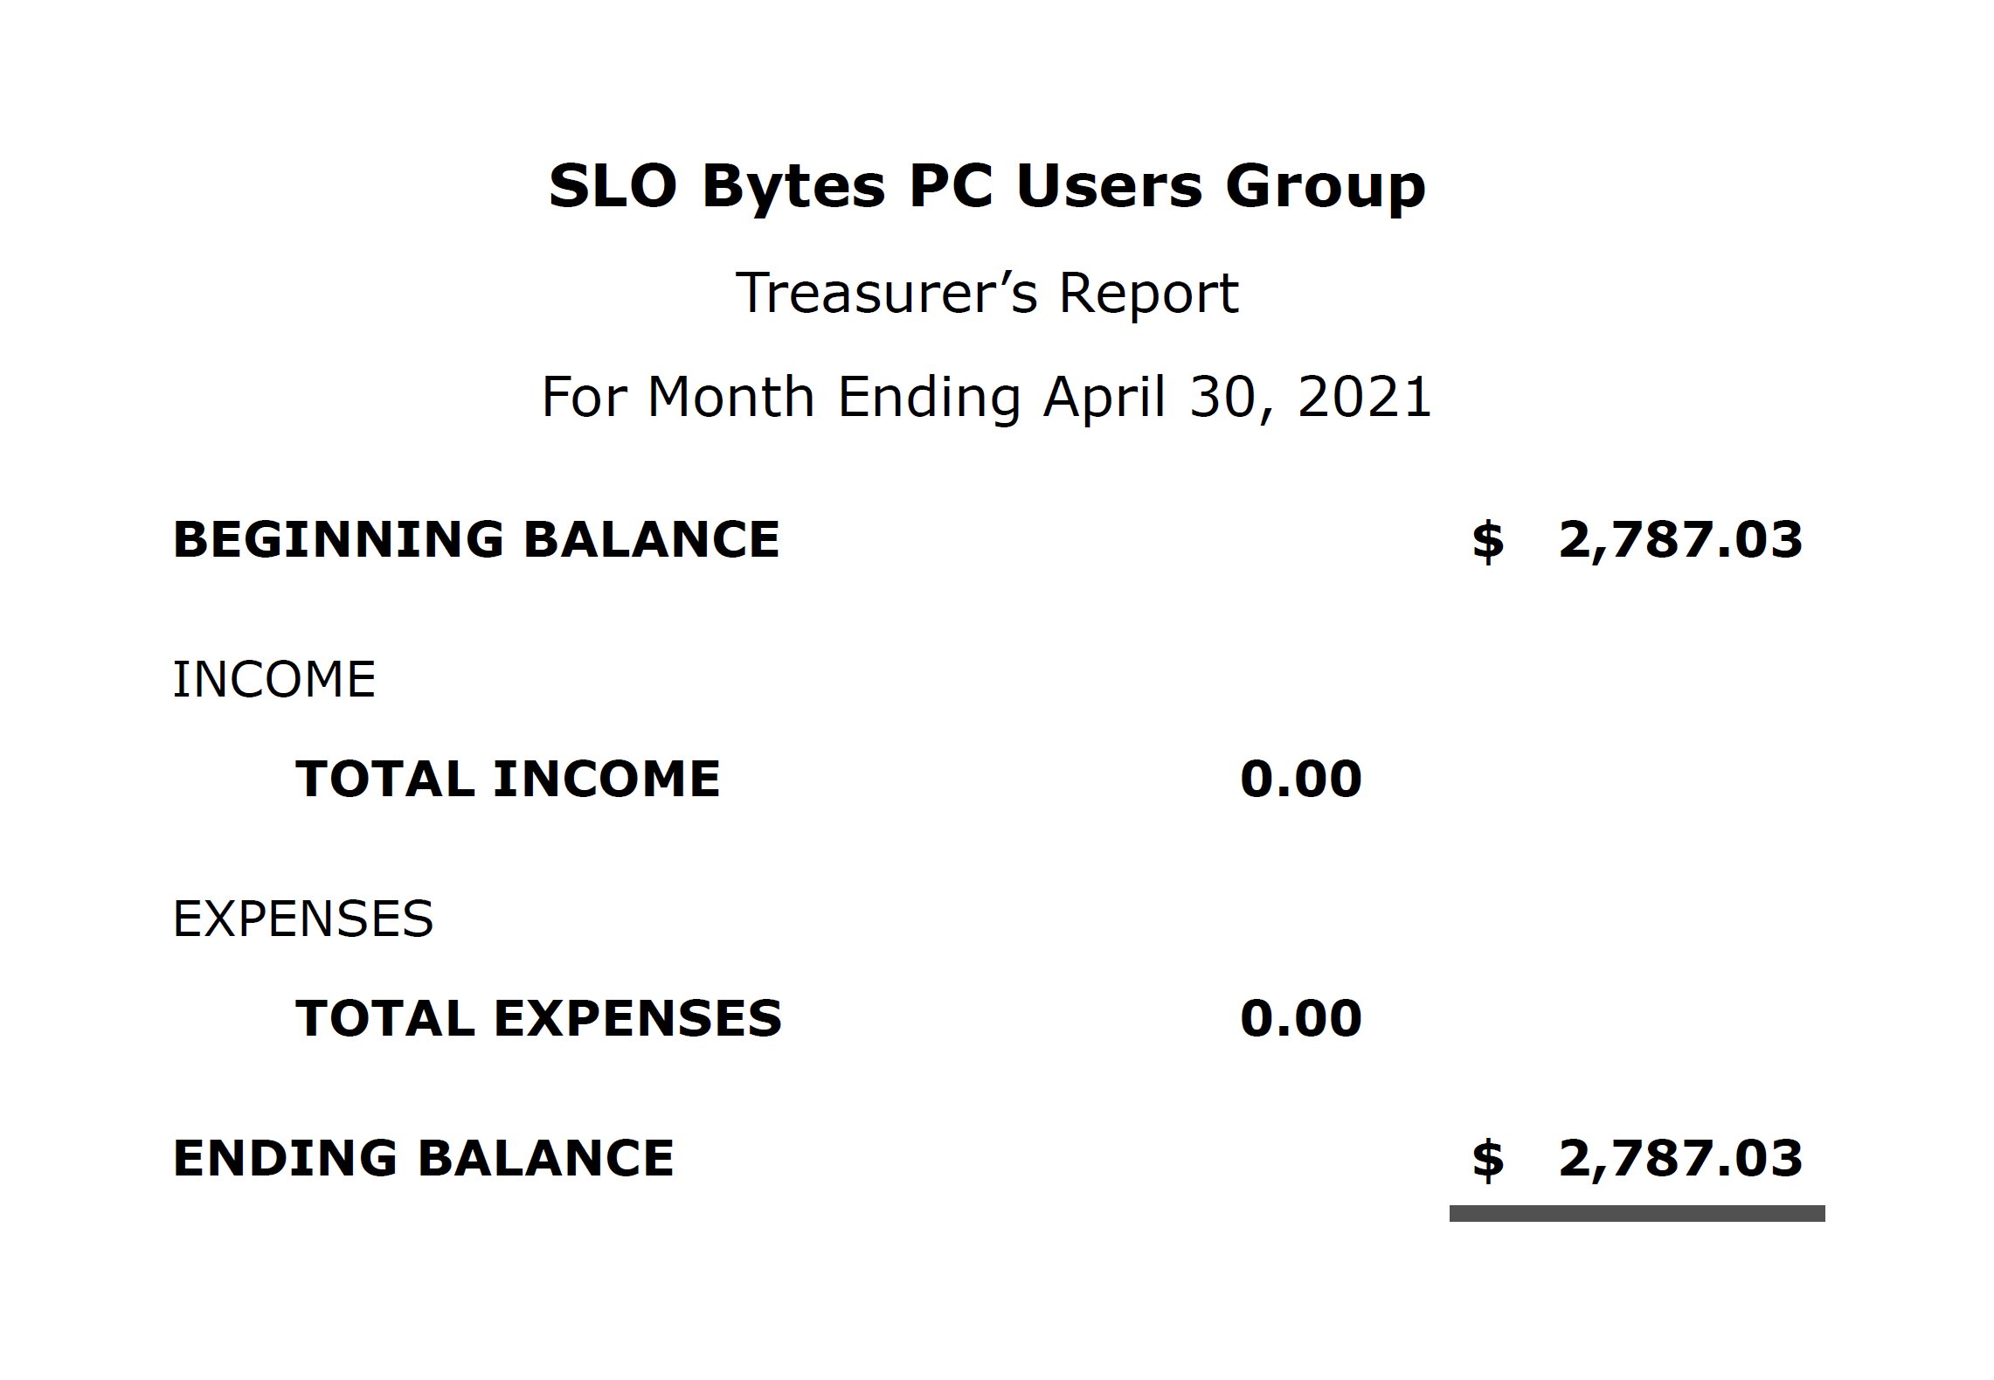

Kaye Raul, Treasurer
Photo Group Report by Ralph Sutter
Notes from the Meeting of 05/16/2021
TOPIC: Vivid Color; The meeting took place via Zoom
In the First Segment, Stanford Brown looked back at flowers, landscapes and structures from around the world, each with one or more dominant colors.
Alan Raul followed, shifting focus to harbors of California's Central Coast featuring Coast Guard vessels private craft
John Waller, using extensive color masking, shared images of aircraft, fire engines, and landscapes.
Alan Raul opened the Second Session displaying flowers and lawn art. His images are available on-line here
Ralph Sutter treated today's session as an opportunity to enhance the colors of flowers and children's toys
Stanford Brown shared many very vivid flowers
Kaye Raul also found colorful flowers as well as brightly colored buildings and gates. She enhanced these scenes by selective color removal.
Connie Sutter contributed images of fruit trees and flowers
In the Third Session, Ralph called attention to Adobe's Digital Negative Converter, free software that allows image editors to manipulate RAW photos when the software does not natively convert the camera that produced those images.
Kaye showed how she selectively removed color from photos using Selective Color.
She offered the following documentation
in Luminar - https://jimnix.com/blog/2019/3/13/selective-color-in-luminar
in Lightroom - https://digital-photography-school.com/how-to-easily-create-selective-color-using-lightroom/
in Luminar AI - https://www.youtube.com/watch?v=OPLMD0KWn9M
John demonstrated how he used both Adobe Photoshop and Adobe Lightroom to highlight a single color and convert others to grey. He explained the workings of Adobe's object selection tool
The next meeting of the Photo group will take place on June 13th beginning at 1:00 pm.
The topic is Favorite Images from Nature; Please share scenes of a place free from human interaction
The meeting will take place via Zoom
An invitation will be e-mailed to Photo Group members shortly before the meeting The meeting schedule for the remainder of 2021 is as follows
July 11
August 8
September 1
October 10
November 14
December 12
Ralph Sutter
▫▫▫▫▫▫▫▫▫▫▫▫▫▫▫▫▫▫▫▫▫▫▫
Push Library
Look at the PUSH archives, http://www.slobytes.org/push/. This is a repository of articles where you will find tips, product reviews, and personal recommendations contributed by computer clubs across the country.
They are provided courtesy of the Association of Computer User Groups, APCUG, the national organization with which SLO Bytes is affiliated.
The actual PUSH articles are hyperlinked from the index located at
http://www.slobytes.org/push/index.html (All articles on one long page)
http://www.slobytes.org/push/push-condensed.html (Links to PUSH articles by month received)
You can view additional APCUG publications here: http://www.slobytes.org/apcug/index.html
▫▫▫▫▫▫▫▫▫▫▫▫▫▫▫▫▫▫▫▫▫▫▫
SLO Bytes Bulletin Board
Everyone can read the SLO Bytes Bulletin Board at http://slobytes.org/smf/index.php?board=1.0 but only subscribers can post comments or respond to the posts of others. Despite the usual connotation of subscribe, it costs nothing to join the bulletin board. It is free to all current SLO Bytes members. However, to guard against cyber-mischief by spammers and other ne’er-do-wells, I have disabled self-registration. If you want to be added to the bulletin board, please send your request to me at ralph@rsutter.com.
If you are currently registered with the SLO Bytes Bulletin Board and wish to change your password, you will find a video screen capture of how to do so at
http://www.slobytes.org/documents/change-bb-password.mp4
▫▫▫▫▫▫▫▫▫▫▫▫▫▫▫▫▫▫▫▫▫▫▫
Club Information and Meeting Times
SLO Bytes, a PC Users Group dedicated to educating its members in the use of personal computers, digital devices and software, meets on the first Sunday of each month via Zoom. Zoom credentials are sent to members twice shortly before each meeting. If you are a SLO Bytes member and don’t receive this e-mail, please contact ralph@rsutter.com.
All meetings are open to the public at no cost. A general interest and Q&A session occurs from 12:45 PM to 2:00 PM and guest speaker presentations begin at 2:30 PM. Contact Ralph Sutter (ralph@rsutter.com) or visit slobytes.org for additional information about SLO Bytes and the scheduled presentation. All ideas for speakers or presentation subjects are welcome.
HardCopy is a monthly publication of SLO Bytes PC Users' Group located in San Luis Obispo, California. Information in this newsletter is derived from both our own membership and other PC user group newsletters.
The purpose of this publication is to inform our members of meetings and provide information related to the use of PCs and various operating systems.
Membership dues are $25 per year. Membership entitles you to our monthly newsletter via e-mail, technical assistance comradeship and a voice in the affairs of the club.
▫▫▫▫▫▫▫▫▫▫▫▫▫▫▫▫▫▫▫▫▫▫▫
Outside Special Interest Groups (SIGs)
The Linux Group normally meets via Zoom at 6:30 PM on the first Thursday of the month.
View the web site at www.slolug.com. Contact Alan@alanraul.com for credentials to join the Zoom Session.
The Photography Group normally meets via Zoom beginning at 1:00 PM on the second Sunday of each month. Contact ralph@rsutter.com for credentials to join the Zoom Session.
Visit the website at www.slobytes.org/digital
SLO Bytes Officers/Volunteers
Officers
Earl Kaplan – President: earlkaplan@gmail.com
John Waller - Vice President; Programs Chair/Publicity: johnlwaller@sbcglobal.net
Kaye Raul – Treasurer; Membership: kaye@kayeraul.com
Ralph Sutter – Secretary, Webmaster/HardCopy Editor, Photo Group Leader: ralph@rsutter.com
Alan Raul – Training Officer/Linux Group Leader: alan@alanraul.com
▫▫▫▫▫▫▫▫▫▫▫▫▫▫▫▫▫▫▫▫▫▫▫
Disclaimer: Neither SLO Bytes PC Users' Group, its officers, editors, or contributors to this newsletter assume liability for damages arising out of this publication of any article, including but not limited to the listing of programming code, batch
files and other helpful hints. Articles from this newsletter may be reprinted by other user groups if credit is given to both
the author and newsletter from which it was taken. Reproduction of articles with a specific copyright notice is prohibited without prior permission from the original author.
SLO Bytes Website: slobytes.org

