**SLO Bytes HardCopy  
A publication of the San Luis Obispo PC Users’ Group  
Vol. 36 No. 6 June 2020**

**May 3rd, 2020 First Session Notes** *by Alan Raul*

NCH Software PhotoStage Slideshow Software  
<https://www.nchsoftware.com/slideshow/>

Netstor Thunderbolt 3 Desktop Storage  
<https://www.netstor.com.tw/product_sublist.aspx?SerID=2&Title=Thunderbolt>

Talley Farms - Get the best California fruits and vegetables year-round delivered to your door  
<https://talleyfarmsfreshharvest.com/how-it-works>

Apple Site Map  
<https://www.apple.com/sitemap/>

Google Products  
<https://about.google/intl/en_us/products/>

Google Account  
<https://myaccount.google.com/intro>

Google Store  
<https://store.google.com/>

Google Cloud Products  
<https://cloud.google.com/products/>

Submit a request regarding a deceased Google user's account  
<https://support.google.com/accounts/troubleshooter/6357590?visit_id=637236103932842951-32190652>

About Google Inactive Account Manager  
<https://support.google.com/accounts/answer/3036546>

Microsoft Site Map  
<https://www.microsoft.com/en-us/sitemap.aspx>

2BrightSparks SyncBackFree - is the best free backup and synchronization software on the planet - with great features and no cost!  
<https://www.2brightsparks.com/freeware/index.html>

Backup Checklist  
<https://www.2brightsparks.com/resources/articles/backup-and-recovery-checklist.html>

Practical and Robust Backup Strategy - The 3-2-1 Backup Rule  
[https://www.2brightsparks.com/resources/articles/3-2-1-backup-strategy.htm**l**](https://www.2brightsparks.com/resources/articles/3-2-1-backup-strategy.html)

**Alan Raul**

**May 3rd 2020 Second Session Notes** *by Ralph Sutter***On-line Vegetable Gardening Resources**  
  
**Better Homes and Gardens**  
<https://www.bhg.com/gardening/>  
  
**Cornell Vegetable MD On-line**  
<http://vegetablemdonline.ppath.cornell.edu/Home.htm>  
  
**Dave’s Garden Plant Data Base**  
<https://davesgarden.com/guides/pf/>  
  
**The Farmers’ Almanac Garden Planner**  
<https://gardenplanner.almanac.com/garden-planner-design.aspx>  
<https://www.almanac.com/vegetable-gardening-for-beginners>  
  
**Gardening Resources for Beginners**  
<https://accidentalhippies.com/2017/04/04/gardening-resources-beginners/>  
  
**Gardeners’ Supply Garden Planner**  
 <https://www.gardeners.com/on/demandware.store/Sites-Gardeners-Site/default/KGP-SitePlan>  
  
**Mother Earth News Vegetable Garden Planner**  
<https://www.motherearthnews.com/garden-planner/vegetable-garden-planner>  
  
**The National Gardening Association**  
<https://garden.org/>  
  
**Trillium Living Gardening Basics**  
<https://trilliumlivingllc.com/category/outdoor-gardening/gardening-basics/>  
  
**University of California Agriculture and Natural Resources**  
<https://ucanr.edu/>  
  
**USDA National Agricultural Library**  
<https://www.nal.usda.gov/topics/home-gardening>  
  
**USDA Plant Hardiness Zone Map**  
<https://planthardiness.ars.usda.gov/PHZMWeb/>  
  
Compiled by **Ralph Sutter**

**June 7th,2020 Programming Schedule** *by Alan Raul*The **First ZOOM Session** in June will feature **Alan Raul** offering a Questions and Answers program from 12:45-2:00 p.m.  
  
Usual topics include security issues, recent changes in Windows operating systems, tablets and smart phones as well as demos of software and hardware. We always encourage questions and observations from the audience.  
  
There will be a break from 2:00-210 pm allowing the audience to sip a beverage, pet the dog or stretch  
  
**Alan** will return for the **Second Session** on the topic **Is it time to purchase a new Desktop computer?**  
  
Raul will help you identify your current computing needs as compared to the time when you lasted purchased a Desktop computer.  
  
He will address a smartphone, tablet, laptop or a traditional Desktop computer as a replacement for your aging Desktop computer or as an additional computing device based on your current computing needs.

View Zoom tutorials at <https://www.youtube.com/playlist?list=PLKpRxBfeD1kEM_I1lId3N_Xl77fKDzSXe>

If you have any questions, please contact Alan Raul at [alan@alanraul.com](mailto:alan@alanraul.com)

**Alan Raul**

**▫▫▫▫▫▫▫▫▫▫▫▫▫▫▫▫▫▫▫▫▫▫▫**

**Treasurers’ Report** *by Kaye Raul*

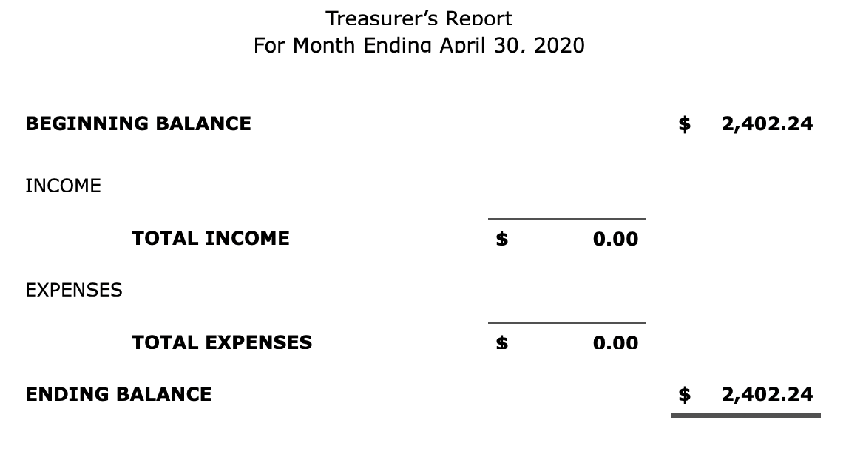

**Kaye Raul**

**Photo Group Report** *by Ralph Sutter***Notes from the Meeting of 05/17/20**    
**TOPIC**: Still-life Photography - subjects could include household items like plants,

**Ralph Sutter**opened the meeting by calling attention to two new resources on the Photography web site, [www.slobytes.org/digital/links.html](https://www.slobytes.org/digital/www.slobytes.org/digital/links.html).  
They were  
**[PhotoStage](https://dl.4kdownload.com/app/4kslideshowmaker_1.8.1_x64.msi?source=website)**; a freeware slideshow creator  
   Thanks to Stanford Brown for the reference  
[**Video Backdrops from British TV**](https://www.bbc.co.uk/archive/empty_sets_collection/zfvy382)  
   Thanks to Ron Jeffries for this link  
  
Ralph then presented a series of images of ripening bananas and a collection of belts  
**Alan Raul** followed offering a tour of the new park at Shell Beach focusing on the light standards  
**Bob Styerwalt** shared photos of plants and tools  
**Connie Sutter** focused on a single crystal vase shown from different angles and in different lights  
**Kaye Raul** also incorporated vases accompanied by fruits  
**John Waller** showed family heirlooms and objects from travel abroad  
 **NEXT MEETING**: Sunday, June 14th, 2020@ 2:00 pm  
The topic is **Animals**; please share images of fauna that walk the earth, fly the skies or swim the seas  
The meeting will take place via **Zoom**  
  
A Zoom invitation will be e-mailed to Photo Group members shortly before the meeting.  
The meeting schedule for the remainder of 2020 is as follows  
   July 12th  
   August 9th  
   September 13th  
   October 11th  
   November 8th  
   December 13th

**Ralph Sutter**

***▫▫▫▫▫▫▫▫▫▫▫▫▫▫▫▫▫▫▫▫▫▫▫***

**Push Library**  
Look at the **PUSH archives**, <http://www.slobytes.org/push/>. This is a repository of articles where you will find tips, product reviews, and personal recommendations contributed by computer clubs across the country.  
They are provided courtesy of the Association of Computer User Groups, **APCUG**, the national organization with which SLO Bytes is affiliated.   
  
The actual **PUSH** articles are hyperlinked from the index located at  
 <http://www.slobytes.org/push/index.html> (All articles on one long page)  
 <http://www.slobytes.org/push/push-condensed.html> (Links to **PUSH** articles by month received)  
You can view additional APCUG publications here: <http://www.slobytes.org/apcug/index.html>

**SLO Bytes Bulletin Board**  
Everyone can read the SLO Bytes Bulletin Board at <http://slobytes.org/smf/index.php?board=1.0> but only subscribers can post comments or respond to the posts of others. Despite the usual connotation of **subscribe**, it costs nothing to join the   
  
bulletin board. It is free to all current SLO Bytes members. However, to guard against cyber-mischief by spammers and   
other ne’er-do-wells, I have disabled self-registration. If you want to be added to the bulletin board, please send your request to me at [ralph@rsutter.com](mailto:ralph@rsutter.com).

If you are currently registered with the SLO Bytes Bulletin Board and wish to change your password, you will find a video screen capture of how to do so at <http://www.slobytes.org/documents/change-bb-password.mp4>

**▫▫▫▫▫▫▫▫▫▫▫▫▫▫▫▫▫▫▫▫▫▫▫**

**Club Information and Meeting Times**

**SLO** **Bytes**, a PC Users Group dedicated to educating its members in the use of personal computers, digital devices and software, meets on the first Sunday of each month at the **San Luis Obispo Guild** **Hall** at 2880 Broad Street, San Luis Obispo. There is a map available at <http://www.slobytes.org/slo-guild-map.html>.

All meetings are open to the public at no cost. A general interest and Q&A session occurs from 12:45 PM to 2:00 PM and guest speaker presentations begin at 2:30 PM. Contact **John** **Waller** (johnlwaller at sbcglobal.net) or visit [slobytes.org](http://www.slobytes.org/index.php) for additional information about SLO Bytes and the scheduled presentation. All ideas for speakers or presentation subjects are welcome.  
 **HardCopy** is a monthly publication of **SLO Bytes PC Users' Group** located in San Luis Obispo, California. Information in this newsletter is derived from both our own membership and other PC user group newsletters.

The purpose of this publication is to inform our members of meetings and provide information related to the use of PCs and various operating systems.  
  
Membership dues are $25 per year. Membership entitles you to our monthly newsletter via e-mail, technical assistance,, a voice in the affairs of the club, and comradeship.

***Outside Special Interest Groups (SIGs)*  
Linux SIG** normally meets at 6:30 PM on the Thursday following our Sunday's General Meeting at the KCBX.NET Training Center, 4100 Vachell Lane, San Luis Obispo. View the web site at [www.slolug.com](http://www.slolug.com).   
**Photography SIG** normally meets at 2:00 PM on the second Sunday of each month at Connie and Ralph Sutter’s home in Arroyo Grande. Call Ralph at 805 478-0826 for directions. Visit the website at [www.slobytes.org/digital](http://www.slobytes.org/digital)

***▫▫▫▫▫▫▫▫▫▫▫▫▫▫▫▫▫▫▫▫▫▫▫***

***SLO Bytes Officers/Volunteers***

**Officers**Earl Kaplan – President: [earlkaplan@gmail.com](mailto:earlkaplan@gmail.com)   
John Waller - Vice President; Programs Chair/Publicity: [johnlwaller@sbcglobal.net](mailto:johnlwaller@sbcglobal.net)   
Kaye Raul – Treasurer; Membership: [kaye@kayeraul.com](mailto:kaye@kayeraul.com)   
Ralph Sutter – Secretary, Webmaster/HardCopy Editor, Photo SIG Leader: [ralph@rsutter.com](mailto:ralph@rsutter.com)   
Alan Raul – Training Officer/Linux Group Leader: [alan@alanraul.com](mailto:alan@alanraul.com)   
 **Other** **Volunteers**  
Nancy Vrooman – Refreshments  
Peter Stonehewer – Refreshments  
Ken Stilts – Set-up/Clean-up

**Disclaimer**: Neither SLO Bytes PC Users' Group, its officers, editors, or contributors to this newsletter assume liability for damages arising out of this publication of any article, including but not limited to the listing of programming code, batch   
files and other helpful hints. Articles from this newsletter may be reprinted by other user groups if credit is given to both   
  
the author and newsletter from which it was taken. Reproduction of articles with a specific copyright notice is prohibited without prior permission from the original author.

**SLO Bytes Website**: [slobytes.org](http://www.slobytes.org/index.html)