SLO Bytes HardCopy
A publication of the San Luis Obispo PC Users’ Group
Vol. 35 No. 5 May 2019
April 7th, 2019 First Session Notes by Alan Raul
2019 Southern California Linux Expo (SCaLE) Video
Video (5 min 44 seconds - 470 MB) of some random pictures of SCaLE 17x.
http://www.slolug.com/videos/104.mp4
It's best to right-click the above link and select Save link as... or Save target as...
2019 Southern California Linux Expo (SCaLE) Report
http://www.slolug.com/scale2019.html
AVADirect Custom Computers
https://www.avadirect.com/
Clevo N151ZU
https://www.avadirect.com/Clevo-N151ZU-15-6-FHD-Core-i7-Intel-UHD-Graphics-620-Custom-Laptop/Configure/12566572
• 8th Generation Intel® Core™ i7-8565U Processor (1.80GHz Base / 4.60GHz Turbo), 4 Cores, 8MB Smart Cache, TDP: 15W
• KINGSTON 32GB Kit (2 x 16GB) HyperX Impact DDR4 2400MHz, CL14, Black, SO-DIMM Memory
• SAMSUNG 512GB 970 PRO 2280, 3500 / 2300 MB/s, V-NAND 2-bit MLC, PCIe 3.0 x4 NVMe, M.2 SSD
Microsoft Edge 75.0.111.0 - is a web browser based on the “Chromium open source project” and other open source software.
https://www.majorgeeks.com/files/details/microsoft_edge.html
Edge Advanced Options = edge://settings/
Chrome Advanced Options = chrome://settings/
Microsoft Edge Insider
https://www.microsoftedgeinsider.com/en-us/
http://slobytes.org/smf/index.php?topic=279.0
Skype from a web browser
https://web.skype.com/
What you can do right now to stop robocalls
https://www.cnn.com/2019/03/29/tech/how-to-stop-robocalls/index.html
Startpage.com - The world's most private search engine.
https://www.startpage.com/
https://betanews.com/2019/03/27/startpage-defeats-google/
Killed by Google - It’s amazing how many projects (Hardware and Software) Google has tried and killed over the years. I would like to see the same thing for Apple and Microsoft.
https://killedbygoogle.com/

Alan Raul
▫▫▫▫▫▫▫▫▫▫▫▫▫▫▫▫▫▫▫▫▫▫▫
April 7th, 2019 Second Session Notes by Ralph Sutter
Setting Up a Netgear Orbi Network
Setting Up a Netgear Orbi Network
My Orbi setup consists of the Netgear Orbi RBK43-200NAS Router and two satellite devices. Think of the satellites as self-configuring wireless access points. The three Orbi devices communicate with one another to create the mesh network. They can do this via a LAN cable or wirelessly with any combination possible between them.
Product Information
Quick Start Guide: : http://www.downloads.netgear.com/files/GDC/RBK43/RBK43_QSG_EN.pdf
Documentation: https://www.netgear.com/support/product/RBK43.aspx#docs
Setup:
Option A: From Netgear Orbi Instruction Sheet, scan QR code, downloading Orbi app for iPhone.
Install Netgear Orbi App on iPhone
Option B: Install from an Internet connected computer. Point your browser to http://orbilogin.net/BRS_index.htm
If you return to this URL after having changed the default user password, clicking on this URL redirects you to https://www.netgear.com/home/products/networking/orbi/orbilogin.aspx
with the unsettling notification “Looks like you’re not connected to your Orbi’s WiFi network. Don’t worry, it happens to the best of us. Try the following steps to get connected:”
Ignore this misinformation and in your browser’s address bar, type in http://192.168.1.1 or whatever the local address of your router is. Common addresses are 192.168.1.1 and 192.168.1.2
If you simply click on the above hyperlink from a Word document, you end up with this screen

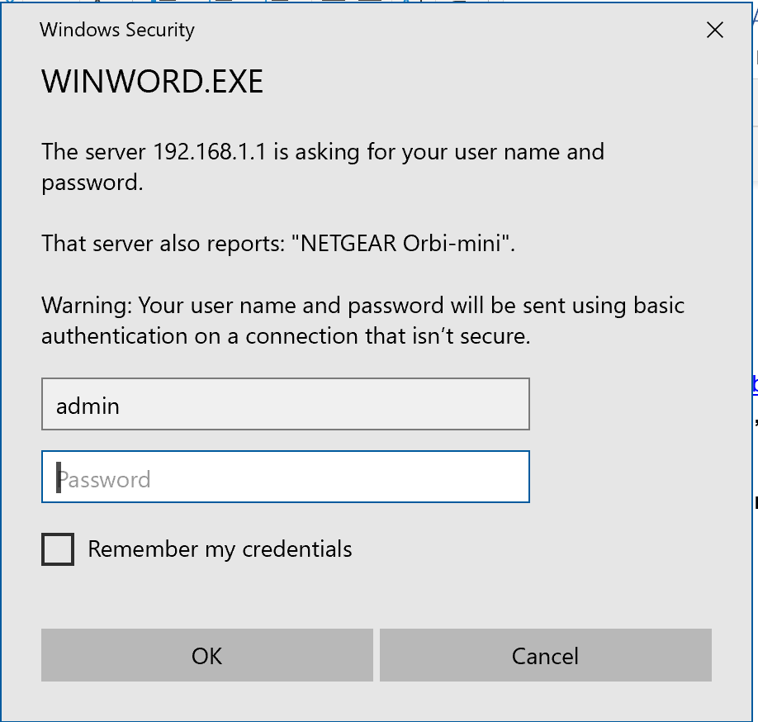
Enter your password here
If you type in http://192.168.1.1 you will get a different screen but will also be asked your Userid and Password
Below is a sample confirmation screen
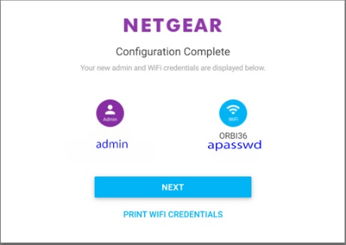
My Internet comes from Advanced Wireless in Santa Maria via terrestrial satellite. I opted to install from a computer. I disconnected my previous router, a Netgear 7900 and connected the feed from Advanced Wireless to the Internet Port of the Orbi Base Station and turned the Orbi on.
I then placed the 2 Orbi Satellite Stations in different areas of my home. I tried connecting them through the Ethernet ports on the three devices but had stronger signals and more consistent results by connecting wirelessly. This surprised me greatly. So that I could easily move the satellites from place to place without powering them off, I used very long extension cords
The Orbi software shows you the signal status and strength of the two satellites. It also shows what devices are connected to the mesh network. See here.
The switches on the Orbi network are here
Ralph Sutter
▫▫▫▫▫▫▫▫▫▫▫▫▫▫▫▫▫▫▫▫▫▫
May 5^{th,} 2019 Programming Schedule by Ralph Sutter
The First Session will feature Alan Raul moderating a Questions and Answers session from 12:45-2:00 p. m.
During the break, from 2:00-2:30 pm, coffee and cookies will be offered as well as the opportunity for you to chat with other club members.
In the Second Session, John Waller will demonstrate photo manipulation of some of his images using Adobe Photoshop. Many of the techniques that he will use are also applicable to other photo manipulation products.
Contact Ralph Sutter at ralph@rsutter.com for additional information about SLO Bytes and the scheduled presentation.
Ralph Sutter
Treasurer’s Report by Bob Styerwalt
Income March 4 through April 7, 2019
 | Renewing Members | $0.00
 | New Members
 | Refreshments donations | $20.00
 | General donations | $
Expenses:
 | Refreshments reimbursement | $
 |  | $
 | Meeting Room Rent | $65.00
Bank Statement ending 03/31/2019
 | Checking account balance | $2,534.31
 | Interest paid this period | $0.00
 | Deposits | $145.00
 | Withdrawals | $116.24
Renewing Members: Thanks to all for your continued interest and support. (No one renewed during this period.)
I continue to believe that we have a friendly group that can provide useful information to any computer user. Please encourage your friends, neighbors, kids, parents and strangers to check us out.
Bob Styerwalt
▫▫▫▫▫▫▫▫▫▫▫▫▫▫▫▫▫▫▫▫▫▫▫
Photo Group Report by Ralph Sutter
Meeting of 04/14/2019
TOPIC: Green; images of a verdant hue
Ralph Sutter began the meeting with photos taken along the shore and from a helicopter over-flying San Luis Obispo, local lakes and beaches.
Kaye Raul revisited the village of Halcyon to photograph some brightly colored glass whimsically placed in the front yard of a local house.
Alan Raul presented images taken as he followed to course of San Luis Obispo Creek above Avila.
Bob Styerwalt walked the shoreline near Shell Beach in search for green and found a dramatically lit window at home.
Connie Sutter brought her iPhone to the Getty Museum in Malibu and captured green vases, green foliage, mixed with local landscapes.
NEXT MEETING Sunday, May 19th, 2019 @ 2:00 pm; moved back one week in deference to Mothers' Day
TOPIC: Boats on the Water
Please share images of floating watercraft
The tentative schedule for the remainder of 2019 is as follows
May 19th one week later than usual due to Mothers' Day
June 9th
July 14th
August 11th
September 8th
October 13th
November 10th
December 8th
LOCATION:
Home of Connie and Ralph Sutter
498 Hansen Hill Road
Arroyo Grande, CA
Map at www.slobytes.org/digital/sutter-map.html
See the Links page for tutorials and other resources
Ralph Sutter
▫▫▫▫▫▫▫▫▫▫▫▫▫▫▫▫▫▫▫▫▫▫▫
Push Library
Look at the PUSH archives, http://www.slobytes.org/push/. This is a repository of articles where you will find tips, product reviews, and personal recommendations contributed by computer clubs across the country.
They are provided courtesy of the Association of Computer User Groups, APCUG, the national organization with which SLO Bytes is affiliated.
The actual PUSH articles are hyperlinked from the index located at
http://www.slobytes.org/push/index.html (All articles on one long page)
http://www.slobytes.org/push/push-condensed.html (Links to PUSH articles by month received)
You can view additional APCUG publications here: http://www.slobytes.org/apcug/index.html
▫▫▫▫▫▫▫▫▫▫▫▫▫▫▫▫▫▫▫▫▫▫▫
SLO Bytes Bulletin Board
Everyone can read the SLO Bytes Bulletin Board at http://slobytes.org/smf/index.php?board=1.0 but only subscribers can post comments or respond to the posts of others. Despite the usual connotation of subscribe, it costs nothing to join the
bulletin board. It is free to all current SLO Bytes members. However, to guard against cyber-mischief by spammers and
other ne’er-do-wells, I have disabled self-registration. If you want to be added to the bulletin board, please send your request to me at ralph@rsutter.com.
If you are currently registered with the SLO Bytes Bulletin Board and wish to change your password, you will find a video screen capture of how to do so at http://www.slobytes.org/documents/change-bb-password.mp4
Club Information and Meeting Times
SLO Bytes, a PC Users Group dedicated to educating its members in the use of personal computers, digital devices and software, meets on the first Sunday of each month at the San Luis Obispo Guild Hall at 2880 Broad Street, San Luis Obispo. There is a map available at http://www.slobytes.org/slo-guild-map.html.
All meetings are open to the public at no cost. A general interest and Q&A session occurs from 12:45 PM to 2:00 PM and guest speaker presentations begin at 2:30 PM. Contact John Waller (johnlwaller at sbcglobal.net) or visit slobytes.org for additional information about SLO Bytes and the scheduled presentation. All ideas for speakers or presentation subjects are welcome.
HardCopy is a monthly publication of SLO Bytes PC Users' Group located in San Luis Obispo, California. Information in this newsletter is derived from both our own membership and other PC user group newsletters.
The purpose of this publication is to inform our members of meetings and provide information related to the use of PCs and various operating systems.
Membership dues are $25 per year. Membership entitles you to our monthly newsletter via e-mail, technical assistance, eligibility for raffle gifts when drawings are held, a voice in the affairs of the club, and comradeship.
▫▫▫▫▫▫▫▫▫▫▫▫▫▫▫▫▫▫▫▫▫▫▫
Outside Special Interest Groups (SIGs)
Linux SIG normally meets at 6:30 PM on the Thursday following our Sunday's General Meeting at the KCBX.NET Training Center, 4100 Vachell Lane, San Luis Obispo. View the web site at www.slolug.com.
Photography SIG normally meets at 2:00 PM on the second Sunday of each month at Ralph Sutter’s home in Arroyo Grande. Call Ralph at 478-0826 for directions. Visit the website at www.slobytes.org/digital
▫▫▫▫▫▫▫▫▫▫▫▫▫▫▫▫▫▫▫▫▫▫▫
SLO Bytes Officers/Volunteers
Officers
Earl Kaplan – President: earlkaplan@gmail.com
John Waller - Vice President; Programs Chair/Publicity: johnlwaller@sbcglobal.net
Bob Styerwalt – Treasurer; Membership: rstyerwalt@gmail.com
Ralph Sutter – Secretary, Webmaster/HardCopy Editor, Photo SIG Leader: ralph@rsutter.com
Alan Raul – Training Officer: alan@alanraul.com
Other Volunteers
Nancy Vrooman – Refreshments
Peter Stonehewer – Refreshments
Ken Stilts – Set-up/Clean-up
▫▫▫▫▫▫▫▫▫▫▫▫▫▫▫▫▫▫▫▫▫▫▫
Disclaimer: Neither SLO Bytes PC Users' Group, its officers, editors, or contributors to this newsletter assume liability for damages arising out of this publication of any article, including but not limited to the listing of programming code, batch
files and other helpful hints. Articles from this newsletter may be reprinted by other user groups if credit is given to both
the author and newsletter from which it was taken. Reproduction of articles with a specific copyright notice is prohibited without prior permission from the original author.
SLO Bytes Website: slobytes.org

