SLO Bytes HardCopy
A publication of the San Luis Obispo PC Users’ Group
Vol. 32 No. 4 April 2016
March 6th General Windows SIG review by Alan Raul
Acronis True Image 2016 Bootable Media Does Not Support NVM Express.
https://kb.acronis.com/content/57521
Macrium Reflect Free
http://www.macrium.com/reflectfree.aspx
How to Create a Windows 10 System Image Backup
Search “Backup and Restore (Windows 7)”
Create a Windows 10 Recovery USB Flash Drive
http://windows.microsoft.com/en-us/windows-10/create-a-recovery-drive https://www.youtube.com/watch?v=z7GVdFt8aJY
Here's a speed comparison using CrystalDiskMark between an older OCZ Vertex 4 SSD and the new Samsung 950 PRO 512GB PCIe NVMe - M.2. You can see that there is a substantial speed increase with the PCIe interface.
http://alanraul.com/10/images/ssd_comparison.jpg
CrystalDiskMark Portable
http://portableapps.com/apps/utilities/crystaldiskmark_portable
Samsung Magician Software forPC
http://www.samsung.com/global/business/semiconductor/minisite/SSD/global/html/support/downloads.html
Performance Benchmark of Samsung 950 PRO 512GB PCIe NVMe - M.2 using the Samsung Magician software.
http://alanraul.com/10/images/magician.jpg
Alan
▫▫▫▫▫▫▫▫▫▫▫▫▫▫▫▫▫▫▫▫▫▫▫
March 6th Second Session review by Ralph Sutter
Roku Demonstration
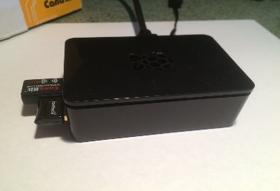
I wanted to create a digital picture frame using a computer monitor and a small computer behind it
I tried Raspberry Pi 2 B; notes at www.fullbean.com/linux/raspberry-pi-notes.html

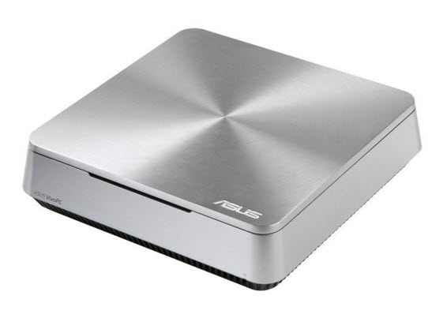
and a small Asus Vivo PC computer
Then, it dawned on me that I should consider using a Roku box.
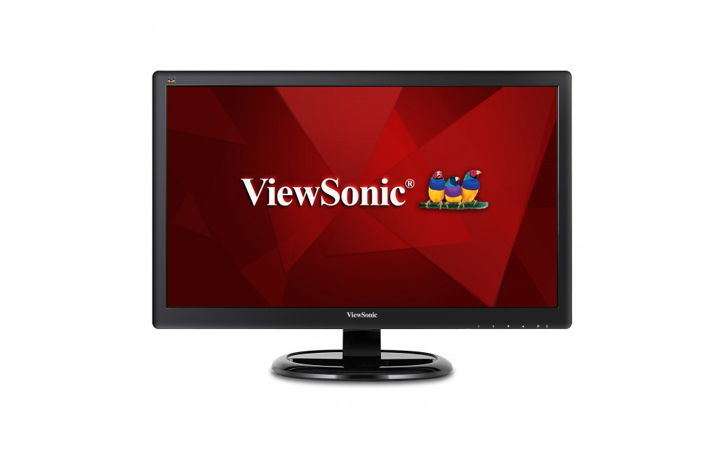
I reasoned that though Roku is usually connected to the HDMI port of a TV, I could hook it up to a stand- alone computer monitor.

http://www.viewsonic.com/us/va2265smh.html
Even though that monitor wasn't connected to a computer I reasoned that the Roku box was capable of telling the monitor what to do.
Since the monitor has internal speakers built in, I wouldn't need a separate audio connection. I could bring sound in over the HDMI cable.
The Roku device is available in several different models. I already have one in my den and another one in my bedroom. I decided to get the Roku 4 because it is 4k compatible. While I don't have a 4k TV yet, I might as well plan for one.
Current Roku models
https://www.roku.com/products/compare
Evolution of the Roku players
https://support.roku.com/hc/en-us/articles/208754518-Get-Started-Player-Overview
Roku 4 Promo:
Roku 4 Features
https://www.roku.com/products/roku-4
Roku 4 Tech Specs
Complete Listing of Roku Channels
https://channelstore.roku.com/browse: all channels
My Digital Picture Frame
I found hopeful candidates for showing personal slide shows at this link; https://channelstore.roku.com/browse/personal-media
However, none of the apps displayed portrait-oriented images properly. PLEX was the only exception. I might have tried Flickr or Shutterfly but I already knew the capabilities of PLEX since I was currently viewing it on my Home Media Center. For today's demonstration, I'll use Roku Media Player. You will notice the rotation problem with the still images.
My in-wall Roku installation with optional Ethernet cable
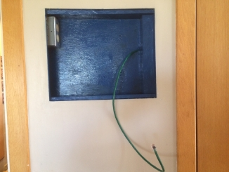 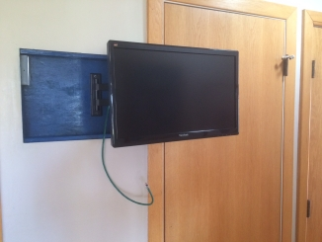 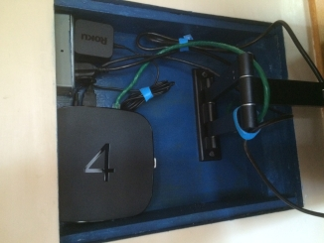 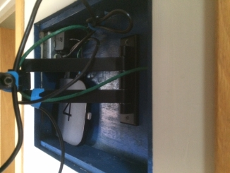
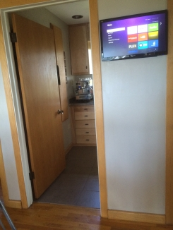
Click the link below for a look at the different Roku channels that I currently have loaded on my device
Screen Capture Video
I can connect the Roku device to Wi-Fi but not to my home network where all of my media resides. Today, I'm getting the media from a flash drive plugged in to the Roku device and accessed through Roku Media Player.
I demoed PLEX by connecting to my home media server via Chrome Remote Desktop. Download Remote Desktop from
https://chrome.google.com/webstore/detail/chrome-remotedesktop/gbchcmhmhahfdphkhkmpfmihenigjmpp?hl=en
▫▫▫▫▫▫▫▫▫▫▫▫▫▫▫▫▫▫▫▫▫▫▫
April 3rd Programming Schedule by Ralph Sutter
The First Session will feature Alan Raul moderating a Questions and Answers program from 12:45-2:00 p. m.
During the break, from 2:00-2:30 pm, coffee and cookies will be offered as well as a chance for you to chat with other club members.
The Second Session will offer a roundtable discussion on Networked Drives, Backup Strategies and Data Storage. A panel of SLO Bytes members will discuss and compare their varied approaches to these issues. All members are invited to join in the discussion.
Ralph Sutter
President’s Message by Earl Kaplan
Although my commitment to listening to music in Monterey took precedent over my attendance at the SLO Bytes General Meeting in March the subject matter of the meeting still held my attention. Writing code for a computer has to be one of the more rewarding efforts one can achieve in life. Forming an idea in your head, thinking through the steps and paths that need to be traversed and writing out code that accomplishes that idea is very stimulating.
I have been fortunate in my technical life. I found myself many times with time on my hands while I monitored an early mainframe computer laboring through its work and all I had to do was wait for something negative to happen. I was able to use tools at my disposal to write code and later, when the main body of work was done, run this code and see if it did what I wanted it to do.
Today, we all have this ability at hand for an amount of money that has to be considered trivial when weighed against the value of the experience. $50 worth of hardware provides you with a tool not only equivalent to what I had available to me in the late 1950’s but far more capable with far more compute speed, RAM, and storage.
Would there be any interest in a hands-on workshop as a second session assembling a Raspberry Pi and programming something? The people on the Board are very interested in finding subject material that interests the membership. We do not seem to have a great talent for mind-reading and we need some feedback.
Earl Kaplan
▫▫▫▫▫▫▫▫▫▫▫▫▫▫▫▫▫▫▫▫▫▫▫
Treasurer’s Report for February 2016 by Bob Styerwalt
Income: February 8 thru March 6, 2016
 | Renewing Members | $25.00
 | New Members | $50.00
 | Refreshments Donations | $20.00
Expenses:
 | Hall rent | $100.00
Bank Statement ending 2/29/2016
 | Checking account balance | $3,341.25
 | Interest paid this period | $0.26
 | Deposits | $295.00
 | Withdrawals | $142.88
Renewing Members: Don Jones renewed at the March 6 meeting. Ben Hansen rejoined following his sojourn on the East Coast. Albert Aji joined us as a new member. Thanks and welcome to all three. Everybody please encourage your friends and neighbors to join us.
Bob Styerwalt
Photo SIG Report by Ralph Sutter
Notes from the meeting of 03/13/16
The focus of the March 13th meeting of the Digital Photography SIG was Reflections.
Members shared reflected images and scenes. We looked at mirrors, reflecting ponds and other indirect points of observation.
The focus then turned to image enhancement. Alan Raul shared an inexpensive yet powerful app for iOS devices called Camera+. Learn more at http://campl.us/
The next meeting will take place on April 10th The topic will be Recent Images. The only requirement is that images be taken in the time frame between the March 2016 meeting and this one. The idea is to encourage an open, diverse selection of images.
Notes from previous meetings of the Photo SIG are available at www.slobytes.org/digital/notes.html or by clicking on Notes tab at the top of all pages of the Photo SIG web site.
Ralph Sutter
▫▫▫▫▫▫▫▫▫▫▫▫▫▫▫▫▫▫▫▫▫▫▫
Push Library
Take a look at the PUSH archives, http://www.slobytes.org/push/. This is a repository of articles where you will find tips, product reviews, and personal recommendations contributed by computer clubs across the country.
They are provided courtesy of the Association of Computer User Groups, APCUG, the national organization with which SLO Bytes is affiliated.
The actual PUSH articles are hyperlinked from the index located at
http://www.slobytes.org/push/index.html (All articles on one long page)
http://www.slobytes.org/push/push-condensed.html (Links to PUSH articles by month received)
You can view additional APCUG publications here: http://www.slobytes.org/apcug/index.html
Take a look at http://www.kcbx.net/training.php to view the various computer-related classes available at the
KCBX.NET Training Facility.
SLO Bytes Bulletin Board
Everyone can read the SLO Bytes Bulletin Board at http://slobytes.org/smf/index.php?board=1.0 but only subscribers can post comments or respond to the posts of others. Despite the usual connotation of subscribe, it costs nothing to join the bulletin board. It is free to all current SLO Bytes members. However, to guard against cyber-mischief by spammers and other ne’er-do-wells, I have disabled self-registration. If you want to be added to the bulletin board, please send your request to me at ralph@rsutter.com.
If you are currently registered with the SLO Bytes Bulletin Board and wish to change your password, you will find a video screen capture of how to do so at http://www.slobytes.org/documents/change-bb-password.mp4
Club Information and Meeting Times
SLO Bytes, a PC Users Group dedicated to educate its members in the use of personal computers, digital devices and software, meets on the first Sunday of each month at the Independent Order of Odd Fellows (IOOF) Hall at 520 Dana Street, San Luis Obispo. All meetings are open to the public at no cost. A general interest and Q&A session occurs from 12:45 PM to 2:00 PM and guest speaker presentations begin at 2:30 PM. Contact John Waller (johnlwaller at sbcglobal.net) or visit slobytes.org for additional information about SLO Bytes and the scheduled presentation.
All ideas for speakers or presentation subjects are welcome.
HardCopy is a monthly publication of SLO Bytes PC Users' Group located in San Luis Obispo, California. Information in this newsletter is derived from both our own membership and other PC user group newsletters. The purpose of this publication is to inform our members of meetings and provide information related to the use of PCs and various operating systems.
Membership dues are $25 per year. Membership entitles you to our monthly newsletter via e-mail, technical assistance, eligibility for raffle gifts when drawings are held, a voice in the affairs of the club, and comradeship.
▫▫▫▫▫▫▫▫▫▫▫▫▫▫▫▫▫▫▫▫▫▫▫
Outside Special Interest Groups (SIGs)
Linux SIG normally meets at 6:30 PM on the Thursday following our Sunday's General Meeting at the KCBX.NET Training Center, 4100 Vachell Lane, San Luis Obispo. View the web site at www.slolug.com.
Photography SIG normally meets at 2:00 PM on the second Sunday of each month at Ralph Sutter’s home in Arroyo Grande. Call Ralph at 478-0826 for directions. Visit the website at www.slobytes.org/digital
▫▫▫▫▫▫▫▫▫▫▫▫▫▫▫▫▫▫▫▫▫▫▫
SLO Bytes Officers/Volunteers
Officers
Earl Kaplan – President: earlkaplan at gmail.com
John Waller - Vice President; Programs Chair/Publicity: johnlwaller at sbcglobal.net
Bob Styerwalt – Treasurer; Membership: rstyerwalt at gmail.com
Ralph Sutter – Secretary, Webmaster/HardCopy Editor, Photo SIG Leader: ralph at rsutter.com
Alan Raul – Training Officer: alan at alanraul.com
Other Volunteers
Nancy Vrooman – Refreshments
Peter Stonehewer – Refreshments
Ken Stilts – Set-up/Clean-up
▫▫▫▫▫▫▫▫▫▫▫▫▫▫▫▫▫▫▫▫▫▫▫
Disclaimer: Neither SLO Bytes PC Users' Group, its officers, editors, or contributors to this newsletter assume liability for damages arising out of this publication of any article, including but not limited to the listing of programming code, batch files and other helpful hints. Articles from this newsletter may be reprinted by other user groups if credit is given to both the author and newsletter from which it was taken. Reproduction of articles with a specific Copyright notice is prohibited without prior permission from the original author.
SLO Bytes Website: slobytes.org

