**SLO Bytes HardCopy  
A publication of the San Luis Obispo PC Users’ Group  
Vol. 37 No.2 February 2021**

**January 3rd 2021 First Session Notes** *by Alan Raul*

**Folding@home** - Together, we have created the most powerful supercomputer on the planet and are using it to help understand SARS-CoV-2/COVID-19 and develop new therapies. We need your help pushing toward a potent, patent-free drug. Use your PC to help fight COVID-19.  
<https://foldingathome.org/>  
  
**Team InputJive 263947 (Joe Stute)**  
<https://stats.foldingathome.org/team/263947>  
  
**NirSoft Wireless Network Watcher**  
<https://www.nirsoft.net/utils/wireless_network_watcher.html>  
   
**Discussion:  
Which "technology new year's resolution" is most important to you for 2021?**  
  
1.   Back up my data more often  
  
2.   Get a password manager  
  
3.   Learn more tech skills  
  
4.   Revamp my desk/work area  
  
5.   Set limits on my personal screen time  
  
6.   Shop for less expensive wireless, Internet or TV service  
  
7.   Use a contact tracing app to help fight the pandemic  
  
8.   Use a wearable monitor to improve my fitness/health  
  
**Alan Raul**

**January 3rd 2021 Second Session Notes** *by Ralph Sutter* **(Insert content from others)**

**Keyboard Shortcuts**

|  |  |
| --- | --- |
| Ctrl + a | Select All |
| Ctrl + c | Copy |
| Ctrl + b | Bold |
| Ctrl + f | Find |
| Ctrl + i | Italic |
|  |  |
| Ctrl + p | Print to default printer |
| Ctrl + s | Save |
| Ctrl + v | Paste |
| Ctrl + x | Cut |
| Ctrl + y | Redo |
| Ctrl + z | Undo |
|  |  |
| Ctrl + Alt + Del | Open Task Manager |
|  |  |
| Windows Key + m | Show Desktop |
| Alt + Tab | Display open programs and toggle through them |
| End | Go to the end of the sentence |
| Ctrl + End | Go to the end of the document |
| Home | Go to the beginning of the sentence |
| Ctrl + Home | Go to the beginning of the document |

Expanded list of keyboard shortcuts: <https://www.computerhope.com/shortcut.htm>

**Ralph Sutter**

**▫▫▫▫▫▫▫▫▫▫▫▫▫▫▫▫▫▫▫▫▫▫▫**

**February 7th Program** *by Ralph Sutter*

The **First ZOOM Session** will feature **Alan Raul** offering a Questions and Answers program from 12:45-2:00 p.m.

To be part of the virtual meeting via **Zoom**, please refer to the e-mail that will be sent to you twice shortly before the meeting with the credentials necessary to join the Zoom session. If you are asked for a **Meeting ID** or a **Password**, copy it from the announcement and paste it into the appropriate box

Usual topics include security issues, recent changes in Windows operating systems, tablets and smart phones as well as demos of software and hardware. We always encourage questions and observations from the audience.  
  
There will be a break from 2:00-2:30 pm allowing the audience to sip a beverage, pet the dog or stretch

The **Second Session will repeat the format of the last several Second Sessions. This time, SLO Bytes members Janet Thatcher, Bob Ward and Doug Depue will offer short presentations on programs or techniques that they use. Thanks to these folks for adding their voices to these Zoom Sessions**

Contact Ralph at [ralph@rsutter.com](mailto:ralph@rsutter.com) for more information

View Zoom tutorials at <https://www.youtube.com/playlist?list=PLKpRxBfeD1kEM_I1lId3N_Xl77fKDzSXe> If you have any questions, please contact [ralph@rsutter.com](mailto:ralph@rsutter.com)   
**Ralph Sutter**

**Treasury Report by Kaye Raul**

**Kaye Raul, Treasurer** 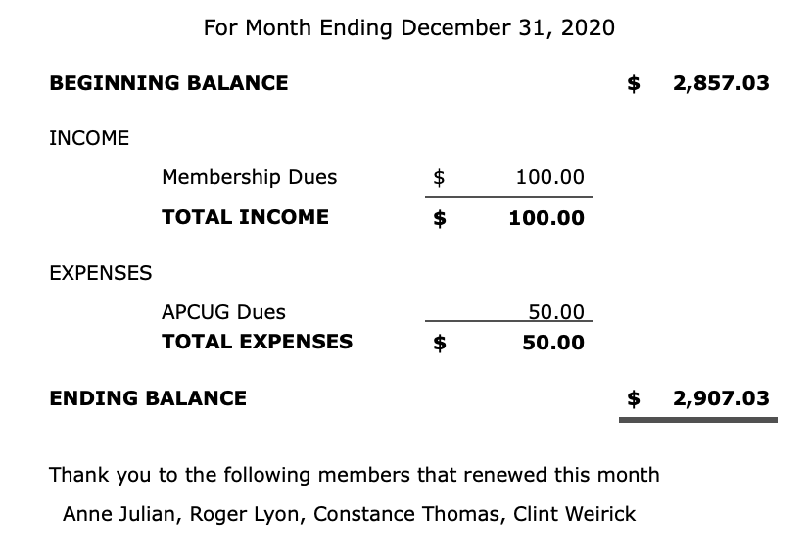

**▫▫▫▫▫▫▫▫▫▫▫▫▫▫▫▫▫▫▫▫▫▫▫**

**Photo Group Report** *by Ralph Sutter***Notes from the Meeting of 01/10/2021**  
**TOPIC**: **Water;** Bring it on

Notes from the meeting of 01/10/2021

**TOPIC**: Water The meeting took place via Zoom

**Ralph Sutter** opened the meeting by calling the group's attention to the posts made by member Doug Depue on the SLO Bytes Bulletin in which he shares his thoughts on the subject. View them here

Sutter continued with shots of fountains, ponds and lakes. He followed with a slow motion/freeze frame video of water dropping in a bowl.

**Stanford Brown** illustrated the many forms in which water is used; in drinking, bathing and playing; filling aquariums, ponds and kitty bowls.

**Alan Raul** captured images of water around the Pismo Beach and Avila Beach areas.

He also provided a link to more of his images here…

<https://www.365.acdsee.com/en/album/alan/2184651/>

<http://www.slolug.com/demo/>

Alan used **Adobe Premiere Elements** to strip out separate video frames of movies shot with a **GoPro** camera.

His video clips of the polar bear dip on New Years eve was stitched together using the same program.

Other pictures were modified using **Skylum Aurora HDR.**

**Kaye Raul** explored the seashore finding images of fishermen, seagulls and seascapes. She then enhanced the pictures by altering the sky with **Luminar AI**.

**Bob Ward** tracked water through its 3 forms showing snow, ponds and falling water. He demonstrated how to alter the look of flowing water by varying the shutter speed and camera ISO.

**Doug** **Depue** offered numerous water shots that he found on line, interspersed with some of his own images of local historical floods.

**John Waller** followed water from the crop irrigation beside his house and then showed waterfalls from Salmon Creek to Little Falls to Yosemite Falls. \

**Bob Styerwalt** began showing a glass of water and then expanded to images of Morro Rock, the Hearst Castle outdoor pool, Lake Cachuma and Lake Arrowhead.

Our next meeting will take place on **February 14th**. The topic is Close-up Photography.

The meeting will take place via **Zoom**. A Zoom invitation will be e-mailed to Photo Group members shortly before the meeting The meeting schedule for the remainder of 2021 is as follows

March 14

April 11

May 16 (Mothers' Day falls on May 9th)

June 13

July 11

August 8

September 12

October 10

November 14

December 12

See the [Links](https://www.slobytes.org/digital/links.html) page for tutorials and other resources.

**Ralph Sutter**

***▫▫▫▫▫▫▫▫▫▫▫▫▫▫▫▫▫▫▫▫▫▫▫***

**Push Library**  
Look at the **PUSH archives**, <http://www.slobytes.org/push/>. This is a repository of articles where you will find tips, product reviews, and personal recommendations contributed by computer clubs across the country.  
They are provided courtesy of the Association of Computer User Groups, **APCUG**, the national organization with which SLO Bytes is affiliated.   
The actual **PUSH** articles are hyperlinked from the index located at  
 <http://www.slobytes.org/push/index.html> (All articles on one long page)  
 <http://www.slobytes.org/push/push-condensed.html> (Links to **PUSH** articles by month received)  
You can view additional APCUG publications here: <http://www.slobytes.org/apcug/index.html>

***▫▫▫▫▫▫▫▫▫▫▫▫▫▫▫▫▫▫▫▫▫▫▫***

**SLO Bytes Bulletin Board**  
Everyone can read the SLO Bytes Bulletin Board at <http://slobytes.org/smf/index.php?board=1.0> but only subscribers can post comments or respond to the posts of others. Despite the usual connotation of **subscribe**, it costs nothing to join the bulletin board. It is free to all current SLO Bytes members. However, to guard against cyber-mischief by spammers and other ne’er-do-wells, I have disabled self-registration. If you want to be added to the bulletin board, please send your request to me at [ralph@rsutter.com](mailto:ralph@rsutter.com).

If you are currently registered with the SLO Bytes Bulletin Board and wish to change your password, you will find a video screen capture of how to do so at   
<http://www.slobytes.org/documents/change-bb-password.mp4>

***▫▫▫▫▫▫▫▫▫▫▫▫▫▫▫▫▫▫▫▫▫▫▫***

**Club Information and Meeting Times**

**SLO** **Bytes**, a PC Users Group dedicated to educating its members in the use of personal computers, digital devices and software, meets on the first Sunday of each month via **Zoom**. Zoom credentials are sent to members twice shortly before each meeting. If you are a SLO Bytes member and don’t receive this e-mail, please contact [ralph@rsutter.com](mailto:ralph@rsutter.com).

All meetings are open to the public at no cost. A general interest and Q&A session occurs from 12:45 PM to 2:00 PM and guest speaker presentations begin at 2:30 PM. Contact **Ralph Sutter** ([ralph@rsutter.com](mailto:ralph@rsutter.com)) or visit [slobytes.org](http://www.slobytes.org/index.php) for additional information about SLO Bytes and the scheduled presentation. All ideas for speakers or presentation subjects are welcome.  
 **HardCopy** is a monthly publication of **SLO Bytes PC Users' Group** located in San Luis Obispo, California. Information in this newsletter is derived from both our own membership and other PC user group newsletters.

The purpose of this publication is to inform our members of meetings and provide information related to the use of PCs and various operating systems.  
Membership dues are $25 per year. Membership entitles you to our monthly newsletter via e-mail, technical assistance comradeship and a voice in the affairs of the club.

***▫▫▫▫▫▫▫▫▫▫▫▫▫▫▫▫▫▫▫▫▫▫▫***

***Outside Special Interest Groups (SIGs)*The Linux Group** normally meets via Zoom at 6:30 PM on the first Thursday of the month.  
View the web site at [www.slolug.com](http://www.slolug.com). Contact [Alan@alanraul.com](mailto:Alan@alanraul.com) for credentials to join the Zoom Session.  
 **The Photography Group** normally meets via Zoom at 2:00 PM on the second Sunday of each month. Contact [ralph@rsutter.com](mailto:ralph@rsutter.com) for credentials to join the Zoom Session.  
Visit the website at [www.slobytes.org/digital](http://www.slobytes.org/digital)

***▫▫▫▫▫▫▫▫▫▫▫▫▫▫▫▫▫▫▫▫▫▫▫***

***SLO Bytes Officers/Volunteers*Officers**Earl Kaplan – President: [earlkaplan@gmail.com](mailto:earlkaplan@gmail.com)   
John Waller - Vice President; Programs Chair/Publicity: [johnlwaller@sbcglobal.net](mailto:johnlwaller@sbcglobal.net)   
Kaye Raul – Treasurer; Membership: [kaye@kayeraul.com](mailto:kaye@kayeraul.com)   
Ralph Sutter – Secretary, Webmaster/HardCopy Editor, Photo SIG Leader: [ralph@rsutter.com](mailto:ralph@rsutter.com)   
Alan Raul – Training Officer/Linux Group Leader: [alan@alanraul.com](mailto:alan@alanraul.com)

***▫▫▫▫▫▫▫▫▫▫▫▫▫▫▫▫▫▫▫▫▫▫▫***

**Disclaimer**: Neither SLO Bytes PC Users' Group, its officers, editors, or contributors to this newsletter assume liability for damages arising out of this publication of any article, including but not limited to the listing of programming code, batch   
files and other helpful hints. Articles from this newsletter may be reprinted by other user groups if credit is given to both   
  
the author and newsletter from which it was taken. Reproduction of articles with a specific copyright notice is prohibited without prior permission from the original author.

**SLO Bytes Website**: [slobytes.org](http://www.slobytes.org/index.html)