SLO Bytes Computer Users' Group
Minutes of the July 30, 2021 Virtual BOD Meeting
Officers present via Zoom: Alan Raul, John Waller and Kaye Raul
Absent: Ralph Sutter, Earl Kapan
Vice-President John Waller called the meeting to order at 6:39 pm.
The Minutes of the BOD meeting of 06/04/2021 were approved as submitted.
Training Officer Alan Raul mentioned the passing of one current and one former member.
Richard (Dick) James passed away July 19, 2021 at the age of 90. Richard Rall passed away July 3, 2021, at the age of 86. Read his obituary - https://www.reisfamilymortuary.net/obituaries/Richard-Rall/#!/Obituary
Alan has summarized attendance at SLO Bytes and SLOLUG meetings from 2019 in the following charts..
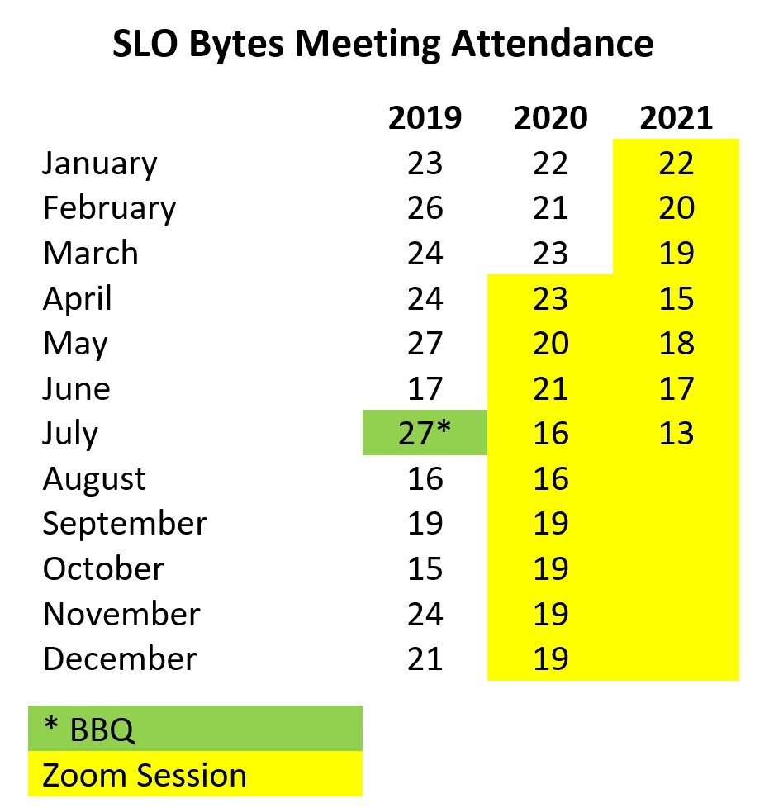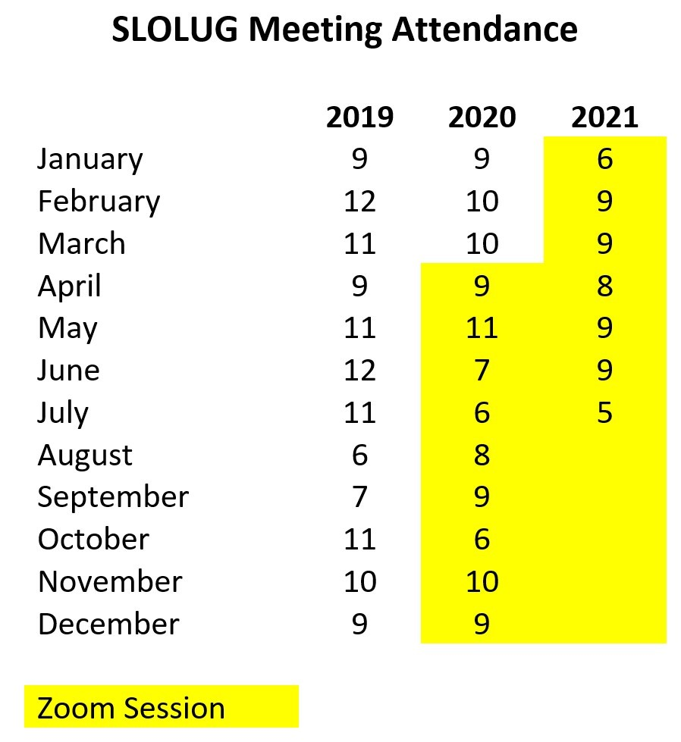
Alan Raul confirmed with John Waller that Waller will continue in his position as Vice-President/ Programs.
Treasurer Kaye Raul gave an update of club financial activity. The club has 29 active members. With limited monthly activity, she has streamlined the monthly Treasurer’s Report.
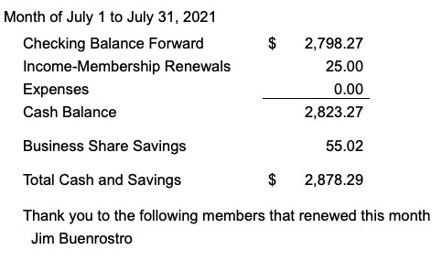
The meeting ended at 6:53 pm
Kaye Raul

