**Notes from Ralph Sutter’s General Session Presentation – 01/01/2017**

Polar Bear Plunge – Avila <http://www.avilabeachpolarbearplunge.com/>

Phone numbers for Businesses:  <https://gethuman.com/>

New to MAC  <https://www.youtube.com/watch?v=rblx-K2XMOU>  from 2012

New to MAC:  for Sierra  <http://techtalkamerica.com/new-to-mac-macos-sierra/>

Create a Windows 10 Recovery Drive:

Was <http://www.pcworld.com/article/3140449/windows/everything-you-need-to-know-about-windows-10-recovery-drives.html?idg_eid=d5c9a380bf4311010ffb8a5997620286&token=%23tk.PCW_nlt_pcw_bestof_html_2016-11-18&utm_source=Sailthru&utm_medium=email&utm_campaign=Best%20of%20PCWorld%202016-11-18&utm_term=pcw_bestof_html#tk.PCW_nlt_pcw_bestof_html_2016-11-18>

Shorten to <http://www.pcworld.com/article/3140449/windows/everything-you-need-to-know-about-windows-10-recovery-drives.html>

Fix Master Boot Record

         At DOS prompt type bootrec.exe /fixmbr

Show how to fix grey background when pasting text from Chrome into an e-mail by using the Format icon

Format is located on the Message tab.  I’ve also added it to the Quick Access Toolbar

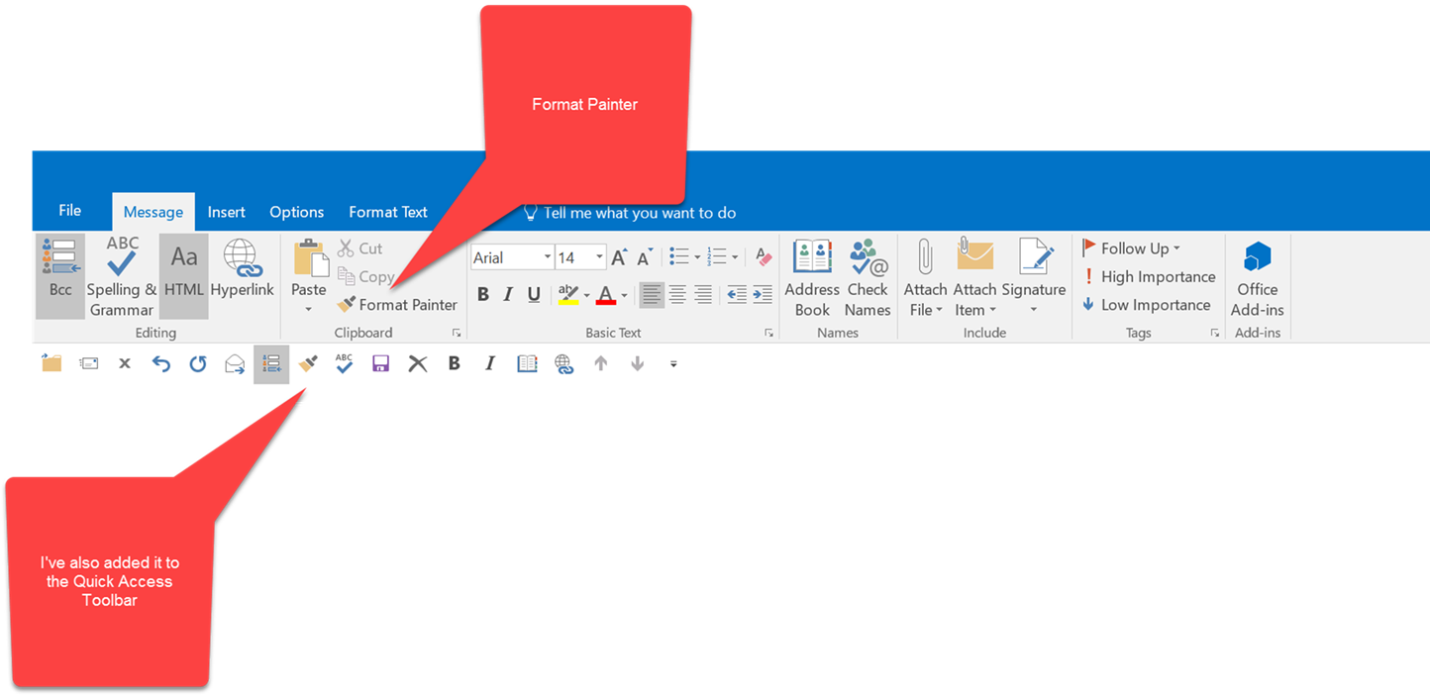

**Alternative**  
You can also click on the Paste tab and choose **Keep** **Text Only**

**Netgear Router Vulnerabilities**:  <http://slobytes.org/smf/index.php?board=1.0>

My Speed tests with Sandisk and Mushkin 16 Gb USB 3.0 Flash Drives

**Speed Tests**

Interested in testing transfer speeds between different devices, I noted the time that it took to copy a 13.8GB series of 1853 files in 11 folders from one location to another.  The files were almost exclusively .jpg images.

I have listed the results below.

|  |  |  |  |  |
| --- | --- | --- | --- | --- |
| Source | Destination | Time  **Minutes**:Seconds | | Comments |
| Server | Desktop of the Computer | **3:**01 |  | CAT 6 Ethernet cable connection; Computer is a Dell XPS 8900 with 3.40 gigahertz Intel Core i7-6700 and 16GB of RAM |
| Desktop | Folder on C Drive | 0:48 |  | C drive is a Samsung 950 m.2 512GB SSD |
| Desktop | Crucial 512GB Internal SSD | 0:46 |  | Secondary Hard Drive installed on a Dell 8900 XPS Desktop Computer |
| Desktop | Internal Seagate 3TB HDD | **1**:30 |  | Secondary Hard Drive installed on a Dell 8900 XPS Desktop Computer |
| Desktop | Seagate Backup Plus External 4TB 3.0 USB HDD Drive | **2**:46 |  | External Hard Drive plugged into USB 3 port |
| Desktop | Mushkin M Ventura Ultra 120 GB USB 3.0 SCSI Device | **6:**32 |  | Flash drive formatted as NTFS allocation size 4KB and plugged into USB 3 port |
| Desktop | Lexar 1000x 64GB Micro SC 3 II SD Card | **6**:37 |  | Micro SD card placed in a standard SD adapter and read by a 3.0 USB card reader |
| Desktop | Lexar 633 64GB Micro SC 10 I SD Card | **11**:00 |  | Micro SD card placed in a standard SD adapter and read by a 3.0 USB card reader |
| Desktop | Mushkin 16GB Atom Flash Drive | **23**:14 |  | Flash drive formatted as FAT 32 allocation size 4096KB and plugged into USB 3 port |
| Desktop | Sandisk 16GB Ultra Fit Flash Drive | **24**:05 |  | Flash drive formatted as FAT 32 allocation size 4096KB and plugged into USB 3 port |

Flash Drives for MicroSD  
Canakit USB Micro SD Card Reader – Loads from the throat

Lexar USB Micro SD Card Reader – Loads from the back

PrintMyFonts:  <http://www.sttmedia.com/printmyfonts-download>; freeware program that displays all the fonts installed on your computer on a single page (Versions for Windows, MAC and Linux)

More freeware from the author, Stefan Trost  <http://www.sttmedia.com/software>

**Idea**:  Take a picture of selected parts of your camera’s instruction manual.  Then, you will be able to view it on your camera when you need it.

**DLNA**: Digital Living Network Alliance suggested by Stanford Brown:    
Established by Sony in 2003

<https://en.wikipedia.org/wiki/Digital_Living_Network_Alliance>   
<http://www.makeuseof.com/tag/dlna-still-used/>

Windows 10 Update breaks Network AdapterNetworking damaged by Win 10 Update  
Solution: Turn off “Turn on fast start up”  
GOTO Control Panel—click Power Options—click “choose what power buttons do—  
click on “ Change settings that are currently unavailable”—uncheck “Turn on fast start up”—click Save Changes  
suggested by Stanford Brown

Darry D Eggleston link suggested by Earl Kaplan  
[www.darryd.com](http://www.darryd.com)

Comics[www.gocomics.com](http://www.gocomics.com)[Baldo](http://www.gocomics.com/baldo)[12-29-16; Commercial](http://www.gocomics.com/baldo/2016/12/29)

**Ralph Sutter**