January Second Session – 01/01/17
OneNote

Items for SLO Bytes January Second Session

The Second Session begins at 2:30 p. m. Ralph Sutter will speak briefly on the free-form information gathering and multi-user collaboration Microsoft product, OneNote.
Sutter will then encourage members of the audience to describe how they use that program and other similar programs such as
Simplenote
Apple Notes
Google Keep
Evernote

Alternatives
E-mail to self
Demo that I can format messages pasted into OneNote as I would any other text document

Link to David A Cox OneNote video from August 23, 2014 Microsoft OneNote Tutorial

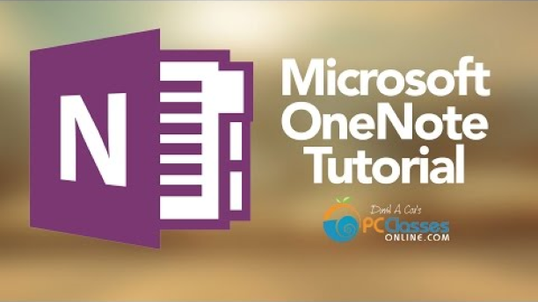

Show Formatting possibilities
Change Font
Change Location
Edit Page
Show Format Painter

If I Copy information from a web site, hyperlinks will be live.
If I Print to OneNote, hyperlinks will not be live.
Copy to OneNote
- Microsoft OneNote 2016 - NEW! TutorialTeacher's Tech127,088 views
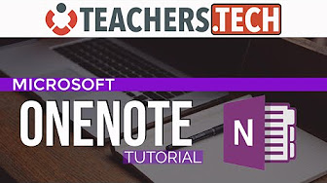
26:59

- Microsoft OneNote 2016 - Full Tutorial for Beginners [+ General Overview]*bai271,287 views
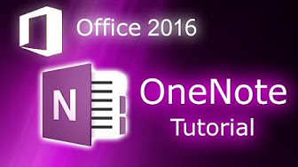
11:08
- Top 10 Most Extreme And Awesome X Factor Auditions HDPool GomezRecommended for you

From <https://www.youtube.com/watch?v=h07qZLLQc4I>

Print to OneNote
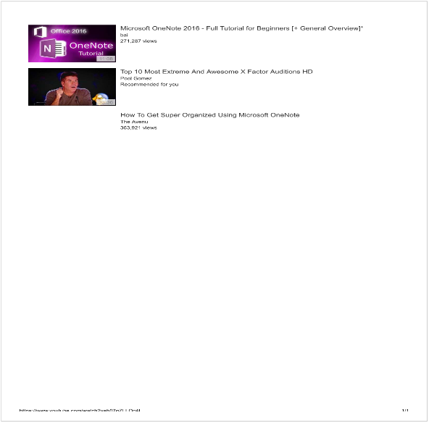

OneNote allows you to insert audio and video recordings either real time or from files
Webcam Recording
<<January Second Session.wmv>>

Demo Sharing Options
(File/Share/E-mail or Get Sharing Link)
Allow read only or editing permissions

Password protect the Section, Protected
Password is the number 1
The entire Section, SLO Bytes Demo is protected

Limitations of pasting from Excel Spread Sheet

IP_ADDRESS | TEST_DATE  This doesn't work properly  Data not shown when column is widened | TIME_ZONE | DOWNLOAD_MEGABITS | UPLOAD_MEGABITS | LATENCY_MS | SERVER_NAME | DISTANCE_MILES
96.90.243.190 | ######## | PDT | 23.4 | 17.5 | 41 | Los Angeles, CA | 150
96.90.243.190 | ######## | PDT | 21.01 | 17.65 | 51 | Los Angeles, CA | 150
96.90.243.190 | ######## | PDT | 24.75 | 13.47 | 41 | Los Angeles, CA | 150
96.90.243.190 | ######## | PDT | 11.01 | 17.49 | 44 | Los Angeles, CA | 150
96.90.243.190 | ######## | PDT | 13.19 | 27.47 | 45 | Los Angeles, CA | 150
96.90.243.190 | ######## | PDT | 15.04 | 14.94 | 62 | Los Angeles, CA | 150
96.90.243.190 | ######## | PDT | 12.68 | 5.64 | 65 | Los Angeles | 150
96.90.243.190 | ######## | PDT | 11.57 | 19.05 | 36 | Los Angeles | 150
96.90.243.190 | ######## | PDT | 7.55 | 2.14 | 50 | Simi Valley, CA | 100
96.90.243.190 | ######## | PDT | 10.46 | 14.68 | 44 | Los Angeles, CA | 150
96.90.243.190 | ######## | PDT | 28.74 | 27.55 | 54 | Los Angeles, CA | 150
96.90.243.190 | ######## | PDT | 4.96 | 1.46 | 48 | Los Angeles, CA | 150
96.90.243.190 | ######## | PDT | 4.87 | 5.25 | 64 | Los Angeles, CA | 150
96.90.243.190 | ######## | PDT | 10.89 | 25.07 | 43 | Los Angeles, CA | 150
96.90.243.190 | ######## | PDT | 9.36 | 22.26 | 31 | Los Angeles, CA | 150
96.90.243.190 | ######## | PDT | 12.54 | 24.67 | 37 | Los Angeles, CA | 150
96.90.243.190 | ######## | PDT | 26.48 | 23.05 | 35 | Los Angeles, CA | 150
96.90.243.190 | ######## | PDT | 20.2 | 25.26 | 49 | Los Angeles, CA | 150
96.90.243.190 | ######## | PDT | 32.71 | 23.83 | 43 | Los Angeles, CA | 150
96.90.243.190 | ######## | PDT | 11.49 | 19.52 | 34 | Los Angeles, CA | 150
96.90.243.190 | ######## | PDT | 17.23 | 24.61 | 40 | Los Angeles, CA | 150
Export or Send OneNote to other Programs
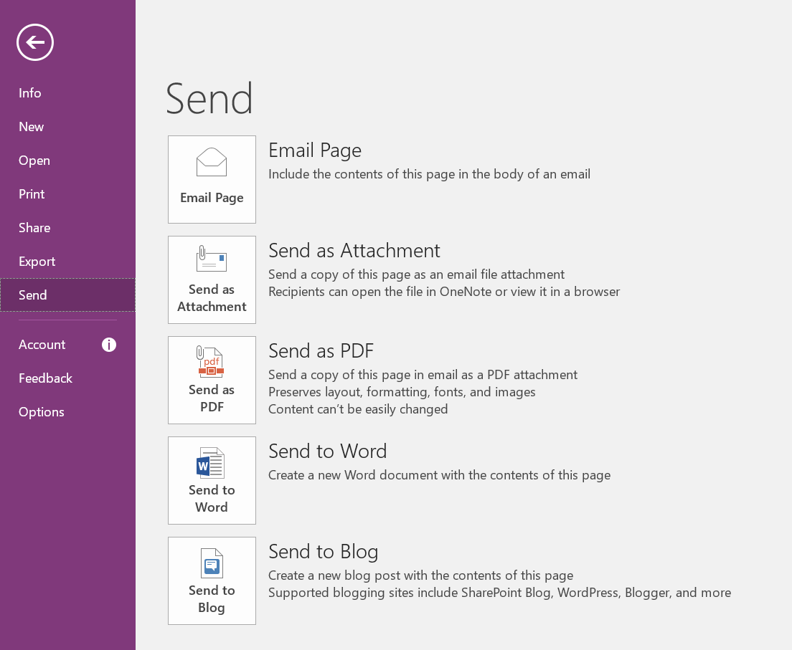

Evernote

Evernote Information
https://help.evernote.com/hc/en-us/articles/209005157

Which Evernote product is right for me?
All Evernote products include:
  - Unlimited total storage
  - Notebook sharing
  - Searching for printed and handwritten text in images
  - Industry-standard security2 and text encryption option
  - Passcode lock on mobile apps
  - Image annotation
  - Salesforce integration for personal notes7 (Evernote Business comes with integration for business notes also)

Features included in all paid Evernote subscriptions
All paid Evernote subscriptions (Plus, Premium, and Evernote Business) come with:
  - Sync across all of your devices (For Basic, sync across 2 devices)
  - 2-step verification via SMS and Google Authenticator (For Basic, 2-step verification is available through Google Authenticator only)
  - Offline access to notes via Desktop and Mobile (For Basic, offline access is available only via Desktop)
  - Evernote agent support (For Basic, only Community Support is available)
Note: For Premium, Priority Evernote agent support and chat are available. For Business, a dedicated Evernote Business agent and chat are available.

Different upload and note sizes to fit your needs
Monthly note uploads1
Basic | Plus | Premium | Evernote Business
60 MB | 1 GB | 10 GB | 10 GB for personal notes + shared 2 GB per user for business notes
Maximum note size
Basic | Plus | Premium | Evernote Business
25 MB | 50 MB | 200 MB | 200 MB

Comparison of key features in paid subscriptions
 | Plus | Premium | Evernote Business
Save emails into Evernote | ✔ | ✔ | ✔
Unlimited paper options in Penultimate app | ✔ | ✔ | ✔
Search in PDFs, Office docs, and attachments |  | ✔ | ✔
Annotate PDFs |  | ✔ | ✔
Scan and digitize business cards3 |  | ✔ | ✔
Turn notes into presentations4 |  | ✔ | ✔
View previous version of notes |  | ✔ | ✔
See content related to your notes5 |  | ✔ | ✔
Switch between multiple accounts |  | ✔ | ✔
Single Sign-on (SSO) |  |  | ✔
Business data ownership |  |  | ✔
IT tools to centralize account administration and user management |  |  | ✔
Team knowledge and content hub6 |  |  | ✔
More about system limits
More about Evernote User Guidelines
1 Example: If you have 5 users in your Evernote Business account, you get a shared 10 GB per month for business note uploads.
2 Your data is secure in transit with TLS/SSL encryption and note content can be locally encrypted using AES encryption. Please note that receiving verification codes via SMS is available for Premium and Business users. Learn more about how encryption and two-step verification work.
3 Business Card Scanning is available for iOS and Android.
4 Present directly from your notes in a full-screen layout for more collaborative, efficient meetings.
5 Context reveals notes with related content and documents, and Knowledge Discovery identifies co-workers who are experts on the topic or project you're working on.
6 Evernote automatically finds and displays relevant content and work from across your entire business so you can avoid duplicate work and discover information you didn't know to look for.
7 Boost customer relationships by easily capturing meeting notes on any device and linking them directly to any Salesforce record. Add attachments including handwritten meeting notes, PDFs, research from the web including articles, photos, and more.

From <https://help.evernote.com/hc/en-us/articles/209005157>
Another Link
Evernote vs OneNote - 5 Key Differences

