SLO Bytes HardCopy
A publication of the San Luis Obispo PC Users’ Group
Vol. 36 No.11 November 2020
October 4th, 2020 First Session Notes by Alan Raul
ACDSee Photo Studio Ultimate 2021 - is an image organizer, viewer, and image editor program for Windows, macOS and iOS, developed by ACD Systems.
https://www.acdsee.com/en/products/photo-studio-ultimate
ACDSee 2021 - Feature Set Preview
https://www.youtube.com/watch?v=0zL5wkpa6J8
How to activate all of Windows 10's secret God Modes
https://betanews.com/2020/02/28/windows-10-god-modes/
The Social Dilemma - The film explores the rise of social media and the damage it has caused to society, focusing on its exploitation of its users for financial gain through surveillance capitalism and data mining, how its design is meant to nurture an addiction, its use in politics, its effect on mental health (including the mental health of adolescents and rising teen suicide rates), and its role in spreading conspiracy theories such as Pizzagate and aiding groups such as flat-earthers.
https://www.youtube.com/watch?v=uaaC57tcci0
https://en.wikipedia.org/wiki/The_Social_Dilemma
https:/www.imdb.com/title/tt11464826/
https://www.thesocialdilemma.com/
https://www.netflix.com/title/81254224
https://www.cnbc.com/2020/09/21/netflix-movie-the-social-dilemma-slams-social-media-review.html
San Luis Obispo Camera Club
http://www.slocameraclub.org/
Santa Maria Camera Club
http://www.santamariacameraclub.org/
Santa Maria Camera Club YouTube
https://www.youtube.com/channel/UCGQuUbYBve8CEsH3U5a_U3g
Intel Tiger Canyon details leaked (Intel NUC with Tiger Lake chips)
https://liliputing.com/2020/09/intel-tiger-canyon-details-leaked-intel-nuc-with-tiger-lake-chips.html
Intel NUC 11 Pro
https://twitter.com/9550pro/status/1308979861722198016
Samsung’s fast, PCIe 4.0-ready 980 Pro SSD can future-proof your PC build
https://www.theverge.com/2020/9/22/21444428/samsung-pc-980-pro-ssd-solid-state-drive-storage-price
Samsung 1TB 980 PRO PCIe 4.0 x4 M.2 Internal SSD
https://www.bhphotovideo.com/c/product/1593680-REG/samsung_mz_v8p1t0b_am_1tb_980_pro_pcie.html
Alan Raul
October 4th Second Session Notes - Good Computing Practices by Alan Raul

- Router Security
  - https://routersecurity.org/
  - Secure your Wi-Fi
- Use a VPN (Virtual Private Network)
  - https://en.wikipedia.org/wiki/Virtual_private_network
  - Private Internet Access
    - https://www.privateinternetaccess.com/
- Use a Ad Blocker
  - AdBlock
    - https://getadblock.com/
- Use a Password Manager
  - LastPass
    - https://www.lastpass.com/
  - DO NOT include e-mail, bank or government passwords in your password manager

- Create a “disaster recovery plan”

- Separate your Operating System from your DATA by partitioning
  - Use the Windows built-in partition tool or a third-party tool
  - Acronis Disk Director
    - https://www.acronis.com/en-us/personal/disk-manager/
  - GNOME Partition Editor
    - https://gparted.org/
  - Parted Magic
    - https://partedmagic.com/
- Backup Types
  - Operating system backup
    - This includes the OS installed, updated, configured, programs installed and configured. ii. The OS and applications are activated
  - Data backup
    - This includes data which you have created which cannot easily, if at all, be recreated.
1. Pictures, music, videos, Word or Excel documents and more
- Backup Software
  - Acronis True Image
    - https://www.acronis.com/en-us/personal/computerbackup/
  - Macrium Reflect 7 Free Edition
    - https://www.macrium.com/reflectfree
  - 2BrightSparks SyncBackFree
    - https://www.2brightsparks.com/freeware/index.html
- Backup locations
  - On-site
    - Preferably a Fireproof box or safe
  - Off-site
    - Safety deposit box
    - A trusted friend or relative
    - Online backup service
- Backup devices
  - External hard drive enclosure
  - USB flash drive
  - NAS (Network Attached Storage)
Miscellaneous Good Computing Practices
- Keep software and programs up to date – In other words DO NOT use Windows 7 and/or Office 2010!
- Enable Automatic Updates
- Keep Windows Defender updated o Install Malwarebytes if needed (FREE or Paid version)
▪ https://www.malwarebytes.com/mwb-download/
- Be suspicious of external downloads and emails o Keep an eye on the news for security incidents. o Beware of scams
o Do not install or download unknown or unsolicited programs/apps to your computer, phone, or other devices.
- An advantage of being a paid SLO Bytes member is that we share information on the latest security incidents, Windows updates and application updates.
- Wipe data from old technology completely
- There is probably more I could list but this should hit the main points.
▫▫▫▫▫▫▫▫▫▫▫▫▫▫▫▫▫▫▫▫▫▫▫
November 1st Program by Ralph Sutter
The First ZOOM Session will feature Alan Raul offering a Questions and Answers program from 12:45-2:00 p.m.
Usual topics include security issues, recent changes in Windows operating systems, tablets and smart phones as well as demos of software and hardware. We always encourage questions and observations from the audience.
There will be a break from 2:00-2:30 pm allowing the audience to sip a beverage, pet the dog or stretch
During the Second Session, the format will change. SLO Bytes members will be encouraged to ask questions relating to computers and electronic devices; their use and care.
The five members of the SLO Bytes Board of Directors will all field these questions, having previously prepared their own conversation starters. The idea here isn't Stump the BOD but rather Learn from Each Other.
Answers to the questions posed may well come not from the Board of Directors but rather from members of the SLO Bytes Community.
If no answers are forthcoming from any source, we'll possibly have that most illusive of animals, a topic for future presentations.
To be part of the virtual meeting via Zoom, please refer to the e-mail that will be sent to you twice shortly before the meeting with the credentials necessary to join the Zoom session. If you are asked for a Meeting ID or a Password, copy it from the announcement and paste it into the appropriate box.
View Zoom tutorials at https://www.youtube.com/playlist?list=PLKpRxBfeD1kEM_I1lId3N_Xl77fKDzSXe If you have any questions, please contact Ralph Sutter at ralph@rsutter.com
Ralph Sutter
▫▫▫▫▫▫▫▫▫▫▫▫▫▫▫▫▫▫▫▫▫▫▫
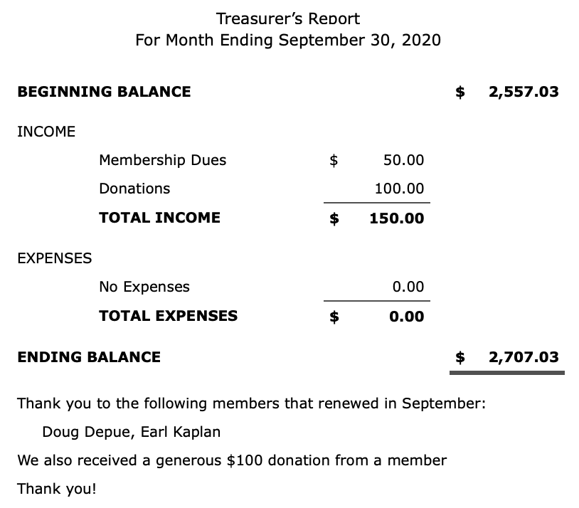
Kaye Raul, Treasurer

Photo Group Report by Ralph Sutter
Notes from the Meeting of 10/11/2020
TOPIC: Images Dominated by a Single Color; photos with a single prominent color. The meeting took place via Zoom

Ralph Sutter opened the meeting, calling attention to the Links Page; https://www.slobytes.org/digital/links.html of the Photography web site.

Sutter continued with closeups of plants and familiar objects along with fog shrouded images of boats on Morro Bay.

Doug DePue offered a lesson in color theory distinguishing between tint, hue and shade. See the Links Page; https://www.slobytes.org/digital/links.html for his sources

Kaye Raul chose images of a puzzle, rusting farm equipment and fields of squash.

Alan Raul showed night shots of the Pismo Beach redevelopment project, moored kayaks and pumpkins

John Waller used the Photoshop Object Selection Tool; https://www.photoshopessentials.com/basics/object-selection-tool/ to enhance his images

NEXT MEETING: Sunday, November 8th, 2020@ 2:00 pm
The topic is Images Dominated by a Single Color (Again). The meeting will take place via Zoom

A Zoom invitation will be e-mailed to Photo Group members shortly before the meeting.
The final meeting of the year will take place on December 13th

See the Links page for tutorials and other resources
Ralph Sutter
▫▫▫▫▫▫▫▫▫▫▫▫▫▫▫▫▫▫▫▫▫▫▫
Push Library
Look at the PUSH archives, http://www.slobytes.org/push/. This is a repository of articles where you will find tips, product reviews, and personal recommendations contributed by computer clubs across the country.
They are provided courtesy of the Association of Computer User Groups, APCUG, the national organization with which SLO Bytes is affiliated.
The actual PUSH articles are hyperlinked from the index located at
http://www.slobytes.org/push/index.html (All articles on one long page)
http://www.slobytes.org/push/push-condensed.html (Links to PUSH articles by month received)
You can view additional APCUG publications here: http://www.slobytes.org/apcug/index.html
SLO Bytes Bulletin Board
Everyone can read the SLO Bytes Bulletin Board at http://slobytes.org/smf/index.php?board=1.0 but only subscribers can post comments or respond to the posts of others. Despite the usual connotation of subscribe, it costs nothing to join the bulletin board. It is free to all current SLO Bytes members. However, to guard against cyber-mischief by spammers and other ne’er-do-wells, I have disabled self-registration. If you want to be added to the bulletin board, please send your request to me at ralph@rsutter.com.
If you are currently registered with the SLO Bytes Bulletin Board and wish to change your password, you will find a video screen capture of how to do so at
http://www.slobytes.org/documents/change-bb-password.mp4
Club Information and Meeting Times
SLO Bytes, a PC Users Group dedicated to educating its members in the use of personal computers, digital devices and software, meets on the first Sunday of each month via Zoom. Zoom credentials are sent to members twice shortly before each meeting. If you are a SLO Bytes member and don’t receive this e-mail, please contact ralph@rsutter.com.
All meetings are open to the public at no cost. A general interest and Q&A session occurs from 12:45 PM to 2:00 PM and guest speaker presentations begin at 2:30 PM. Contact Ralph Sutter (ralph@rsutter.com) or visit slobytes.org for additional information about SLO Bytes and the scheduled presentation. All ideas for speakers or presentation subjects are welcome.
HardCopy is a monthly publication of SLO Bytes PC Users' Group located in San Luis Obispo, California. Information in this newsletter is derived from both our own membership and other PC user group newsletters.
The purpose of this publication is to inform our members of meetings and provide information related to the use of PCs and various operating systems.
Membership dues are $25 per year. Membership entitles you to our monthly newsletter via e-mail, technical assistance comradeship and a voice in the affairs of the club.
Outside Special Interest Groups (SIGs)
The Linux Group normally meets via Zoom at 6:30 PM on the first Thursday of the month.
View the web site at www.slolug.com. Contact Alan@alanraul.com for credentials to join the Zoom Session.
The Photography Group normally meets via Zoom at 2:00 PM on the second Sunday of each month. Contact ralph@rsutter.com for credentials to join the Zoom Session.
Visit the website at www.slobytes.org/digital
▫▫▫▫▫▫▫▫▫▫▫▫▫▫▫▫▫▫▫▫▫▫▫
SLO Bytes Officers/Volunteers
Officers
Earl Kaplan – President: earlkaplan@gmail.com
John Waller - Vice President; Programs Chair/Publicity: johnlwaller@sbcglobal.net
Kaye Raul – Treasurer; Membership: kaye@kayeraul.com
Ralph Sutter – Secretary, Webmaster/HardCopy Editor, Photo SIG Leader: ralph@rsutter.com
Alan Raul – Training Officer/Linux Group Leader: alan@alanraul.com
Other Volunteers
Peter Stonehewer – Refreshments
▫▫▫▫▫▫▫▫▫▫▫▫▫▫▫▫▫▫▫▫▫▫▫
Disclaimer: Neither SLO Bytes PC Users' Group, its officers, editors, or contributors to this newsletter assume liability for damages arising out of this publication of any article, including but not limited to the listing of programming code, batch
files and other helpful hints. Articles from this newsletter may be reprinted by other user groups if credit is given to both
the author and newsletter from which it was taken. Reproduction of articles with a specific copyright notice is prohibited without prior permission from the original author.
SLO Bytes Website: slobytes.org

