SLO Bytes HardCopy
A publication of the San Luis Obispo PC Users’ Group
Vol. 36 No.9 September 2020
August 2nd, 2020 First Session Notes by Alan Raul
Intel Unveils Thunderbolt 4
https://betanews.com/2020/07/08/thunderbolt-4-intel/

Differences between Thunderbolt 4, USB 4, Thunderbolt 3, and USB 3
https://liliputing.com/2020/07/differences-between-thunderbolt-4-usb-4-thunderbolt-3-and-usb-3.html

Intel details Thunderbolt 4: Required DMA protection, longer cables, and more
https://arstechnica.com/gadgets/2020/07/intel-details-thunderbolt-4-required-dma-protection-longer-cables-and-more/

How to Turn On or Off Fast Startup in Windows 10
https://www.tenforums.com/tutorials/4189-turn-off-fast-startup-windows-10-a.html

Who needs Windows 10 Pro: 5 reasons to upgrade
https://www.pcworld.com/article/2952408/who-needs-windows-10-pro-5-reasons-to-upgrade.html

Windows Sandbox Configuration
https://docs.microsoft.com/en-us/windows/security/threat-protection/windows-sandbox/windows-sandbox-configure-using-wsb-file
▫▫▫▫▫▫▫▫▫▫▫▫▫▫▫▫▫▫▫▫▫▫▫
September 6th Program by Ralph Sutter
The First ZOOM Session in August will feature Alan Raul offering a Questions and Answers program from 12:45-2:00 p.m.
Usual topics include security issues, recent changes in Windows operating systems, tablets and smart phones as well as demos of software and hardware. We always encourage questions and observations from the audience.
There will be a break from 2:00-2:30 pm allowing the audience to sip a beverage, pet the dog or stretch
During the Second Session, John Waller will introduce some of the resources of Geeks on Tour.
To be part of the virtual meeting via Zoom, please refer to the e-mail that will be sent to you on August 28th and again on September 5th. It will contain instructions on how to join the September 6th Zoom Session
If you are asked for a Meeting ID or a Password, copy it from the announcement and paste it into the appropriate box.
View Zoom tutorials at https://www.youtube.com/playlist?list=PLKpRxBfeD1kEM_I1lId3N_Xl77fKDzSXe
If you have any questions, please contact Ralph Sutter at ralph@rsutter.com
Ralph Sutter
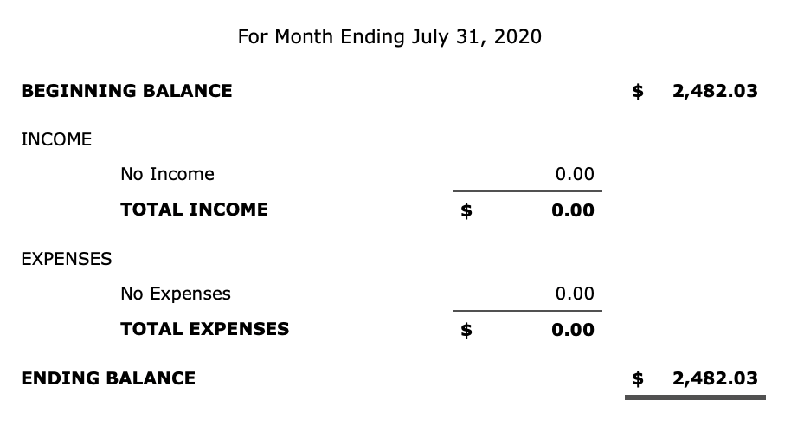
Treasurers’ Report by Kaye Raul

Kaye Raul, Treasurer
▫▫▫▫▫▫▫▫▫▫▫▫▫▫▫▫▫▫▫▫▫▫▫
Photo Group Report by Ralph Sutter
Notes from the Meeting of 08/09/2020
TOPIC: Artistic Growth-Phase Two; Learn a new skill for use inside or outside the camera and present it to the group.
The meeting took place via Zoom
Ralph Sutter showed the Links Page at https://slobytes.org/digital/links.htm
He called attention to https://askleo.com/how_do_pixels_and_dpi_and_resolution_and_picture_size_and_file_size_all_relate_to_each_other/ and his own slideshow, Kayaking in the San Juan Islands, https://youtu.be/cgaL6nGPgEs

Sutter opened the session by playing his San Juan Kayaking Slide Show

Alan Raul followed showing how he used the Sketch feature in Adobe Photoshop to create drawings from some of his seascapes

Doug DePue first showed how he fused several slides together with his scanning program, Powerslide 3650. He then demonstrated the numerous configurations possible for magnifying displayed image with Microsoft's Magnifier, a feature of Windows 10 built-in

Stanford Brown demoed the audio compression program, Switch by NCH Software, using it to compress audio files without noticeable loss of clarity.

Kaye Raul experimented with low angle photography and adding texture to images by creating semi-transparent layers in Adobe Photoshop

John Waller tried out a 10X adjustable neutral density filter, using it to extend the exposure time when shooting. With the longer exposure time, he then tried light painting and wave flattening.

Bob Styerwalt shared high quality photos of Yosemite that he shot in 1967

NEXT MEETING: Sunday, September 13th, 2020@ 2:00 pm
The topic will once again be Artistic Growth – Now Phase Three The meeting will take place via Zoom

A Zoom invitation will be e-mailed to Photo Group members shortly before the meeting.
The meeting schedule for the remainder of 2020 is as follows
October 11th
November 8th
December 13th

See the Links page for tutorials and other resources

Ralph Sutter
▫▫▫▫▫▫▫▫▫▫▫▫▫▫▫▫▫▫▫▫▫▫▫
Push Library
Look at the PUSH archives, http://www.slobytes.org/push/. This is a repository of articles where you will find tips, product reviews, and personal recommendations contributed by computer clubs across the country.
They are provided courtesy of the Association of Computer User Groups, APCUG, the national organization with which SLO Bytes is affiliated.
The actual PUSH articles are hyperlinked from the index located at
http://www.slobytes.org/push/index.html (All articles on one long page)
http://www.slobytes.org/push/push-condensed.html (Links to PUSH articles by month received)
You can view additional APCUG publications here: http://www.slobytes.org/apcug/index.html
SLO Bytes Bulletin Board
Everyone can read the SLO Bytes Bulletin Board at http://slobytes.org/smf/index.php?board=1.0 but only subscribers can post comments or respond to the posts of others. Despite the usual connotation of subscribe, it costs nothing to join the bulletin board. It is free to all current SLO Bytes members. However, to guard against cyber-mischief by spammers and other ne’er-do-wells, I have disabled self-registration. If you want to be added to the bulletin board, please send your request to me at ralph@rsutter.com.
If you are currently registered with the SLO Bytes Bulletin Board and wish to change your password, you will find a video screen capture of how to do so at
http://www.slobytes.org/documents/change-bb-password.mp4
▫▫▫▫▫▫▫▫▫▫▫▫▫▫▫▫▫▫▫▫▫▫▫
Club Information and Meeting Times
SLO Bytes, a PC Users Group dedicated to educating its members in the use of personal computers, digital devices and software, meets on the first Sunday of each month via Zoom. Zoom credentials are sent to members twice shortly before each meeting. If you are a SLO Bytes member and don’t receive this e-mail, please contact ralph@rsutter.com.
All meetings are open to the public at no cost. A general interest and Q&A session occurs from 12:45 PM to 2:00 PM and guest speaker presentations begin at 2:30 PM. Contact Ralph Sutter (ralph@rsutter.com) or visit slobytes.org for additional information about SLO Bytes and the scheduled presentation. All ideas for speakers or presentation subjects are welcome.
HardCopy is a monthly publication of SLO Bytes PC Users' Group located in San Luis Obispo, California. Information in this newsletter is derived from both our own membership and other PC user group newsletters.
The purpose of this publication is to inform our members of meetings and provide information related to the use of PCs and various operating systems.
Membership dues are $25 per year. Membership entitles you to our monthly newsletter via e-mail, technical assistance comradeship and a voice in the affairs of the club.
Outside Special Interest Groups (SIGs)
The Linux Group normally meets via Zoom at 6:30 PM on the first Thursday of the month.
View the web site at www.slolug.com. Contact Alan@alanraul.com for credentials to join the Zoom Session.
The Photography Group normally meets via Zoom at 2:00 PM on the second Sunday of each month. Contact ralph@rsutter.com for credentials to join the Zoom Session.
Visit the website at www.slobytes.org/digital
▫▫▫▫▫▫▫▫▫▫▫▫▫▫▫▫▫▫▫▫▫▫▫
SLO Bytes Officers/Volunteers
Officers
Earl Kaplan – President: earlkaplan@gmail.com
John Waller - Vice President; Programs Chair/Publicity: johnlwaller@sbcglobal.net
Kaye Raul – Treasurer; Membership: kaye@kayeraul.com
Ralph Sutter – Secretary, Webmaster/HardCopy Editor, Photo SIG Leader: ralph@rsutter.com
Alan Raul – Training Officer/Linux Group Leader: alan@alanraul.com
Other Volunteers
Peter Stonehewer – Refreshments
▫▫▫▫▫▫▫▫▫▫▫▫▫▫▫▫▫▫▫▫▫▫▫
Disclaimer: Neither SLO Bytes PC Users' Group, its officers, editors, or contributors to this newsletter assume liability for damages arising out of this publication of any article, including but not limited to the listing of programming code, batch
files and other helpful hints. Articles from this newsletter may be reprinted by other user groups if credit is given to both
the author and newsletter from which it was taken. Reproduction of articles with a specific copyright notice is prohibited without prior permission from the original author.
SLO Bytes Website: slobytes.org

