**SLO Bytes HardCopy  
A publication of the San Luis Obispo PC Users’ Group  
Vol. 36 No. 5 May 2020**

**April 5tht, 2020 First Session Notes** *by Alan Raul*

**Quick Assist** is a Windows 10 app. It allows someone you trust to take over your computer and help you solve a problem. To get started, your helper needs to launch the Quick Assist app, get a 6-digit code, and share that with you.  
<https://support.microsoft.com/en-us/help/4027243/windows-10-solve-pc-problems-with-quick-assist>   
<https://community.windows.com/en-us/stories/windows-quick-assist>

**TeamViewer** - Remotely access, manage, and support computers, mobile devices, network machines, and more — from anywhere, anytime  
<https://www.teamviewer.com/en-us/>

**TeamViewer QuickSupport** - Optimized for instant remote desktop support, this small customer module does not require installation or administrator rights — simply download, double click, and give the provided ID and password to your supporter.  
<https://download.teamviewer.com/download/TeamViewerQS.exe>

**TeamViewer Portable** generally comprises all the features of the full version of TeamViewer without the need to install anything. Instead, TeamViewer portable runs directly from a USB stick or a CD — TeamViewer Portable is the perfect solution when you are on the road and using different computers.  
<https://download.teamviewer.com/download/TeamViewerPortable.zip>

**Caltrans CCTV Map**<http://cwwp2.dot.ca.gov/vm/iframemap.htm>

US-101 : Pismo Beach US-101 : Mattie Road  
<http://cwwp2.dot.ca.gov/vm/loc/d5/us101mattieroad.htm>

**Surfline** - United States Surf Reports & Cams  
**Avila Beach Surf Report & Forecast**<https://www.surfline.com/surf-report/avila-beach/5842041f4e65fad6a77089ab>

**Virtual Railfan**<https://www.youtube.com/channel/UCOIkT9bq-1N2BvrsBjhNlag/videos>  **San Juan Capistrano, California USA - Virtual Railfan LIVE**<https://www.youtube.com/watch?v=zXqx56hlpd4>

**4kdownload.com**<https://www.4kdownload.com/>

**4K Video Downloader** allows downloading videos, playlists, channels and subtitles from YouTube, Facebook, Vimeo and other video sites in high quality.

**4K Stogram** is an Instagram Viewer and Downloader.

**4K YouTube to MP3** was specifically created for audio extraction from YouTube, VEVO, SoundCloud and Facebook in MP3, M4A, OGG.

**4K Video to MP3** extracts audio from any video.

**4K Slideshow Maker** - is an extremely easy-to-use app to create slideshows. Just add your favorite photos from Instagram or from your own computer, select the music and then apply gorgeous effects and transitions. Get started for free!  
<https://www.4kdownload.com/products/product-slideshowmaker>

**Alan Raul**

**▫▫▫▫▫▫▫▫▫▫▫▫▫▫▫▫▫▫▫▫▫▫▫**

**April 5th 2020 Second Session Notes** *by Ralph Sutter*

**Windows Media Player (WMP)**

Get Windows Media Player <https://support.microsoft.com/en-us/help/14209>

More at <https://support.microsoft.com/en-us/help/17615/windows-media-player-12>

WMP has been included in Windows since Windows 7

DVD playback isn't included in Windows 10. Go to the [DVD playback for Windows](https://support.microsoft.com/en-us/help/10771) page to find out how to add DVD playback to Windows 10.

1. Click the **Start** button, type **features**, and then select **Turn Windows features on or off**.
2. Expand **Media Features** and see whether the **Windows Media Player** check box is selected. If it is, clear the check box.
3. Click **OK**and then restart your PC. This will remove your current version of **Windows Media Player**.
4. After your PC has restarted, repeat step 1.
5. Expand **Media Features** and select the **Windows Media Player** check box.
6. Click **OK**and then restart your PC. This will reinstall the latest version of **Windows Media Player** for your system (Windows Media Player 12, with a few exceptions).

Windows Media Player can play: Music, Videos, Pictures, and Recorded TV.

I created a video screen capture showing the process for extracting music from CDs (ripping).

View it at <https://www.fullbean.com/tutorials/wmp.mp4>.

WMP doesn’t offer an advanced editor for changing a song’s *tags*. Instead, the player edits them for you automatically from an online database.

You can rate tracks from within WMP by clicking the appropriate number of stars

To capture music from the computer, use **Audacity**

I demonstrate how at <https://www.youtube.com/watch?v=-VemWC_2Jpg>

**▫▫▫▫▫▫▫▫▫▫▫▫▫▫▫▫▫▫▫▫▫▫▫**

**May 3rd,2020 Programming Schedule** *by Ralph Sutter*During the **Second ZOOM Session**, **Ralph Sutter**will present a list of on-line resources for vegetable gardening, inviting others to share additional sites that they use.

View Zoom tutorials at <https://www.youtube.com/playlist?list=PLKpRxBfeD1kEM_I1lId3N_Xl77fKDzSXe>

If you have any questions, please contact Ralph Sutter at [ralph@rsutter.com](mailto:ralph@rsutter.com)

**Ralph Sutter**

**▫▫▫▫▫▫▫▫▫▫▫▫▫▫▫▫▫▫▫▫▫▫▫**

**Treasurers’ Report** *by Kaye Raul*

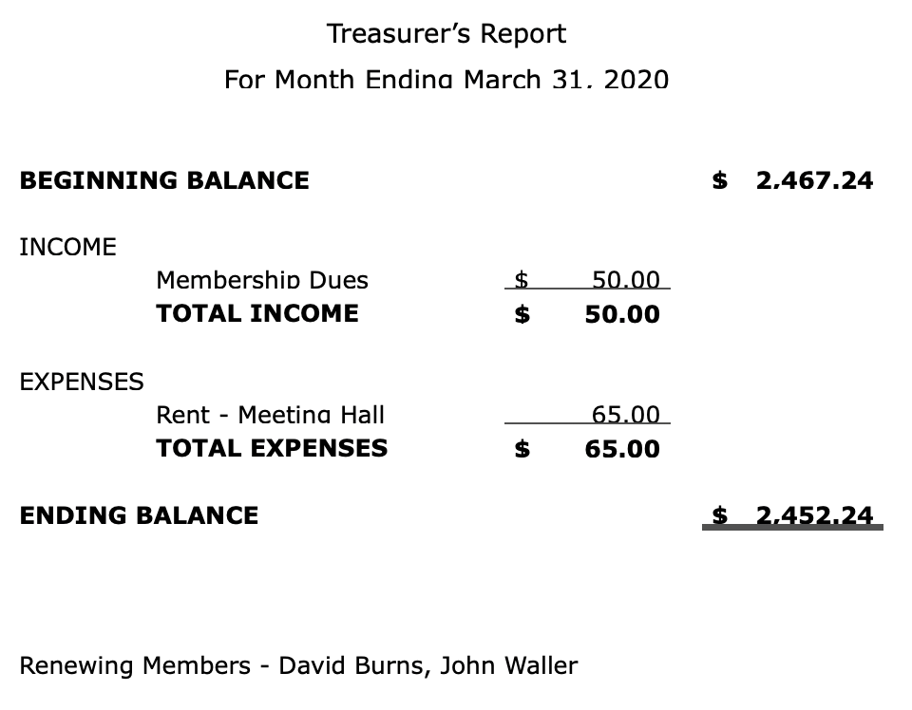

**Kaye Raul**

**Photo Group Report** *by Ralph Sutter***Notes from the Meeting of 04/19/20**    
**TOPIC**: **Reflections**; Where water meets the sky  
**NOTE** Due to concerns over the **COVID-19 Virus**, the Photo Group did not meet in March.

Here are my notes from the April meeting.

**Ralph Sutter** opened the meeting by calling attention to two new resources on the Photography web site, [www.slobytes.org/digital](http://www.slobytes.org/digital).

They were

[Change the order in which Irfanview displays Images](https://www.fullbean.com/tutorials/irfanview-display-order.html)

and

[4K Downloader Slideshow Maker](https://dl.4kdownload.com/app/4kslideshowmaker_1.8.1_x64.msi?source=website)

Ralph then showed still and video images of water and images reflected in water.

**John Waller** followed with reflections on Yosemite lakes and Disneyland water rides

**Kaye Raul** offered seascapes of Morro Bay and Avila

**Alan Raul** chose reflections from Waller Park, Santa Maria , circular rainbows and local waterfronts

View them at <https://alan10f6.myportfolio.com/>   
**Bob Styerwalt** caught reflections in windows and in puddles around his home.  
**Linda Styerwalt** ventured farther afield with shots taken in Cambria, Carmel and Alaska  
**Barry Dorfman** showed stunning images of snow and water in Yosemite  
**Connie Sutter** opted for dramatic cloud formations as seen from home in Arroyo Grande  
**Stanford Brown** travelled to Amsterdam and Budapest for his reflections.

**NEXT MEETING**: Sunday, May 17th, 2020@ 2:00 pm   
This is one week later than usual due to Mothers’ Day  
**TOPIC**: Still-life Photography - subjects could include household items like plants, bottles, vases and items in your garage. Let your creative skills come to the surface with unique lighting, composition and digital manipulation. The meeting will take place via **Zoom**  
  
A Zoom invitation will be e-mailed to Photo Group members shortly before the meeting.  
The meeting schedule for the remainder of 2020 is as follows    
  June 14th  
   July 12th  
   August 9th  
   September 13th  
   October 11th  
   November 8th  
   December 13th

**Ralph Sutter**

**Push Library**  
Look at the **PUSH archives**, <http://www.slobytes.org/push/>. This is a repository of articles where you will find tips, product reviews, and personal recommendations contributed by computer clubs across the country.  
They are provided courtesy of the Association of Computer User Groups, **APCUG**, the national organization with which SLO Bytes is affiliated.   
  
The actual **PUSH** articles are hyperlinked from the index located at  
 <http://www.slobytes.org/push/index.html> (All articles on one long page)  
 <http://www.slobytes.org/push/push-condensed.html> (Links to **PUSH** articles by month received)  
You can view additional APCUG publications here: <http://www.slobytes.org/apcug/index.html>

**▫▫▫▫▫▫▫▫▫▫▫▫▫▫▫▫▫▫▫▫▫▫▫**

**SLO Bytes Bulletin Board**  
Everyone can read the SLO Bytes Bulletin Board at <http://slobytes.org/smf/index.php?board=1.0> but only subscribers can post comments or respond to the posts of others. Despite the usual connotation of **subscribe**, it costs nothing to join the   
  
bulletin board. It is free to all current SLO Bytes members. However, to guard against cyber-mischief by spammers and   
other ne’er-do-wells, I have disabled self-registration. If you want to be added to the bulletin board, please send your request to me at [ralph@rsutter.com](mailto:ralph@rsutter.com).

If you are currently registered with the SLO Bytes Bulletin Board and wish to change your password, you will find a video screen capture of how to do so at <http://www.slobytes.org/documents/change-bb-password.mp4>

**▫▫▫▫▫▫▫▫▫▫▫▫▫▫▫▫▫▫▫▫▫▫▫**

**Club Information and Meeting Times**

**SLO** **Bytes**, a PC Users Group dedicated to educating its members in the use of personal computers, digital devices and software, meets on the first Sunday of each month at the **San Luis Obispo Guild** **Hall** at 2880 Broad Street, San Luis Obispo. There is a map available at <http://www.slobytes.org/slo-guild-map.html>.

All meetings are open to the public at no cost. A general interest and Q&A session occurs from 12:45 PM to 2:00 PM and guest speaker presentations begin at 2:30 PM. Contact **John** **Waller** (johnlwaller at sbcglobal.net) or visit [slobytes.org](http://www.slobytes.org/index.php) for additional information about SLO Bytes and the scheduled presentation. All ideas for speakers or presentation subjects are welcome.  
 **HardCopy** is a monthly publication of **SLO Bytes PC Users' Group** located in San Luis Obispo, California. Information in this newsletter is derived from both our own membership and other PC user group newsletters.

The purpose of this publication is to inform our members of meetings and provide information related to the use of PCs and various operating systems.  
  
Membership dues are $25 per year. Membership entitles you to our monthly newsletter via e-mail, technical assistance, eligibility for raffle gifts when drawings are held, a voice in the affairs of the club, and comradeship.

***Outside Special Interest Groups (SIGs)*  
Linux SIG** normally meets at 6:30 PM on the Thursday following our Sunday's General Meeting at the KCBX.NET Training Center, 4100 Vachell Lane, San Luis Obispo. View the web site at [www.slolug.com](http://www.slolug.com).   
**Photography SIG** normally meets at 2:00 PM on the second Sunday of each month at Connie and Ralph Sutter’s home in Arroyo Grande. Call Ralph at 805 478-0826 for directions. Visit the website at [www.slobytes.org/digital](http://www.slobytes.org/digital)

***▫▫▫▫▫▫▫▫▫▫▫▫▫▫▫▫▫▫▫▫▫▫▫***

***SLO Bytes Officers/Volunteers***

**Officers**Earl Kaplan – President: [earlkaplan@gmail.com](mailto:earlkaplan@gmail.com)   
John Waller - Vice President; Programs Chair/Publicity: [johnlwaller@sbcglobal.net](mailto:johnlwaller@sbcglobal.net)   
Kaye Raul – Treasurer; Membership: [kaye@kayeraul.com](mailto:kaye@kayeraul.com)   
Ralph Sutter – Secretary, Webmaster/HardCopy Editor, Photo SIG Leader: [ralph@rsutter.com](mailto:ralph@rsutter.com)   
Alan Raul – Training Officer/Linux Group Leader: [alan@alanraul.com](mailto:alan@alanraul.com)   
 **Other** **Volunteers**  
Nancy Vrooman – Refreshments  
Peter Stonehewer – Refreshments  
Ken Stilts – Set-up/Clean-up

**Disclaimer**: Neither SLO Bytes PC Users' Group, its officers, editors, or contributors to this newsletter assume liability for damages arising out of this publication of any article, including but not limited to the listing of programming code, batch   
files and other helpful hints. Articles from this newsletter may be reprinted by other user groups if credit is given to both   
  
the author and newsletter from which it was taken. Reproduction of articles with a specific copyright notice is prohibited without prior permission from the original author.

**SLO Bytes Website**: [slobytes.org](http://www.slobytes.org/index.html)