**SLO Bytes HardCopy  
A publication of the San Luis Obispo PC Users’ Group  
Vol. 36 No. 4 April 2020**

**March 1st, 2020 First Session Notes** *by Alan Raul*

**Autoruns for Windows 13.96** is a utility, which has the most comprehensive knowledge of auto-starting locations of any startup monitor, shows you what programs are configured to run during system bootup or login, and when you start various built-in Windows applications like Edge, Explorer and media players.  
<https://docs.microsoft.com/en-us/sysinternals/downloads/autoruns>  
  
**NirSoft Wireless Network Watcher 2.21**is a small utility that scans your wireless network and displays the list of all computers and devices that are currently connected to your network.  
<http://www.nirsoft.net/utils/wireless_network_watcher.html>  
  
**Synergy** is a software download that shares one mouse and one keyboard between multiple computers. Simply move your mouse between your computers effortlessly. You can even copy and paste between computers. Synergy works on Windows, macOS, Linux, and Raspberry Pi. You only need a regular Ethernet or Wi-Fi network connection, and no special hardware. It works like magic.  
<https://symless.com/synergy>  
  
**How to Clear All Cache in Windows 10**  
<https://www.youtube.com/watch?v=z3cjTqCQemU>  
  
**Clear browser cache for all web browsers**  
C:\Windows\SoftwareDistribution\Download  
C:\Users\alan\AppData\Local\Temp (replace alan with your username)  
C:\Windows\Temp  
C:\Windows\Prefetch  
Run wsreset.exe  
Settings > Privacy > Location > Clear location history on this device  
Windows PowerShell (Administrator) Type ipconfig /flushdns  
Create a Restore Point > Configure > Delete all restore points for this drive > Create a restore point  
Start > Disk Cleanup > Clean up system files > More Options > System Restore and Shadow Copies  
Go back to the Disk Cleanup tab and select OK  
  
**How to Stop Receiving Junk Mail**  
<https://www.youtube.com/watch?v=aItyGCibbTE>  
  
<https://www.optoutprescreen.com/>  
<https://dmachoice.org/>  
<https://www.valpak.com/>  
<https://www.retailmenot.com/everyday/unsubscribe> Additional link not in the video.  
**NOT AT THIS ADDRESS**  
Make sure and cover up the bar code of the mail you are sending back or it will be sent back to you.  
  
**How Much Are We Paying for Our Subscription Services?** A Lot  
In 2019, we each spent $640 on digital subscriptions like streaming video and music services, cloud storage, dating apps and online productivity tools, according to an analysis for The New York Times by Mint, the online-budgeting tool owned by Intuit, using data from millions of its users.  
<https://www.seattletimes.com/business/technology/how-much-are-we-paying-for-our-subscription-services-a-lot/>  
  
**Subscriptions Manager for Excel 2007-2016** is a way to list and manage the many online plans we sign up for; HBO, Netflix, Amazon, Spotify and so many more.  
<https://office-watch.com/2020/subscriptions-manager-for-excel-2007-2016/>  
<https://office-watch.com/2020/starting-with-the-excel-subscriptions-manager/>  
<https://office-watch.com/2020/more-about-the-excel-subscriptions-manager/>  
  
**How To Make Windows 10 Fix Itself No Special Software Needed**  
<https://www.youtube.com/watch?v=52my2TVfVEM>  
***Alan Raul***

**▫▫▫▫▫▫▫▫▫▫▫▫▫▫▫▫▫▫▫▫▫▫▫**

**April 5th,2020 Programming Schedule** *by Ralph Sutter*Due to the **COVID-19 Virus Epidemic**, the SLO Bytes General Meeting scheduled for **04/05/2020** will not be held as an in-person event.   
Instead, we will conduct the meeting via the free version of **Zoom**, the program that the club has used previously for the presentations of Gene Barlow and Bob Gostischa (Avast).   
Members will be e-mailed an invitation to join a Zoom session several days before the actual event.   
Clicking on the link in the invitation will install Zoom in memory and give directions for joining the SLO Bytes General Session.   
View Zoom tutorials at <https://www.youtube.com/playlist?list=PLKpRxBfeD1kEM_I1lId3N_Xl77fKDzSXe>

If you have any questions, please contact Ralph Sutter at [ralph@rsutter.com](mailto:ralph@rsutter.com)

**Ralph Sutter**

**Treasurers’ Report** *by Kaye Raul*

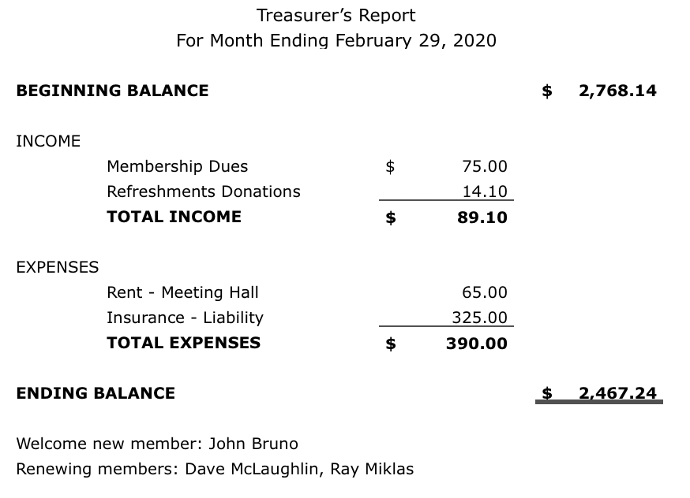

**Kaye Raul**

**▫▫▫▫▫▫▫▫▫▫▫▫▫▫▫▫▫▫▫▫▫▫▫**

**Photo Group Report** *by Ralph Sutter***Notes from the Meeting of 03/15/20**    
**TOPIC**: **Reflections**; Where water meets the sky  
**NOTE** Due to concerns over the **COVID-19 Virus**, this scheduled meeting did not take place.  
It has been rescheduled for **April 19, 2020**, one week later than usual since Easter falls on 04/12/20.  
 **NEXT MEETING**: Sunday, April 19th, 2020@ 2:00 pm  
**TOPIC**: The topic for our next meeting is **Reflections**; Where water meets the sky  
The meeting will take place via **Zoom**  
  
A Zoom invitation will be e-mailed to Photo Group members shortly before the meeting.  
The next several meetings have been moved back one week due to intervening schedules/holidays  
The meeting schedule for the remainder of 2020 is as follows  
   May 17th  
   June 14th  
   July 12th  
   August 9th  
   September 13th  
   October 11th  
   November 8th  
   December 13th  
**Ralph Sutter**

**Push Library**  
Look at the **PUSH archives**, <http://www.slobytes.org/push/>. This is a repository of articles where you will find tips, product reviews, and personal recommendations contributed by computer clubs across the country.

They are provided courtesy of the Association of Computer User Groups, **APCUG**, the national organization with which SLO Bytes is affiliated.   
  
The actual **PUSH** articles are hyperlinked from the index located at

<http://www.slobytes.org/push/index.html> (All articles on one long page)

<http://www.slobytes.org/push/push-condensed.html> (Links to **PUSH** articles by month received)  
You can view additional APCUG publications here: <http://www.slobytes.org/apcug/index.html>

**▫▫▫▫▫▫▫▫▫▫▫▫▫▫▫▫▫▫▫▫▫▫▫**

**SLO Bytes Bulletin Board**  
Everyone can read the SLO Bytes Bulletin Board at <http://slobytes.org/smf/index.php?board=1.0> but only subscribers can post comments or respond to the posts of others. Despite the usual connotation of **subscribe**, it costs nothing to join the   
  
bulletin board. It is free to all current SLO Bytes members. However, to guard against cyber-mischief by spammers and   
other ne’er-do-wells, I have disabled self-registration. If you want to be added to the bulletin board, please send your request to me at [ralph@rsutter.com](mailto:ralph@rsutter.com).

If you are currently registered with the SLO Bytes Bulletin Board and wish to change your password, you will find a video screen capture of how to do so at <http://www.slobytes.org/documents/change-bb-password.mp4>

**Club Information and Meeting Times**

**SLO** **Bytes**, a PC Users Group dedicated to educating its members in the use of personal computers, digital devices and software, meets on the first Sunday of each month at the **San Luis Obispo Guild** **Hall** at 2880 Broad Street, San Luis Obispo. There is a map available at <http://www.slobytes.org/slo-guild-map.html>.

All meetings are open to the public at no cost. A general interest and Q&A session occurs from 12:45 PM to 2:00 PM and guest speaker presentations begin at 2:30 PM. Contact **John** **Waller** (johnlwaller at sbcglobal.net) or visit [slobytes.org](http://www.slobytes.org/index.php) for additional information about SLO Bytes and the scheduled presentation. All ideas for speakers or presentation subjects are welcome.  
 **HardCopy** is a monthly publication of **SLO Bytes PC Users' Group** located in San Luis Obispo, California. Information in this newsletter is derived from both our own membership and other PC user group newsletters.

The purpose of this publication is to inform our members of meetings and provide information related to the use of PCs and various operating systems.  
  
Membership dues are $25 per year. Membership entitles you to our monthly newsletter via e-mail, technical assistance, eligibility for raffle gifts when drawings are held, a voice in the affairs of the club, and comradeship.

***Outside Special Interest Groups (SIGs)*  
Linux SIG** normally meets at 6:30 PM on the Thursday following our Sunday's General Meeting at the KCBX.NET Training Center, 4100 Vachell Lane, San Luis Obispo. View the web site at [www.slolug.com](http://www.slolug.com).  **Photography SIG** normally meets at 2:00 PM on the second Sunday of each month at Connie and Ralph Sutter’s home in Arroyo Grande. Call Ralph at 805 478-0826 for directions. Visit the website at [www.slobytes.org/digital](http://www.slobytes.org/digital)

***▫▫▫▫▫▫▫▫▫▫▫▫▫▫▫▫▫▫▫▫▫▫▫***

***SLO Bytes Officers/Volunteers***

**Officers**Earl Kaplan – President: [earlkaplan@gmail.com](mailto:earlkaplan@gmail.com)   
John Waller - Vice President; Programs Chair/Publicity: [johnlwaller@sbcglobal.net](mailto:johnlwaller@sbcglobal.net)   
Kaye Raul – Treasurer; Membership: [kaye@kayeraul.com](mailto:kaye@kayeraul.com)   
Ralph Sutter – Secretary, Webmaster/HardCopy Editor, Photo SIG Leader: [ralph@rsutter.com](mailto:ralph@rsutter.com)   
Alan Raul – Training Officer/Linux Group Leader: [alan@alanraul.com](mailto:alan@alanraul.com)   
 **Other** **Volunteers**  
Nancy Vrooman – Refreshments  
Peter Stonehewer – Refreshments  
Ken Stilts – Set-up/Clean-up

**Disclaimer**: Neither SLO Bytes PC Users' Group, its officers, editors, or contributors to this newsletter assume liability for damages arising out of this publication of any article, including but not limited to the listing of programming code, batch   
files and other helpful hints. Articles from this newsletter may be reprinted by other user groups if credit is given to both   
  
the author and newsletter from which it was taken. Reproduction of articles with a specific copyright notice is prohibited without prior permission from the original author.

**SLO Bytes Website**: [slobytes.org](http://www.slobytes.org/index.html)