**SLO Bytes HardCopy  
A publication of the San Luis Obispo PC Users’ Group  
Vol. 36 No. 3 March 2020**

**February 2nd, 2020 First Session Notes** *by Alan Raul*

**Leaked Documents Expose the Secretive Market for Your Web Browsing Data**  
<https://www.vice.com/en_us/article/qjdkq7/avast-antivirus-sells-user-browsing-data-investigation>  
  
**The Cost of Avast's Free Antivirus: Companies Can Spy on Your Clicks**  
<https://www.pcmag.com/news/the-cost-of-avasts-free-antivirus-companies-can-spy-on-your-clicks>  
  
**Stay in control of your Microsoft privacy**  
<https://account.microsoft.com/account/privacy>  
  
**Use Snip & Sketch to take a screenshot in Windows 10**  
<https://community.windows.com/en-us/videos/use-snip-sketch-to-take-a-screenshot-in-windows-10/T1p2kgd-Rsc>  
  
**Welcome to Microsoft Tips**  
<https://www.microsoft.com/en-us/tips/home>   
  
**Chromium-Based Microsoft Edge Browser Released**  
<https://www.microsoft.com/en-us/edge>  
  
**Welcome to the new Microsoft Edge**  
<https://microsoftedgewelcome.microsoft.com/en-us/>  
  
**Send Microsoft feedback about the new Edge browser**  
In Edge, press ***Alt + Shift + i*** to bring up the “Send feedback” dialog.  
  
**Microsoft Edge Forum**  
<https://answers.microsoft.com/en-us/microsoftedge/forum>  
  
**How to back up your Favorites in Chromium Edge**  
Type "***edge://version***" into the address bar and look at "***Profile path***:". This will tell you where your settings are stored. Backup the file called "Bookmarks".  
The cleaner easier way…  Type " ***edge://favorites***" into the address bar and look at the bottom left side and select “***Export favorites***” and follow the prompts.  
  
**WARNING: EXPERIMENTAL FEATURES AHEAD!** By enabling these features, you could lose browser data or compromise your security or privacy. Enabled features apply to all users of this browser.  
Type "***edge://flags***" into the address bar.  
  
**Hidden configuration pages offer additional settings for Edge, Chrome, Firefox browsers**  
<https://www.thewindowsclub.com/about-chrome-flags-config-edge-firefox>  
   
**New Edge Browser (Chromium) Tips and Tricks for Windows 10**  
<https://www.thewindowsclub.com/edge-browser-chromium-tips-and-tricks>  
***Alan Raul***

**February 2nd, 2020 Second Session Notes** *by Alan Raul*

**NAS (Network Attached Storage) Notes**

Synology is a company that specializes in Network Attached Storage (NAS) appliances. A NAS is an intelligent storage device connected to your home or office network. You can store all your family and colleagues’ files on the NAS, from important documents to precious photos, music and video collections. By using a web browser or mobile apps, you can access files and use various services provided by the NAS via the Internet.  
<https://www.synology.com/en-us>

Synology DiskStation DS218+ - All-around storage solution optimized to safeguard your data and more.  
<https://www.synology.com/en-us/products/DS218>+

Synology DiskStation Manager (DSM) is an intuitive web-based operating system for every Synology NAS, designed to help you manage your digital assets across home and office.  
<https://www.synology.com/en-us/dsm>

Synology Add-On Packages are available to expand the value and functionality of your Synology NAS. You will be able to download and install the packages designed specifically for your unique needs, whether it's sharing files on the cloud, sharing photos on an online album, setting up a VPN environment or even an antivirus to protect your system. Everything can be found and done in Package Center, with just a few clicks.  
<https://www.synology.com/en-us/dsm/packages>

Synology DiskStation Manager Tutorials & FAQ’s  
<https://www.synology.com/en-us/knowledgebase/DSM/tutorial>

Synology DiskStation Manager Video Tutorials  
<https://www.synology.com/en-us/knowledgebase/DSM/video>

Synology DiskStation Manager Help Articles  
<https://www.synology.com/en-us/knowledgebase/DSM/help>

Helpful YouTube Videos:

Synology  
<https://www.youtube.com/user/synologyinc/videos>

Getting Started With Synology  
<https://www.youtube.com/watch?v=ABw3qHsi2sg>

Robust Photography Backups on a Budget  
<https://www.youtube.com/watch?v=80kgljZiUQU>

Willie Howe  
<https://www.youtube.com/results?search_query=willie+howe+synology>

Mydoodads  
<https://www.youtube.com/user/mydoodads/videos>

NASCompares  
<https://www.youtube.com/channel/UCFyP17HoU-vpxhIpGXnXx2g/>

RickMakes  
<https://www.youtube.com/watch?v=UmxNC-KD0Qc&list=PLErU2HjQZ_ZPL8Yx7FxnY6xKxcMiVWkkJ>

SPANdotCOM  
<https://www.youtube.com/user/SPANdotCOM/videos>

KNOW HOW... 380 SYNOLOGY MADNESS - PART I  
<https://www.twit.tv/shows/know-how/episodes/380>

KNOW HOW... 382 SYNOLOGY MADNESS - PART 2  
<https://www.twit.tv/shows/know-how/episodes/382>

KNOW HOW... 384 SYNOLOGY MADNESS - PART 3  
<https://www.twit.tv/shows/know-how/episodes/384>

KNOW HOW... 386 SYNOLOGY MADNESS - PART 4  
<https://www.twit.tv/shows/know-how/episodes/386>

ORICO Tool free USB 3.0 to SATA External 3.5 Hard Drive Enclosure  
<https://www.amazon.com/ORICO-Toolfree-External-Enclosure-Support/dp/B00GAML7OK>

2BrightSparks SyncBackPro, SyncBackSE and SyncBackFree – is the best backup software for a Windows PC: powerful, easy to use solution for backing up and synchronizing files on local/network drive, cloud, FTP server and more.  
<https://www.2brightsparks.com/>   
<https://www.2brightsparks.com/freeware/index.html>   
  
**Alan Raul**

**▫▫▫▫▫▫▫▫▫▫▫▫▫▫▫▫▫▫▫▫▫▫▫**

**March 1st,2020 Programming Schedule** *by John Waller*

In the **First Session**, **Alan Raul** will offer a Questions and Answers program from 12:45-2:00 p.m. Usual topics include security issues, recent changes in Windows operating systems, tablets and smart phones as well as demos of software and hardware. We always encourage questions and observations from the audience.  
  
There will be a break from 2:00-230pm, offering coffee, light snacks and an opportunity to talk with other members of the group.   
  
  
 **During the second session, John Waller will be giving a demonstration of “Muvee Encore” as a possible replacement for ProShow. He will discuss ProShow and any other options he may find for it.**

**John Waller**

***▫▫▫▫▫▫▫▫▫▫▫▫▫▫▫▫▫▫▫▫▫▫▫***

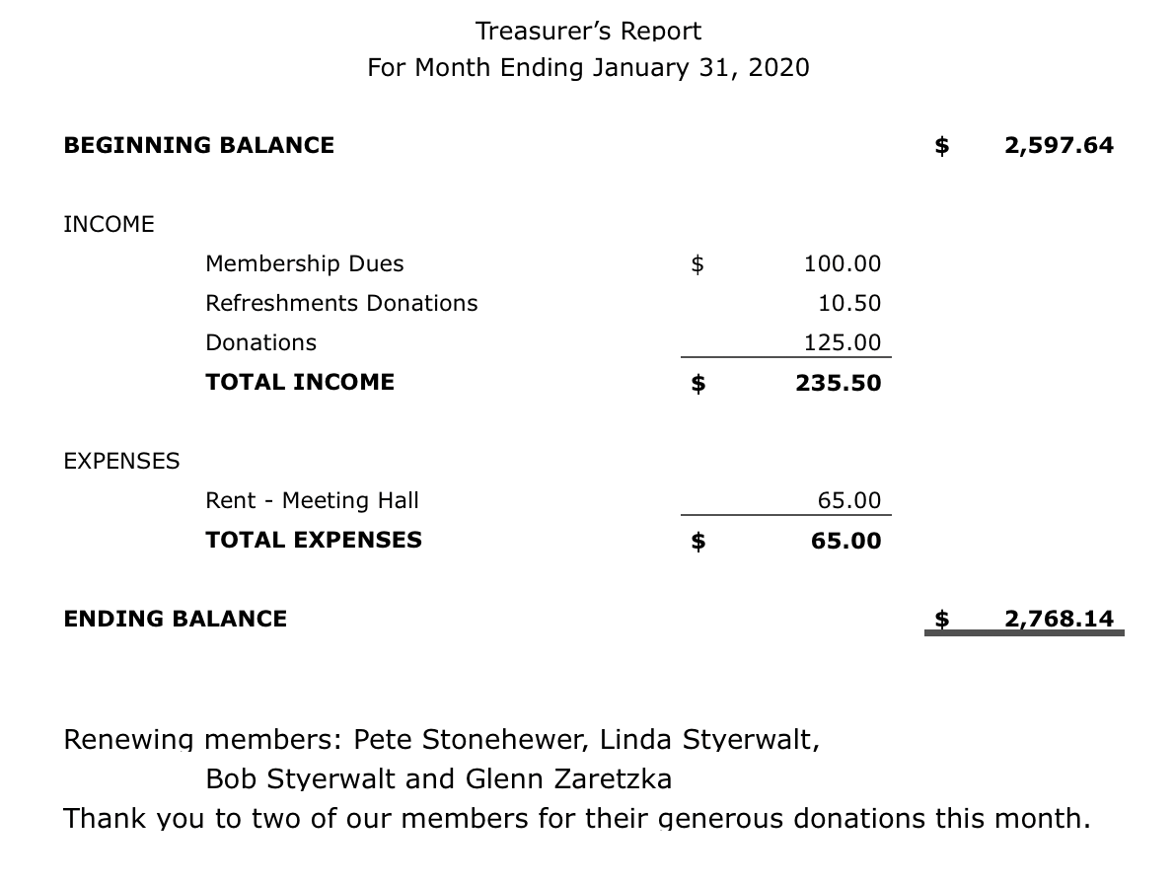

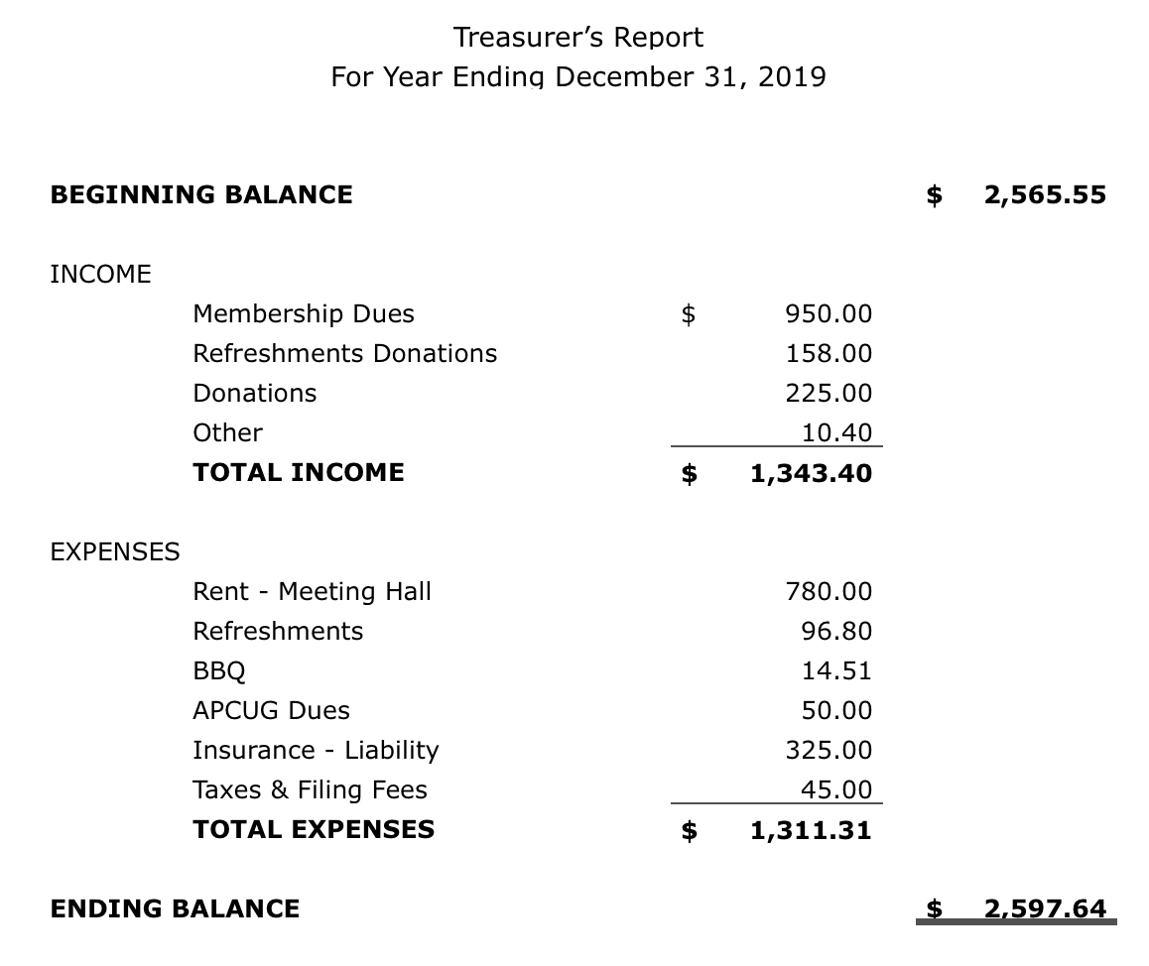

**Kaye Raul**

**▫▫▫▫▫▫▫▫▫▫▫▫▫▫▫▫▫▫▫▫▫▫▫**

**Photo Group Report** *by Ralph Sutter***Meeting of 02/23/2020**   
**TOPIC**: Photo Editing Software; Please share images that you modified using your favorite image manipulation software.

**The next three meetings have been moved back one week due to intervening schedules/holidays**

**Connie Sutter opened the session with many spectacular images of sunsets.**

**Ralph Sutter followed showing photos of water activities enhanced with various tools in the Skylum Luminar editing program.**

**Alan Raul showed how he managed his photo editing work flow and then shared black and white/color images for startling effect.**

**John Waller demonstrated sophisticated use of RGB filters, layer replacement and superimposed text both restoring damaged old photographs and improving new ones.**

**Kaye Raul offered a movie all in black and white showcasing natural landscapes and iconic scenes of familiar locations.**

**Bob Styerwalt cropped photographs of family and used careful editing to showcase his newly adopted dog.**

**NEXT MEETING: Sunday, March 15th, 2020@ 2:00 pm;**

**LOCATION:   
Home of Connie and Ralph Sutter**

**498 Hansen Hill Road**

**Arroyo Grande, CA**

**The topic for our next meeting is Reflections;** Where water meets the sky

**The meeting schedule for the remainder of 2020 is as follows**

**March 15th**

**April 19th**

**May 17th**

**June 14th**

**July 12th**

**August 9th**

**September 13th**

**October 11th**

**November 8th**

**December 13th**

**Map at** [www.slobytes.org/digital/sutter-map.html](http://www.slobytes.org/digital/sutter-map.html)

**Dashcam video at** [www.slobytes.org/digital/images/dashcam-to-photo-group.mp4](http://www.slobytes.org/digital/images/dashcam-to-photo-group.mp4)

***Ralph Sutter***

**▫▫▫▫▫▫▫▫▫▫▫▫▫▫▫▫▫▫▫▫▫▫▫**

**Push Library**  
Look at the **PUSH archives**, <http://www.slobytes.org/push/>. This is a repository of articles where you will find tips, product reviews, and personal recommendations contributed by computer clubs across the country.

They are provided courtesy of the Association of Computer User Groups, **APCUG**, the national organization with which SLO Bytes is affiliated.   
  
The actual **PUSH** articles are hyperlinked from the index located at

<http://www.slobytes.org/push/index.html> (All articles on one long page)

<http://www.slobytes.org/push/push-condensed.html> (Links to **PUSH** articles by month received)  
You can view additional APCUG publications here: <http://www.slobytes.org/apcug/index.html>

**▫▫▫▫▫▫▫▫▫▫▫▫▫▫▫▫▫▫▫▫▫▫▫**

**SLO Bytes Bulletin Board**  
Everyone can read the SLO Bytes Bulletin Board at <http://slobytes.org/smf/index.php?board=1.0> but only subscribers can post comments or respond to the posts of others. Despite the usual connotation of **subscribe**, it costs nothing to join the   
  
bulletin board. It is free to all current SLO Bytes members. However, to guard against cyber-mischief by spammers and   
other ne’er-do-wells, I have disabled self-registration. If you want to be added to the bulletin board, please send your request to me at [ralph@rsutter.com](mailto:ralph@rsutter.com).

If you are currently registered with the SLO Bytes Bulletin Board and wish to change your password, you will find a video screen capture of how to do so at <http://www.slobytes.org/documents/change-bb-password.mp4>

**Club Information and Meeting Times**

**SLO** **Bytes**, a PC Users Group dedicated to educating its members in the use of personal computers, digital devices and software, meets on the first Sunday of each month at the **San Luis Obispo Guild** **Hall** at 2880 Broad Street, San Luis Obispo. There is a map available at <http://www.slobytes.org/slo-guild-map.html>.

All meetings are open to the public at no cost. A general interest and Q&A session occurs from 12:45 PM to 2:00 PM and guest speaker presentations begin at 2:30 PM. Contact **John** **Waller** (johnlwaller at sbcglobal.net) or visit [slobytes.org](http://www.slobytes.org/index.php) for additional information about SLO Bytes and the scheduled presentation. All ideas for speakers or presentation subjects are welcome.  
 **HardCopy** is a monthly publication of **SLO Bytes PC Users' Group** located in San Luis Obispo, California. Information in this newsletter is derived from both our own membership and other PC user group newsletters.

The purpose of this publication is to inform our members of meetings and provide information related to the use of PCs and various operating systems.  
  
Membership dues are $25 per year. Membership entitles you to our monthly newsletter via e-mail, technical assistance, eligibility for raffle gifts when drawings are held, a voice in the affairs of the club, and comradeship.

***▫▫▫▫▫▫▫▫▫▫▫▫▫▫▫▫▫▫▫▫▫▫▫***

***Outside Special Interest Groups (SIGs)*  
Linux SIG** normally meets at 6:30 PM on the Thursday following our Sunday's General Meeting at the KCBX.NET Training Center, 4100 Vachell Lane, San Luis Obispo. View the web site at [www.slolug.com](http://www.slolug.com).  **Photography SIG** normally meets at 2:00 PM on the second Sunday of each month at Connie and Ralph Sutter’s home in Arroyo Grande. Call Ralph at 805 478-0826 for directions. Visit the website at [www.slobytes.org/digital](http://www.slobytes.org/digital)

***▫▫▫▫▫▫▫▫▫▫▫▫▫▫▫▫▫▫▫▫▫▫▫***

***SLO Bytes Officers/Volunteers***

**Officers**Earl Kaplan – President: [earlkaplan@gmail.com](mailto:earlkaplan@gmail.com)   
John Waller - Vice President; Programs Chair/Publicity: [johnlwaller@sbcglobal.net](mailto:johnlwaller@sbcglobal.net)   
Kaye Raul – Treasurer; Membership: [kaye@kayeraul.com](mailto:kaye@kayeraul.com)   
Ralph Sutter – Secretary, Webmaster/HardCopy Editor, Photo SIG Leader: [ralph@rsutter.com](mailto:ralph@rsutter.com)   
Alan Raul – Training Officer/Linux Group Leader: [alan@alanraul.com](mailto:alan@alanraul.com)   
 **Other** **Volunteers**  
Nancy Vrooman – Refreshments  
Peter Stonehewer – Refreshments  
Ken Stilts – Set-up/Clean-up

**Disclaimer**: Neither SLO Bytes PC Users' Group, its officers, editors, or contributors to this newsletter assume liability for damages arising out of this publication of any article, including but not limited to the listing of programming code, batch   
files and other helpful hints. Articles from this newsletter may be reprinted by other user groups if credit is given to both   
  
the author and newsletter from which it was taken. Reproduction of articles with a specific copyright notice is prohibited without prior permission from the original author.

**SLO Bytes Website**: [slobytes.org](http://www.slobytes.org/index.html)