SD Card Speed Classification
There are wide discrepancies in memory card transmission speeds depending on the SD memory card manufacturer and brand. Varying speeds make it difficult to determine which card will provide reliable recording of streaming content. Recording video require a constant minimum write speed to ensure a smooth playback. The SD Association defines Speed Class standards indicated by speed symbols to help consumers decide what card will provide the required minimum performance for reliability. There are two kinds of speed indications regarding SD bus generation:

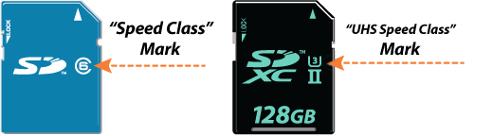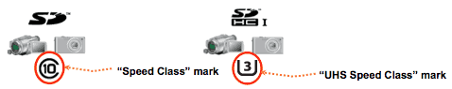

Speed Class and UHS Speed Class* symbols indicate minimum writing performance to ensure smooth writing of streaming content such as video shooting. This is important mainly for camcorders, video recorders and other devices with video recording capabilities.
Speed Class designates minimum writing performance to record video. The Speed Classes defined by the SD Association are Class 2, 4, 6 and 10.
UHS Speed Class is designed for UHS** devices only and designates minimum writing performance to record video on UHS products. The UHS Speed Classes defined by the SD Association are UHS Speed Class 1 (U1) and UHS Speed Class 3 (U3).
* (Speed Class and the UHS Speed Class are not compatible.)
**UHS (Ultra High Speed), the fastest performance category available today, defines bus-interface speeds up to 312 Megabytes per second for greater device performance. It is available on SDXC and SDHC memory cards and devices.

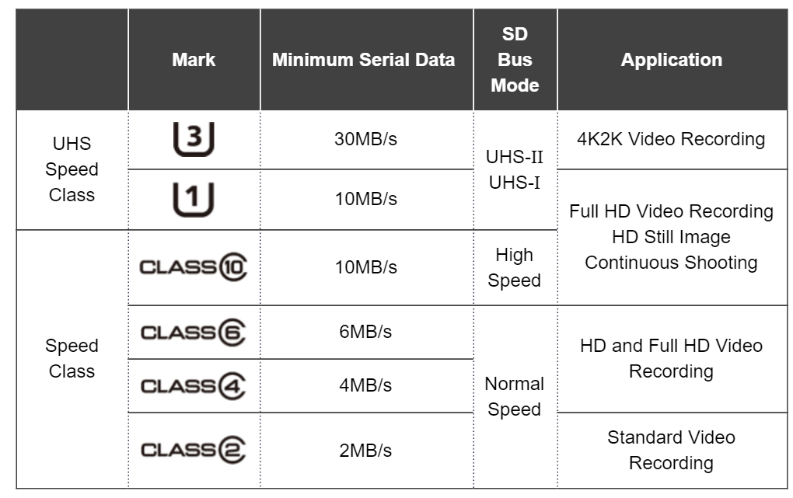
Extracted from https://www.sdcard.org/developers/overview/speed_class/

