**SLO Bytes HardCopy  
A publication of the San Luis Obispo PC Users’ Group  
Vol. 37 No. 8 August 2021**

**July 4th 2021 First Session Notes** *by Alan Raul*

**Windows 11**  
Current Windows 10 users, if compatible, will not be offered Windows 11 until the first half of 2022.  
If you are not compatible, Windows 10 will be supported till 2025, or maybe even longer.  
The screen captures below shows:  
* Using **Microsoft’s PC Health Check app** to see if my old HTPC (Home Theatre PC) meets the requirements to run Windows 11.  
* It shows my old 8th Gen Intel HTPC is Windows 11 compatible.  
* Using **WhyNotWin11** shows it is also compatible with more details.  
* Checking **Windows Device Manager** to see if it shows the TPM (Trusted Platform Module) 2.0 under Security devices.  
* If it does not show you may have to get into your UEFI and enable TPM.  
  
**Introducing Windows 11** - A new Windows experience, bringing you closer to the people and things you love. Scroll down the web page for FAQ's.  
<https://www.microsoft.com/en-us/windows/windows-11>  
  
**Check for compatibility** - Use the PC Health Check app to see if your current PC meets the requirements to run Windows 11. If so, you can get a free upgrade when it rolls out.  
<https://aka.ms/GetPCHealthCheckApp>  
  
**WhyNotWin11** is a better Windows 11 compatibility checker  
<https://betanews.com/2021/06/26/whynotwin11-is-a-better-windows-11-compatibility-checking-tool/>  
  
**Windows 11 Compatibility Confusion** - What You Need To Know  
<https://youtu.be/WUXeUepcw9U>  
  
**Supported Intel Processors**  
<https://docs.microsoft.com/en-us/windows-hardware/design/minimum/supported/windows-11-supported-intel-processors>  
  
**Supported AMD Processors**  
<https://docs.microsoft.com/en-us/windows-hardware/design/minimum/supported/windows-11-supported-amd-processors>  
   
**YouTube Windows 11 search**  
<https://www.youtube.com/results?search_query=microsoft+windows+11>

**Alan Raul**

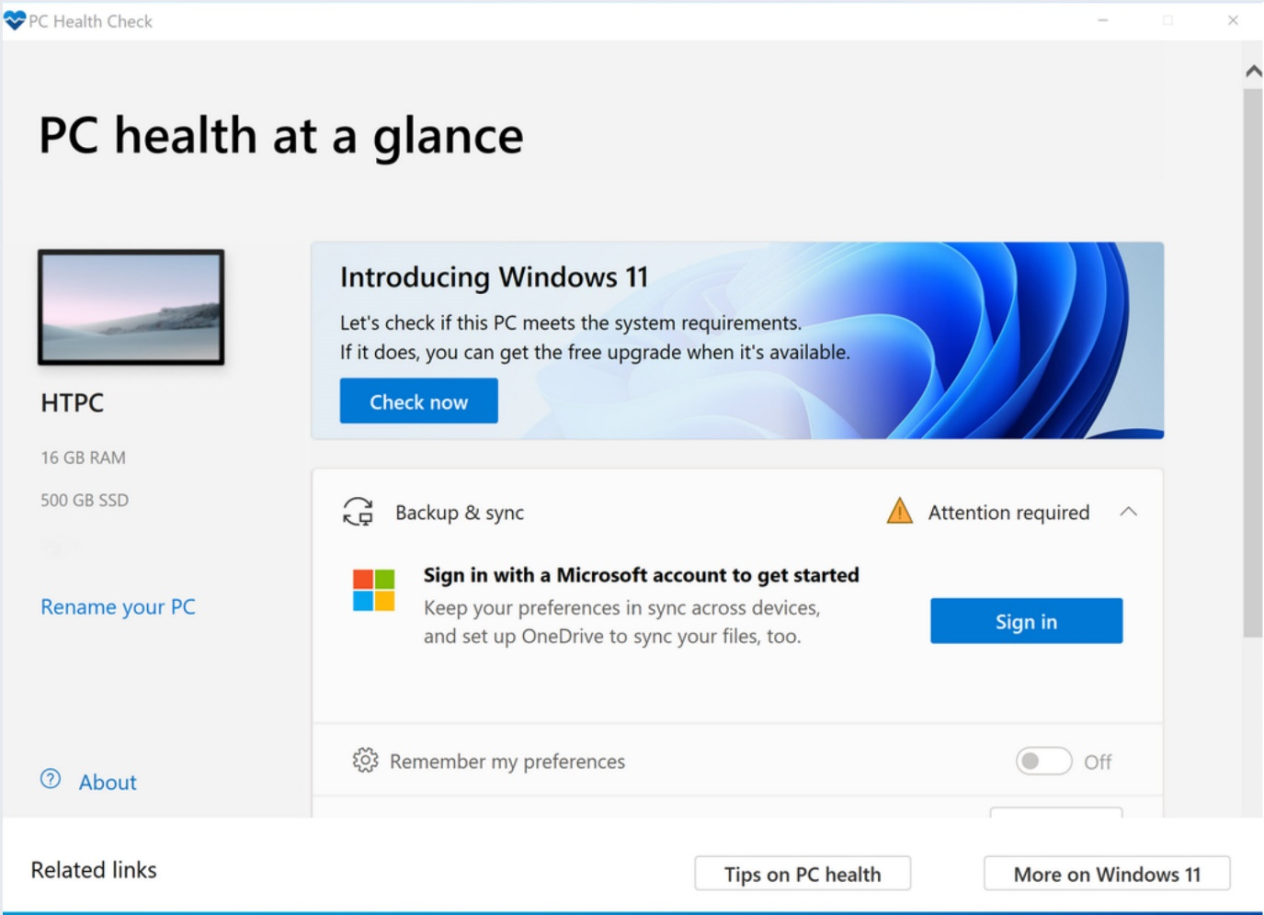

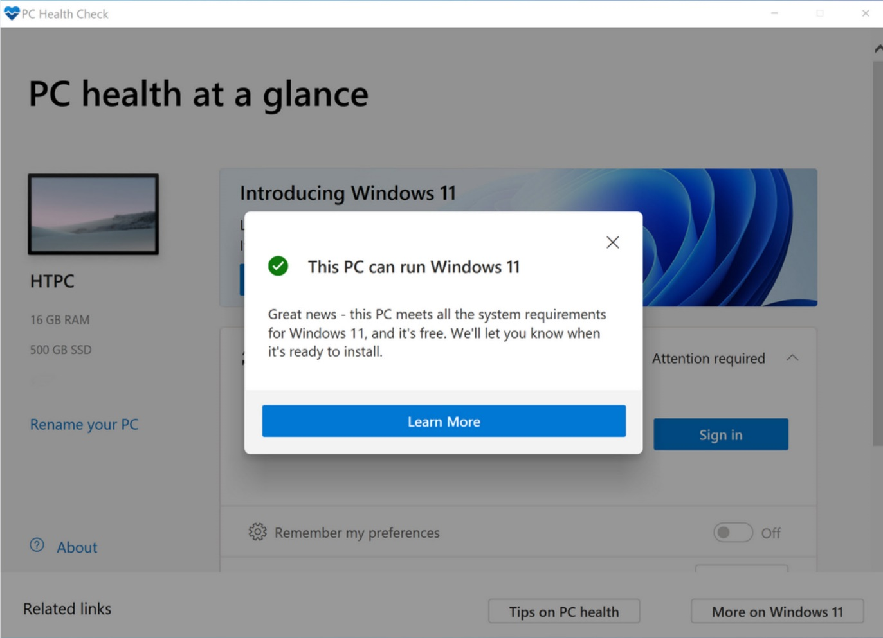

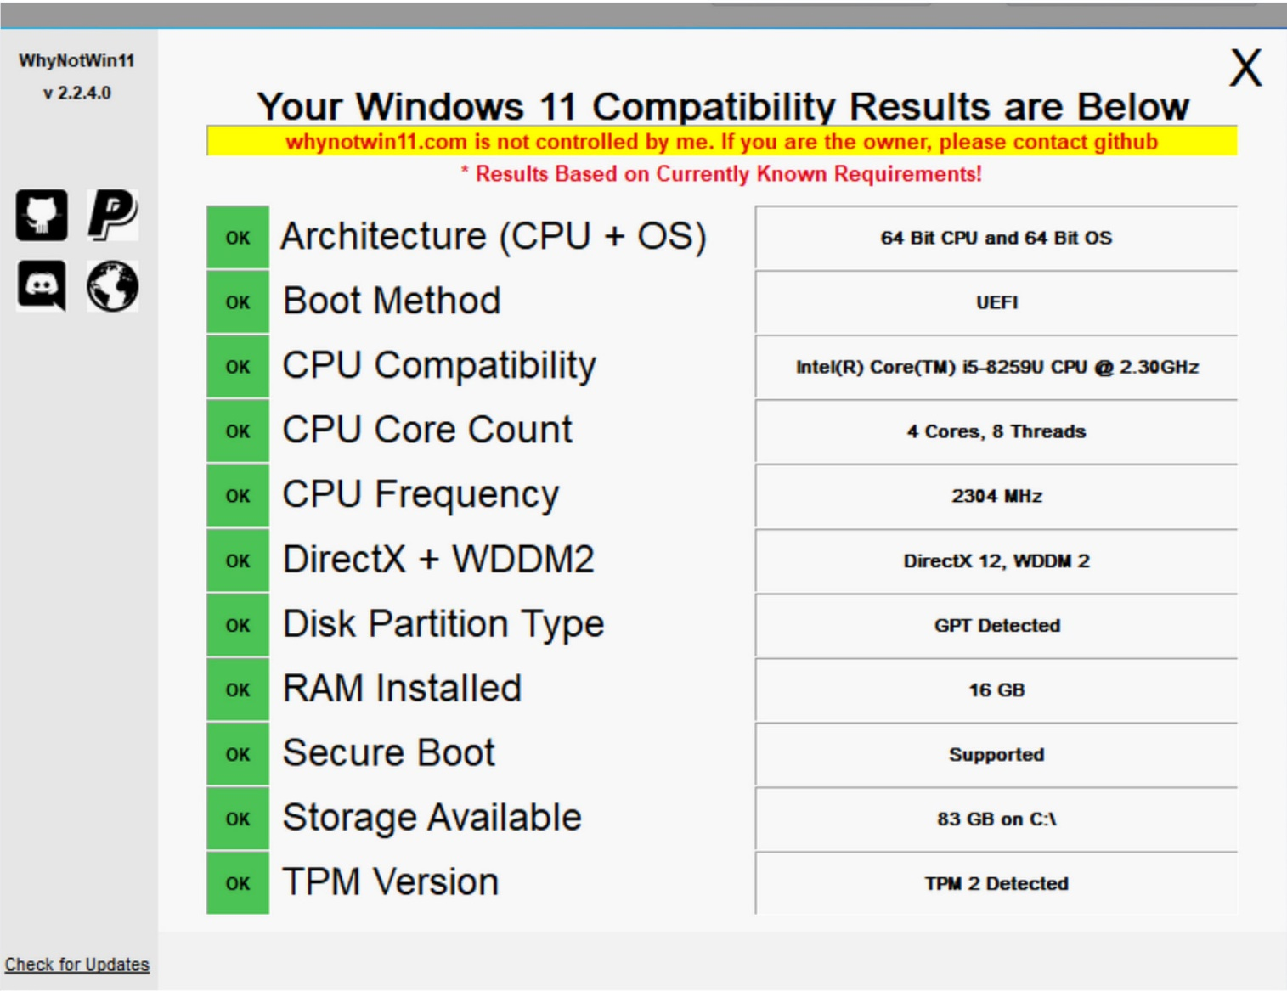

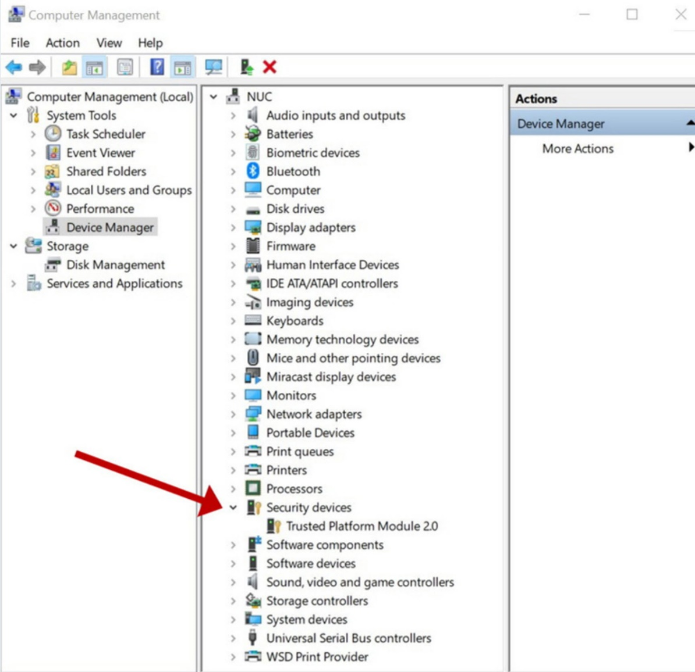

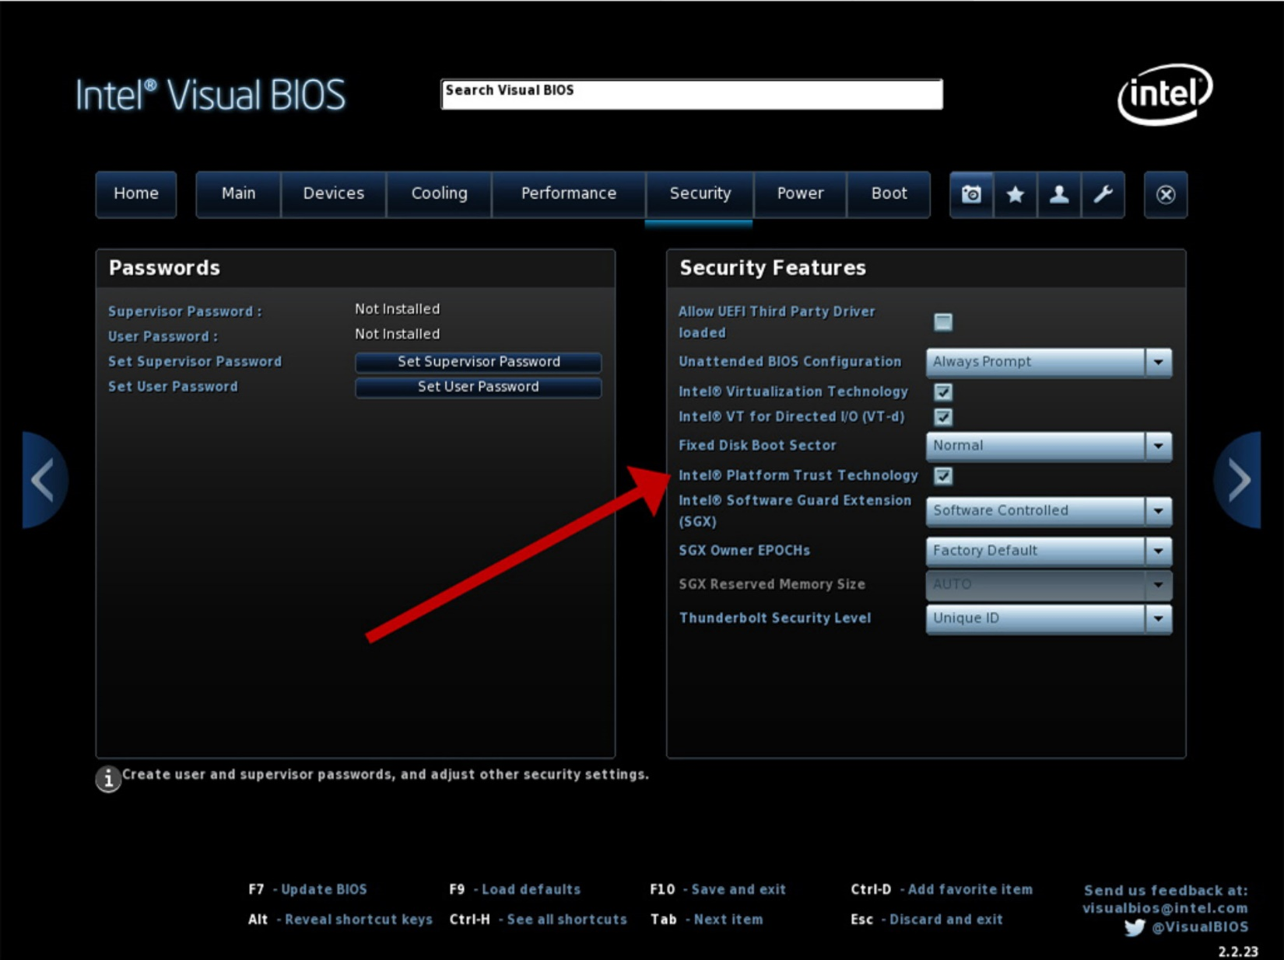

**July 4th, 2021 Program** *by Ralph Sutter*

The **First ZOOM Session** will feature **Alan Raul** offering a Questions and Answers program from 12:45-2:00 p.m.  
Usual topics include security issues, recent changes in Windows operating systems, tablets and smart phones

as well as demos of software and hardware. We always encourage questions and observations from the audience.  
There will be a break from 2:00-2:30 pm allowing the audience to sip a beverage, pet the dog or stretch

To be part of the virtual meeting via **Zoom**, please refer to the e-mail that will be sent to you twice shortly before the meeting with the credentials necessary to join the Zoom session. If you are asked for a **Meeting ID** or a **Password**, copy it from the announcement and paste it into the appropriate box

The **Second Session will continue with the format begun recently. Speakers will be members of the SLO Bytes audience . Afterwards, everyone is invited to pose computer issues that they face and/or solutions to them. We will call this segment Potpourri.**

Contact Ralph at [ralph@rsutter.com](mailto:ralph@rsutter.com) for more information

View Zoom tutorials at <https://www.youtube.com/playlist?list=PLKpRxBfeD1kEM_I1lId3N_Xl77fKDzSXe> If you have any questions, please contact [ralph@rsutter.com](mailto:ralph@rsutter.com)   
  
**Ralph Sutter**

**▫▫▫▫▫▫▫▫▫▫▫▫▫▫▫▫▫▫▫▫▫▫▫**

**Treasury Report by Kaye Raul**

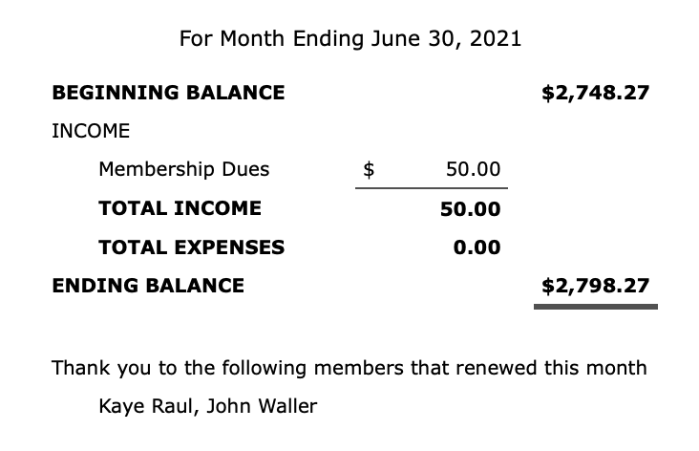

***▫▫▫▫▫▫▫▫▫▫▫▫▫▫▫▫▫▫▫▫▫▫▫***

**Photo Group Report** *by Ralph Sutter*

**TOPIC**: Follow That Creature  The meeting took place via **Zoom**  
  
In the **First Segment**, **John Waller** shared images of dogs from his past.  
  
The **Second Session** opened with **Ralph Sutter** offering a video that featured Andy the Wonderdog cowering in the presence of a snake skin and boldly attacking a Kleenex  
**Kaye Raul** visited the Flamingos at the Atascadero Zoo.  
**Stanford Brown** took us on a walk past Alpacas, friendly Dogs, Deer, Hawks, Cats, Snakes, Mayflies, Eagles, Foxes and Possums  
**John Waller** introduced his dog, as the animal strutted John's house and surrounding property.  
**Bob Styerwalt** showed off his Yorkie, Coco, walking, relaxing and recovering from a bath. The Third Session had us talking about optical character recognition and using Microsoft OneNote to capture text from images.  
  
Our next meeting will take place on **August 8th**  
The topic is **Textures** The meeting will take place via Zoom.  
  
A Zoom invitation will be e-mailed to Photo Group members shortly before the meeting

The meeting schedule for the remainder of 2021 is as follows  
   September 12  
   October 10  
   November 14  
   December 12

See the [Links](https://www.slobytes.org/digital/links.html) page for tutorials and other resources  
  
**Ralph Sutter**

***▫▫▫▫▫▫▫▫▫▫▫▫▫▫▫▫▫▫▫▫▫▫▫***

**Push Library**  
Look at the **PUSH archives**, <http://www.slobytes.org/push/>. This is a repository of articles where you will find tips, product reviews, and personal recommendations contributed by computer clubs across the country.  
They are provided courtesy of the Association of Computer User Groups, **APCUG**, the national organization with which SLO Bytes is affiliated.   
The actual **PUSH** articles are hyperlinked from the index located at  
 <http://www.slobytes.org/push/index.html> (All articles on one long page)  
 <http://www.slobytes.org/push/push-condensed.html> (Links to **PUSH** articles by month received)  
You can view additional APCUG publications here: <http://www.slobytes.org/apcug/index.html>

***▫▫▫▫▫▫▫▫▫▫▫▫▫▫▫▫▫▫▫▫▫▫▫***

**SLO Bytes Bulletin Board**  
Everyone can read the SLO Bytes Bulletin Board at <http://slobytes.org/smf/index.php?board=1.0> but only subscribers can post comments or respond to the posts of others. Despite the usual connotation of **subscribe**, it costs nothing to join the bulletin board. It is free to all current SLO Bytes members. However, to guard against cyber-mischief by spammers and other ne’er-do-wells, I have disabled self-registration. If you want to be added to the bulletin board, please send your request to me at [ralph@rsutter.com](mailto:ralph@rsutter.com).

If you are currently registered with the SLO Bytes Bulletin Board and wish to change your password, you will find a video screen capture of how to do so at   
<http://www.slobytes.org/documents/change-bb-password.mp4>

***▫▫▫▫▫▫▫▫▫▫▫▫▫▫▫▫▫▫▫▫▫▫▫***

**Club Information and Meeting Times**

**SLO** **Bytes**, a PC Users Group dedicated to educating its members in the use of personal computers, digital devices and software, meets on the first Sunday of each month via **Zoom**. Zoom credentials are sent to members twice shortly before each meeting. If you are a SLO Bytes member and don’t receive this e-mail, please contact [ralph@rsutter.com](mailto:ralph@rsutter.com).

All meetings are open to the public at no cost. A general interest and Q&A session occurs from 12:45 PM to 2:00 PM and guest speaker presentations begin at 2:30 PM. Contact **Ralph Sutter** ([ralph@rsutter.com](mailto:ralph@rsutter.com)) or visit [slobytes.org](http://www.slobytes.org/index.php) for additional information about SLO Bytes and the scheduled presentation. All ideas for speakers or presentation subjects are welcome.  
 **HardCopy** is a monthly publication of **SLO Bytes PC Users' Group** located in San Luis Obispo, California. Information in this newsletter is derived from both our own membership and other PC user group newsletters.

The purpose of this publication is to inform our members of meetings and provide information related to the use of PCs and various operating systems.  
Membership dues are $25 per year. Membership entitles you to our monthly newsletter via e-mail, technical assistance comradeship and a voice in the affairs of the club.

***▫▫▫▫▫▫▫▫▫▫▫▫▫▫▫▫▫▫▫▫▫▫▫***

***Outside Special Interest Groups (SIGs)*The Linux Group** normally meets via Zoom at 6:30 PM on the first Thursday of the month.  
View the web site at [www.slolug.com](http://www.slolug.com). Contact [Alan@alanraul.com](mailto:Alan@alanraul.com) for credentials to join the Zoom Session.  
 **The Photography Group** normally meets via Zoom beginning at 1:00 PM on the second Sunday of each month. Contact [ralph@rsutter.com](mailto:ralph@rsutter.com) for credentials to join the Zoom Session.  
Visit the website at [www.slobytes.org/digital](http://www.slobytes.org/digital)

***SLO Bytes Officers/Volunteers*Officers**Earl Kaplan – President: [earlkaplan@gmail.com](mailto:earlkaplan@gmail.com)   
John Waller - Vice President; Programs Chair/Publicity: [johnlwaller@sbcglobal.net](mailto:johnlwaller@sbcglobal.net)   
Kaye Raul – Treasurer; Membership: [kaye@kayeraul.com](mailto:kaye@kayeraul.com)   
Ralph Sutter – Secretary, Webmaster/HardCopy Editor, Photo Group Leader: [ralph@rsutter.com](mailto:ralph@rsutter.com)   
Alan Raul – Training Officer/Linux Group Leader: [alan@alanraul.com](mailto:alan@alanraul.com)

***▫▫▫▫▫▫▫▫▫▫▫▫▫▫▫▫▫▫▫▫▫▫▫***

**Disclaimer**: Neither SLO Bytes PC Users' Group, its officers, editors, or contributors to this newsletter assume liability for damages arising out of this publication of any article, including but not limited to the listing of programming code, batch   
files and other helpful hints. Articles from this newsletter may be reprinted by other user groups if credit is given to both   
  
the author and newsletter from which it was taken. Reproduction of articles with a specific copyright notice is prohibited without prior permission from the original author.

**SLO Bytes Website**: [slobytes.org](http://www.slobytes.org/index.html)