SLO Bytes HardCopy
A publication of the San Luis Obispo PC Users’ Group
Vol. 33 No. 7 July 2017
June 4th 2017 First Session Notes by Alan Raul
3D YouTube Downloader - is a simple yet powerful downloader from YouTube and other popular video sites.
https://yd.3dyd.com/
YouTube Downloader HD - is the fastest free video downloader.
http://www.youtubedownloaderhd.com/
Hammers that I Have Known - a slide show by Ralph Sutter
https://www.youtube.com/watch?v=D61SAsE2Y5g
Atomic Clock Sync - a free configuration utility.
http://www.worldtimeserver.com/atomic-clock/
Pismo Preserve - Starting in June, the Land Conservancy of San Luis Obispo County will hold two “Discovery Days” each month, where people can explore the preserve’s 900 acres unsupervised.
https://lcslo.org/project/pismopreserve/
Pismo Preserve Map
https://www.lcslo.org/pismopreserve/trailmapfs.html
Hikers can soon explore Pismo Preserve on their own — but only on these days.
http://www.sanluisobispo.com/news/local/article153463054.html
All in One – System Rescue Toolkit - The All in One Linux distribution is an Ubuntu-based live disc for performing system rescue, data retrieval and hardware tests. This utility disc is designed to quickly and efficiently aid a technician with troubleshooting and repairing Windows based PC's.
https://paul.is-a-geek.org/aio-srt/
All in One – System Rescue Toolkit 2017-05-26
http://www.majorgeeks.com/files/details/all_in_one_–_system_rescue_toolkit_technician.html
Lenovo Yoga 720 (13")
http://www3.lenovo.com/us/en/laptops/yoga/700-series/Yoga-720-13/p/88YG7000827
https://www.youtube.com/watch?v=84Hh6gj9jnE
ZTE Mobley - Car Wi-Fi Hotspot Device AT&T
https://www.att.com/devices/zte/mobley.html#sku=sku7700323
Alan Raul

June 4th 2017 Second Session Notes by Ralph Sutter
Google Earth Pro and other Google Mapping Products
Google Earth doesn’t show the recent natural calamities on Highway 1.
Pfeiffer Canyon Bridge Big Sur CA Partial collapse on 2/25/17
Mud Creek Landslide 05/120/17 and Mud Creek 2
http://www.sfchronicle.com/bayarea/article/Bridge-failure-severs-Big-Sur-s-ties-to-outside-10958200.php
Google Earth Presentation
Access Google Maps from https://www.maps.google.com (redirects to www.google.com/maps)
Good GM tutorial at https://www.youtube.com/watch?v=XQUaQpoF8xE
Download Google Earth from https://www.google.com/earth/
Download Google Earth Pro from https://www.google.com/earth/download/gep/agree.html
Good GEP tutorial at https://uwaterloo.ca/library/geospatial/sites/ca.library.geospatial/files/uploads/files/google_earth_2016.pdf
In order to use GEP, users will need to enter their email address and the key GEPFREE.
GM is optimized to be used for getting directions while driving. It can show routes, local businesses and photos.
GE and GEP are better suited for viewing information geographically; showing climate information, analyzing change over time, viewing historical imagery, importing shape files, geocode addresses, and creating routes.
Screen Shots
Google Maps – Map view
Google Maps -Satellite view
Google Earth
Google Earth Pro
Both GE and GEP have a button to switch to Google Maps
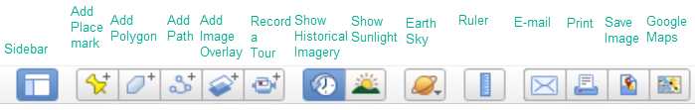
Feature Comparison of GE and GEP
Features | Google Earth | Google Earth Pro
Print resolution | 1000 pixels | 4800 pixels
Import GIS data | --- | ESRI .shp, MapInfo .tab
Import addresses in bulk | Manually Geo-locate each address | Automatically Geo-locate up to 2500 at a time
Import large image files | limited to texture size | Super Image Overlays
Supplemental Layers | --- | Demographics, Parcels, Traffic Counts
Create premium movies for export | --- | HD 1920x1080
Measurement tools | Line, Path | Line, Path, Polygon, Circle, 3D Path, 3D Polygon

What's the difference between Google Earth and Google Earth Pro?
From http://download.cnet.com/guides/google-earth/
Google Earth lets you explore extensive geographical content, zoom from space to street level, search businesses, visualize and share your GPS tracks, fly around the world in 3D, time travel with historical imagery, and dive beneath the surface of the ocean.
Google Earth Pro enables you to utilize everything Google Earth has to offer, plus capitalize on advanced business tools, which enable you to compute distances and areas using measurement tools, use Movie Maker to create media collateral, print high-res images for reports, import large vector image files to quickly map GIS data, and map addresses with the Spreadsheet Importer.
By default, GM does not provide a high-resolution image for using in documents
This link shows how to get a higher resolution image in that program
http://www.alvipixels.co.uk/blog/high_resolution_google_map_300dpi.php
Observations
GEP and GE share the same myplaces.klm file, where all of a user’s personally created files are stored. In order to preserve files from one session to another, save them to My Places. (Save/Save My Places).
Recent Product Changes:
The following three layers and Parcel (APN) Search feature were removed from Google Earth Pro on January 29, 2016:
U.S. Demographics, U.S. Parcels Data, U.S. Daily Traffic Counts
Live traffic is still available in Google Maps (https://www.google.com/maps/ ). You can access it via the option in the left menu. Click the three horizontal lines at the top left to access the menu.
File Types
.kml; Keyhole markup language
About KML files; https://developers.google.com/kml/
KMZ; zipped kml files
GEP is available for Windows, Mac and Linux
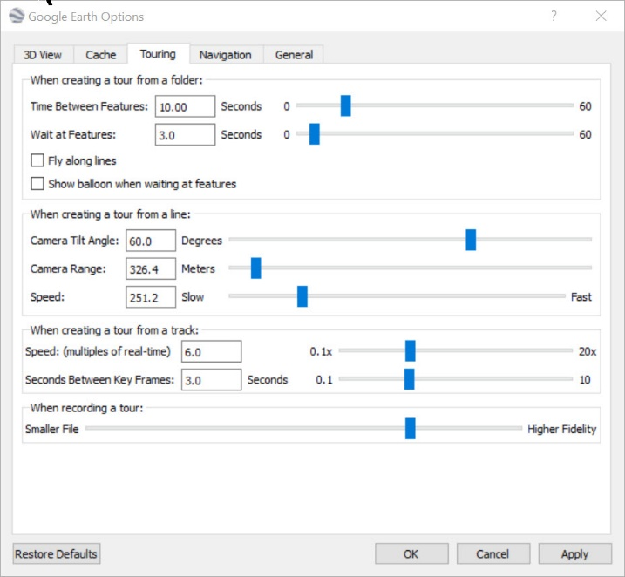
Explanation of how to install GEP on Ubuntu from the Terminal
http://ubuntuhandbook.org/index.php/2017/04/install-google-earth-in-ubuntu-17-04/
Show the power of opening a .kml file in GEP
https://developers.google.com/kml/media/everytrail_halfdome.kmz
Display Sutter Demo folder in GEP for Half Dome, Earthquakes and London
Using GEP; Lopez Lake
Add Placemarks
Use the Add Path Tool to draw a route
Set the viewing altitude (Right-click Path/Properties/Altitude)
Set the playback speed
Record a tour by tracing a route and then clicking the tour button
Play screen capture of tour
Play the Tour
Demo the Historical Slider to show changing water levels
Check/uncheck boxes to display or hide the route
Show Elevation Profile (Right-click/Path/Profile)
To share data between multiple instances of GEP
Import previous sessions by opening myplaces.kml with GEP
On my Windows machine running Windows Creator’s Edition,
the file resides at
C:\Users\ralph\AppData\LocalLow\Google\GoogleEarth\myplaces.kml
E-mail the file to another user. Instruct user to open the file with GEP
(File/Open) He or she can then save the files to My Places in GEP
Narrated tour of Lopez Lake from the Lopez Lake Marina to Lopez Arm Camp
http://www.slobytes.org/presentations/sutter-0617/lopez-lake-tour.mp4
Detailed Recording Steps with Movie Maker
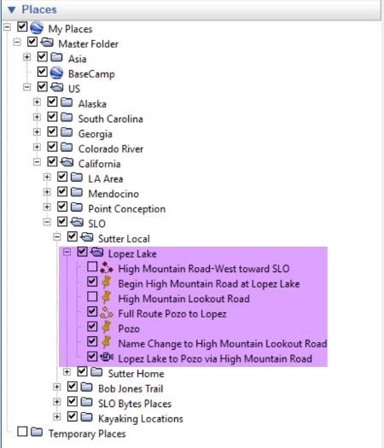
Make sure that all files that are part of the same tour are saved in the same folder

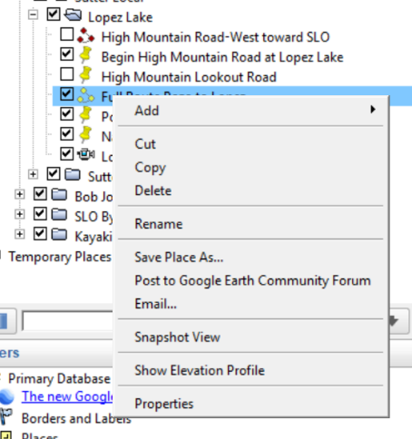
Right click on a path to show the options here

Set height of camera above the terrain here
Select Path

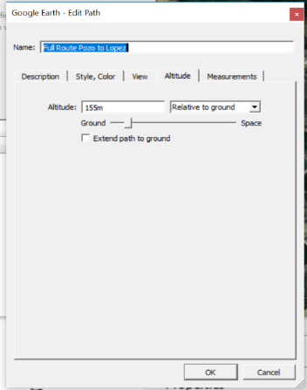

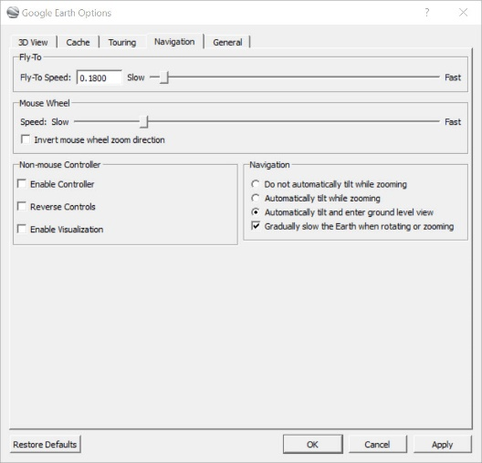

Set video frame speed from this box on accessed
By clicking Tools/Options

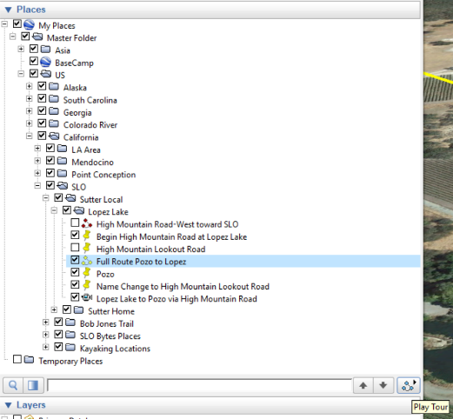
Play a Tour by clicking this icon

Uncheck the Path that you are highlighting if you do not want
it to display in the recorded Tour. (The Tour will still follow the
route marked by the Path.
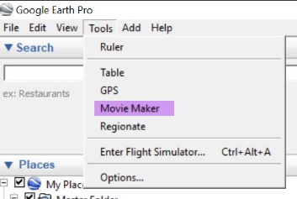
Access GEP Movie Maker here
Audio doesn’t work. Use Audacity
To record the audio track while playing the
Video by running the .kml/kmz file.
Put audio and video together with Adobe
Premiere Elements or similar video editor

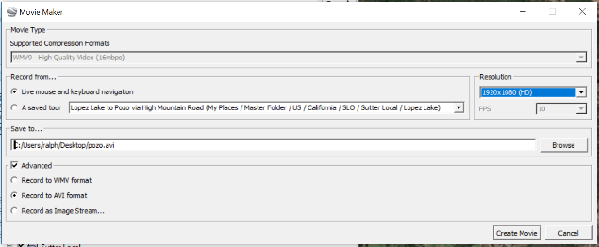
Set the Movie Maker Resolution here.

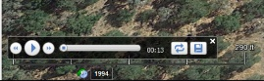
If Movie Maker is greyed out, make sure that
Record a Tour is not enabled (controls appear
on bottom of screen)

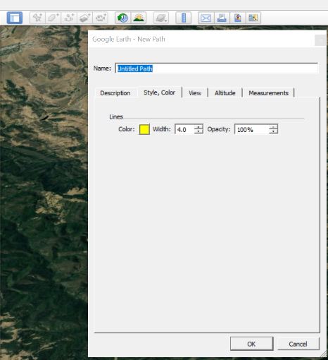
Draw Paths in GEP with this tool
Note: Do not click OK until you are done
drawing the path. Otherwise you will close
the dialog box

Set Snagit video capture resolution here (video screen capture)
You may wish to play the Tour with GEP while doing a video screen capture with Snagit, set for high resolution.
Otherwise, you can record the Tour with GEP’s Movie Maker and add audio upon playback
Topo Fusion is a GPS mapping program that allows you to create overlays of map content to GEP or similar programs
I have posted a video screen capture of the program here.
Resources
Creating a Tour Istanbul to Barcelona - https://www.youtube.com/watch?v=mxzkM6pUL-4&t=505s
https://www.youtube.com/watch?v=EYHhhMlFdsY GEP Tutorial
Movie making with Google Earth Pro
The following is from
https://docs.google.com/document/d/14WEgTl1-_7unaQQqJPDjd18Fp6aiK9XLMaAhvwZ0mQU/edit#
Play Tour tool
This will create a tour based on a folder of Placemarks, resulting in a much smaller tour file that won't develop a wobble when recording a movie. We have a site set up with the instructions for this here:
https://sites.google.com/site/kmltouring/google-earth-tools/record-a-tour
My Personal Observations
GEP and GE share the same myplaces.klm file
Demo of Google Fusion Files
https://www.youtube.com/watch?v=5l7IyS3u4w8

July 2nd Programming Schedule by Ralph Sutter
The First Session will feature Alan Raul moderating a Questions and Answers program from 12:45-2:00 p. m.
In lieu of the customary break and the Second Session topic, SLO Bytes will hold its annual BBQ. Please join us for oak-grilled hamburgers with all the fixings. The event is free for all SLO Bytes members as a benefit of your club membership. You may also bring one guest at no charge. For additional guests, we ask for a $5 per guest donation. Voluntary donations are also welcome!
Contact Ralph Sutter at ralph@rsutter.com for additional information about SLO Bytes and to RSVP for the BBQ.
Ralph Sutter
▫▫▫▫▫▫▫▫▫▫▫▫▫▫▫▫▫▫▫▫▫▫▫
President’s Message by Earl Kaplan
After missing a SLO bytes meeting for the first time for medical reasons I can attest to the dearth of technical knowledge that I have absorbed during this time of separation from the wisdom of Alan and company. Since it is June we can look forward to the totally non-technical input we will be offered in July.
The new location has outside eating space as well as indoor space so you can dine al fresco if that is what turns you on.
In any event we will be trying to develop future programs which will explain technical processes which have always puzzled you and other people as well. As I have requested before we would be much more likely to satisfy your desire for information if we have some feedback as to what interests you. Give it a try.
Earl Kaplan
▫▫▫▫▫▫▫▫▫▫▫▫▫▫▫▫▫▫▫▫▫▫▫
Treasurer’s Report for May 2017 by Bob Styerwalt
Income May 8 thru June 4, 2017
 | Renewing Members | $125.00
 | New Members
 | Refreshments donations | $20.00
Expenses:
 | Hall rent | $65.00
 | Refreshments reimbursement
Bank Statement ending 5/31/2017
 | Checking account balance | $2,313.58
 | Interest paid this period
 | Deposits | $170.00
 | Withdrawals | $65.00
Renewing Members: Five members renewed during this period, Alice Rew, Ralph Sutter, Connie Sutter,
Ken Stilts, and Ian Hughes. Thanks to all for your continuing interest and support. Everyone please continue to encourage your friends, neighbors, kids, parents and strangers to join us. It would be particularly nice to add some younger members – perhaps some of those very bright and up-to-date Cal Poly students. Good Hunting!
Bob Styerwalt
▫▫▫▫▫▫▫▫▫▫▫▫▫▫▫▫▫▫▫▫▫▫▫
Webmaster Notes by Ralph Sutter
On 06/03/2017, the SLO Bytes Bulletin Board; http://slobytes.org/smf/index.php?board=1.0 suffered an unrecoverable crash. I recreated it but previous posts and registered user information was lost. Members who wish to have me re-subscribe them to the BB should send an e-mail to me at ralph@rsutter.com. I will register on your behalf.
I re-posted the SLO Bytes Bulletin Board Information Page, expanding how registered users can reset their password and recover a forgotten one.
Watch the video at http://www.slobytes.org/reset.mp4
Ralph Sutter
▫▫▫▫▫▫▫▫▫▫▫▫▫▫▫▫▫▫▫▫▫▫▫
Photo Group Report by Ralph Sutter
NEXT MEETING Sunday, July 9th 2017 @ 2:00 pm
LOCATION: Home of Connie and Ralph Sutter
498 Hansen Hill Road, Arroyo Grande
MAP at www.slobytes.org/digital/sutter-map.html
You will find a dashcam video tracing the route through the village of Arroyo Grande to the Photo Group on YouTube at https://www.youtube.com/watch?v=dhGQelxHxbE
Notes from the Photography Group meeting of 06/11/17
TOPIC: Distortion with a Purpose
The concept is to create a pre-meditated non-standard outcome either when taking or editing an image.
Notes from the June 11th Session
TOPIC Photographing Food
Ralph Sutter opened the meeting displaying a series of high-resolution images from around the world; Mount Blanc, London, Bergen, Seville, and Astana.
Sutter then showed images of common foods, condiments and cooking oils as well as their storage locations.
Connie Sutter followed, sharing photos of apples, strawberries, bananas and how they were incorporated in beverages and edibles.
Monica Tarzier offered pictures of flowering bushes, local landscapes, shots of the sky and sunlight radiating from a bowl of tomatoes
Alan Raul rounded out the presentations with a slide show of memorable dishes that he ate in various restaurants along California's Central Coast
See the Links page for tutorials on Links and other topics
Ralph Sutter
▫▫▫▫▫▫▫▫▫▫▫▫▫▫▫▫▫▫▫▫▫▫▫
Push Library
Look at the PUSH archives, http://www.slobytes.org/push/. This is a repository of articles where you will find tips, product reviews, and personal recommendations contributed by computer clubs across the country.
They are provided courtesy of the Association of Computer User Groups, APCUG, the national organization with which SLO Bytes is affiliated.
The actual PUSH articles are hyperlinked from the index located at
http://www.slobytes.org/push/index.html (All articles on one long page)
http://www.slobytes.org/push/push-condensed.html (Links to PUSH articles by month received)
You can view additional APCUG publications here: http://www.slobytes.org/apcug/index.html
▫▫▫▫▫▫▫▫▫▫▫▫▫▫▫▫▫▫▫▫▫▫▫
SLO Bytes Bulletin Board
Everyone can read the SLO Bytes Bulletin Board at http://slobytes.org/smf/index.php?board=1.0 but only subscribers can post comments or respond to the posts of others. Despite the usual connotation of subscribe, it costs nothing to join the bulletin board. It is free to all current SLO Bytes members. However, to guard against cyber-mischief by spammers and other ne’er-do-wells, I have disabled self-registration. If you want to be added to the bulletin board, please send your request to me at ralph@rsutter.com.
If you are currently registered with the SLO Bytes Bulletin Board and wish to change your password, you will find a video screen capture of how to do so at http://www.slobytes.org/documents/change-bb-password.mp4
▫▫▫▫▫▫▫▫▫▫▫▫▫▫▫▫▫▫▫▫▫▫▫
Club Information and Meeting Times
SLO Bytes, a PC Users Group dedicated to educating its members in the use of personal computers, digital devices and software, meets on the first Sunday of each month at the San Luis Obispo Guild Hall at 2880 Broad Street, San Luis Obispo. There is a map available at http://www.slobytes.org/slo-guild-map.html. All meetings are open to the public at no cost. A general interest and Q&A session occurs from 12:45 PM to 2:00 PM and guest speaker presentations begin at 2:30 PM. Contact John Waller (johnlwaller at sbcglobal.net) or visit slobytes.org for additional information about SLO Bytes and the scheduled presentation.
All ideas for speakers or presentation subjects are welcome.
HardCopy is a monthly publication of SLO Bytes PC Users' Group located in San Luis Obispo, California. Information in this newsletter is derived from both our own membership and other PC user group newsletters. The purpose of this

publication is to inform our members of meetings and provide information related to the use of PCs and various operating systems.
Membership dues are $25 per year. Membership entitles you to our monthly newsletter via e-mail, technical assistance, eligibility for raffle gifts when drawings are held, a voice in the affairs of the club, and comradeship.
▫▫▫▫▫▫▫▫▫▫▫▫▫▫▫▫▫▫▫▫▫▫▫
Outside Special Interest Groups (SIGs)
Linux SIG normally meets at 6:30 PM on the Thursday following our Sunday's General Meeting at the KCBX.NET Training Center, 4100 Vachell Lane, San Luis Obispo. View the web site at www.slolug.com.
Photography SIG normally meets at 2:00 PM on the second Sunday of each month at Ralph Sutter’s home in Arroyo Grande. Call Ralph at 478-0826 for directions. Visit the website at www.slobytes.org/digital
▫▫▫▫▫▫▫▫▫▫▫▫▫▫▫▫▫▫▫▫▫▫▫
SLO Bytes Officers/Volunteers
Officers
Earl Kaplan – President: earlkaplan at gmail.com
John Waller - Vice President; Programs Chair/Publicity: johnlwaller at sbcglobal.net
Bob Styerwalt – Treasurer; Membership: rstyerwalt at gmail.com
Ralph Sutter – Secretary, Webmaster/HardCopy Editor, Photo SIG Leader: ralph at rsutter.com
Alan Raul – Training Officer: alan at alanraul.com
Other Volunteers
Nancy Vrooman – Refreshments
Peter Stonehewer – Refreshments
Ken Stilts – Set-up/Clean-up
▫▫▫▫▫▫▫▫▫▫▫▫▫▫▫▫▫▫▫▫▫▫▫
Disclaimer: Neither SLO Bytes PC Users' Group, its officers, editors, or contributors to this newsletter assume liability for damages arising out of this publication of any article, including but not limited to the listing of programming code, batch files and other helpful hints. Articles from this newsletter may be reprinted by other user groups if credit is given to both the author and newsletter from which it was taken. Reproduction of articles with a specific Copyright notice is prohibited without prior permission from the original author.
SLO Bytes Website: slobytes.org

