#1 A Place Of Enchantment

#2 This Palm Tree Fell Over And Curved Right Back Up
#3 This Tree Fell Over And Grew 4 More Trees Out Of Itself
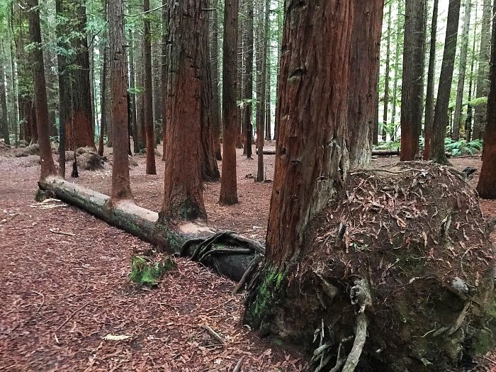

#4 The Only Tree That Survived The Tsunami In Japan Between 70,000 Trees. TodayProtected And Restored
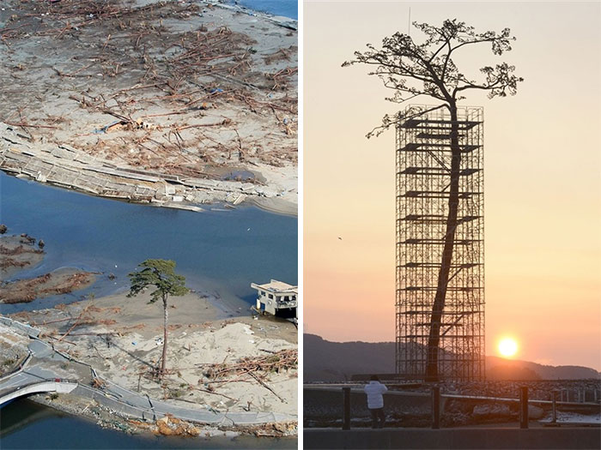

#5 Tree Of Life - Olympic National Park, Washington
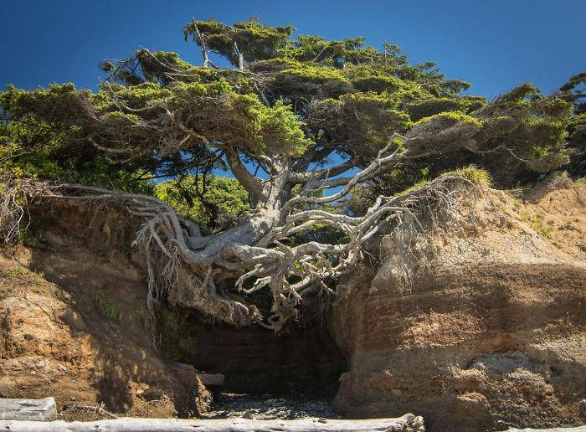
#6 A Tree's Root Spill Over The Sidewalk
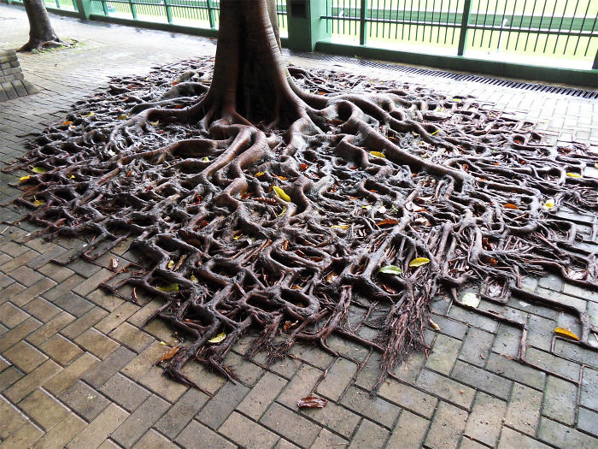
#7 Nature FTW
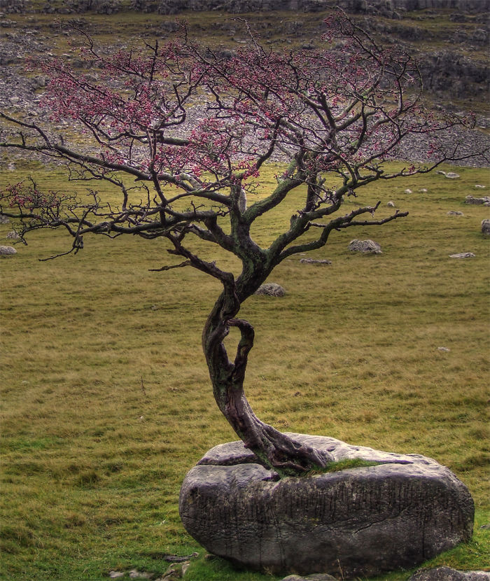
#8 I Found A Tree Growing Through Speed Limit Sign
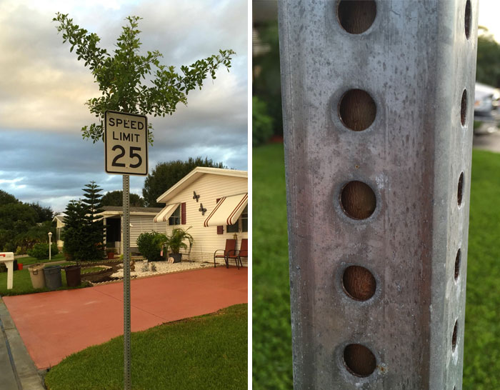
#9 This Tree That Refuses to Die
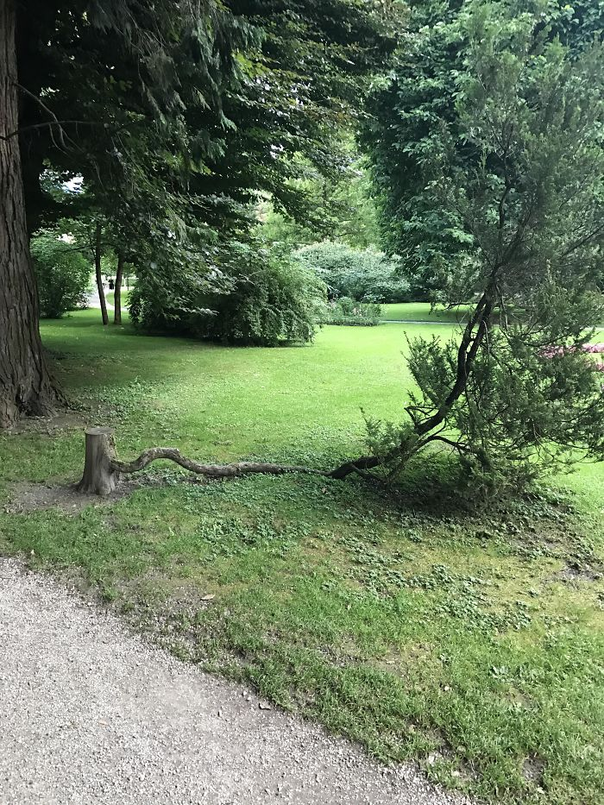
#10 This Tree Still Has Its Leaves Because Of The Light Shining On It
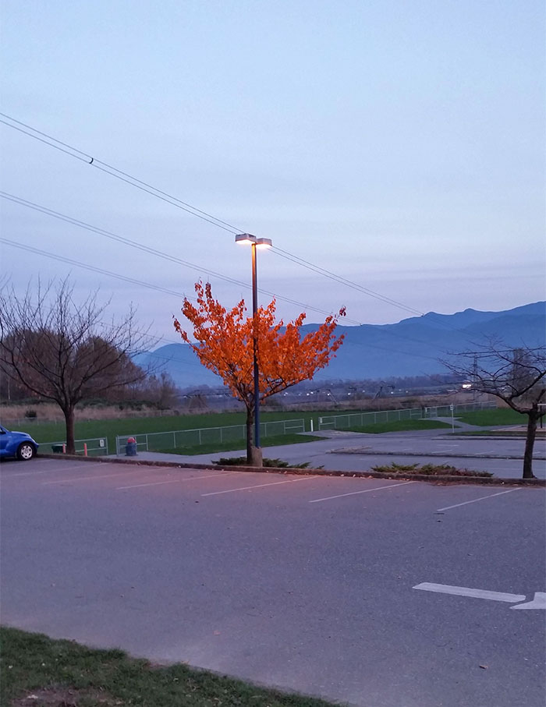
#11 Life Finds A Way
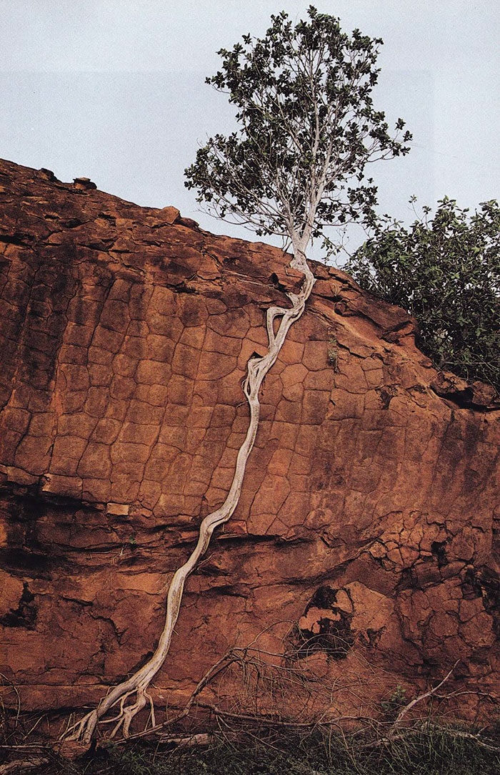
#12 Tree Roots Extend Across A Gap To The Mainland For Nutrients
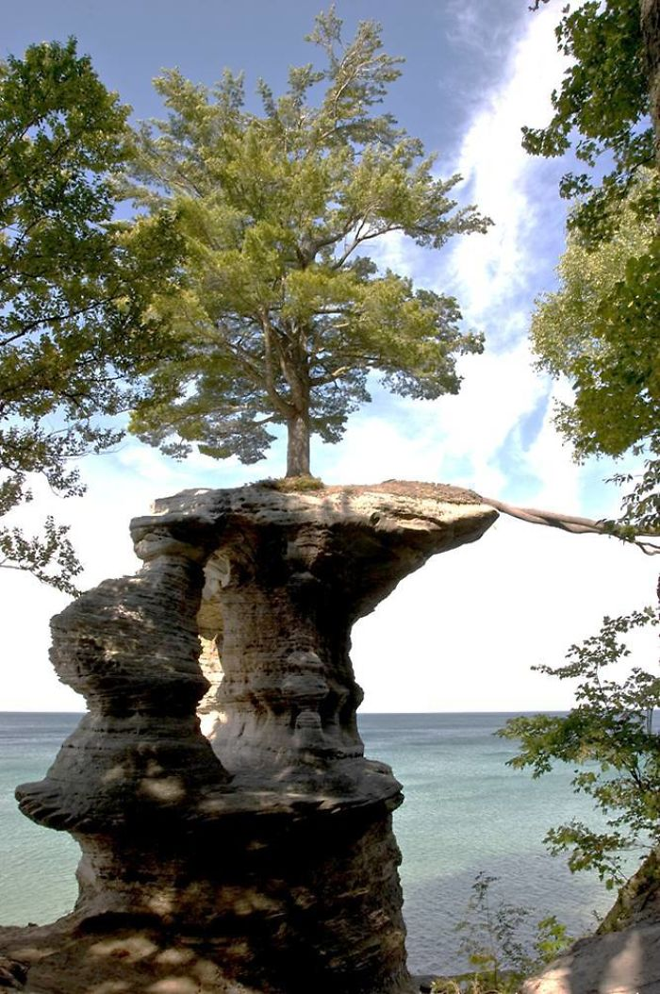
#13 Life Finds A Way
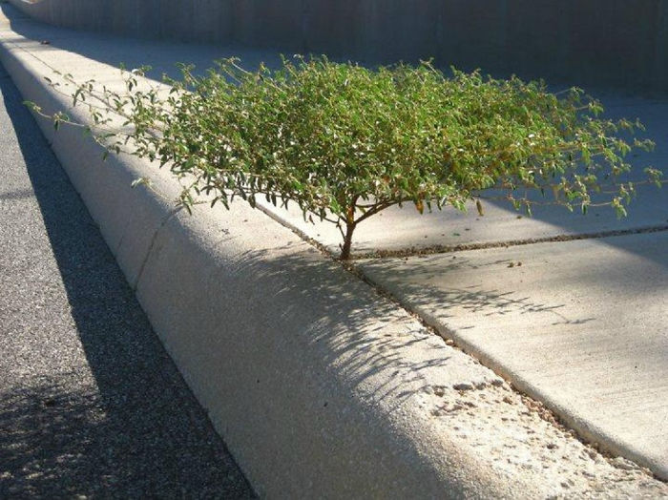
#14 Ta Promh Temple In Cambodia
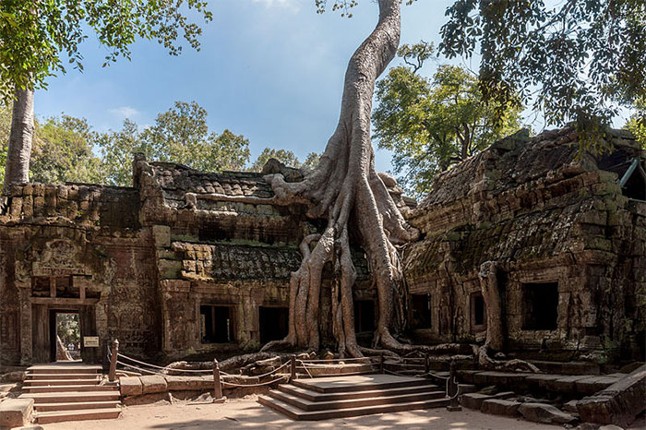
#15 Striving
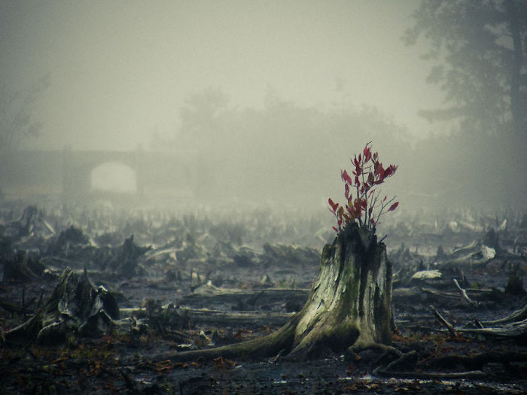

#16 My Grandpa Hung His Skates On A Small Tree When He Was Younger. He Forgot He Had Left Them There And Found Them Years Later
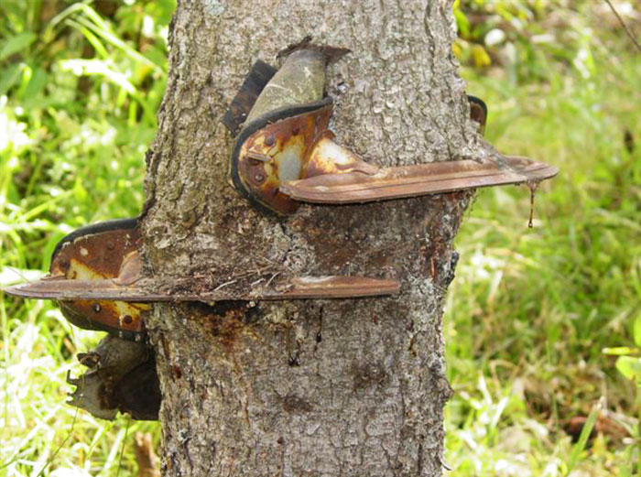

#17 A Tree Growing On Another Tree
#18 This Tree Is Growing Out Of Another Tree
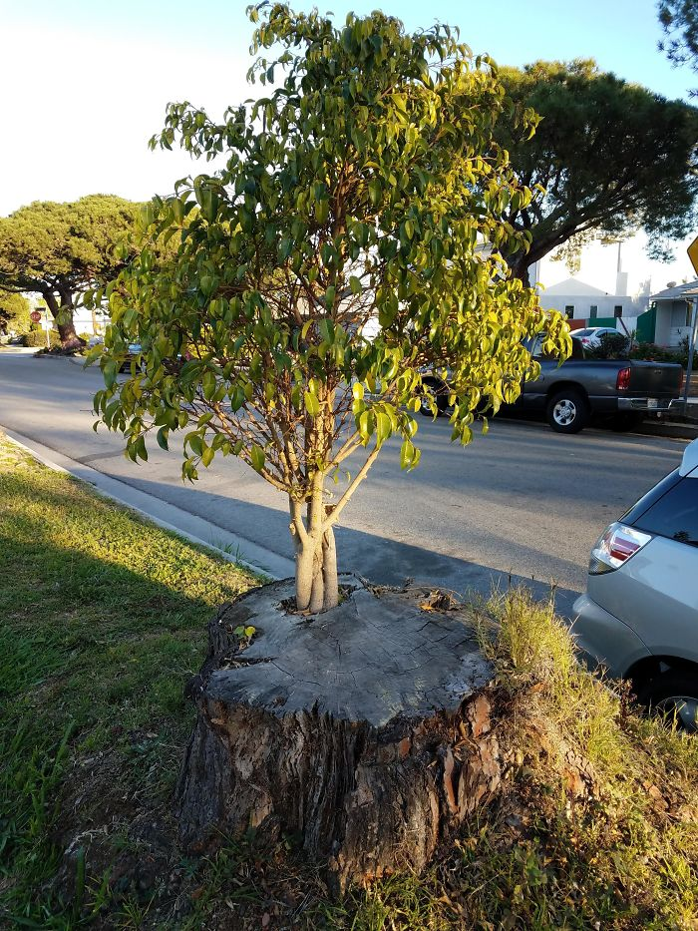
#19 This Tree Grew Out Of The Stump Of A Dead Tree And Then The Stump Rotted Away
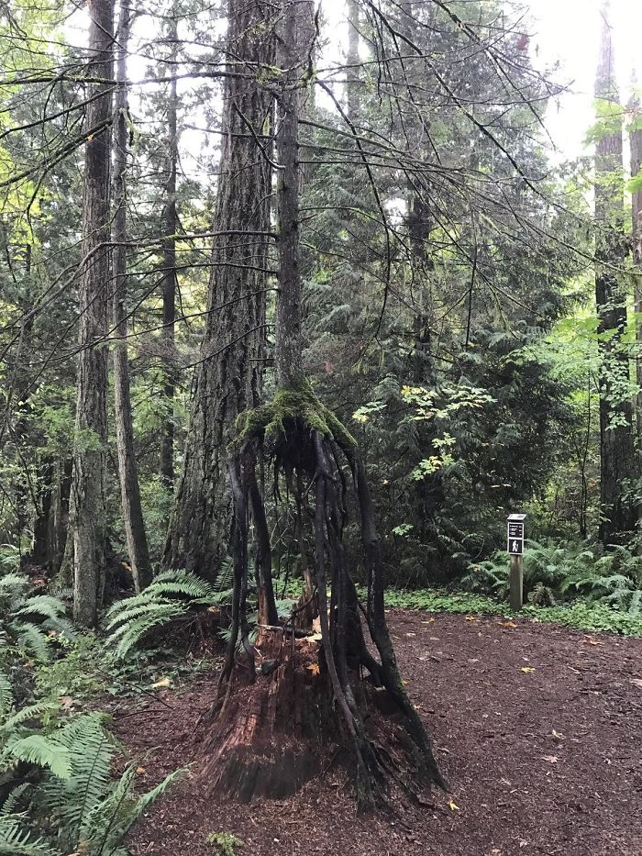
#20 A Tree Grows From Third Floor Window
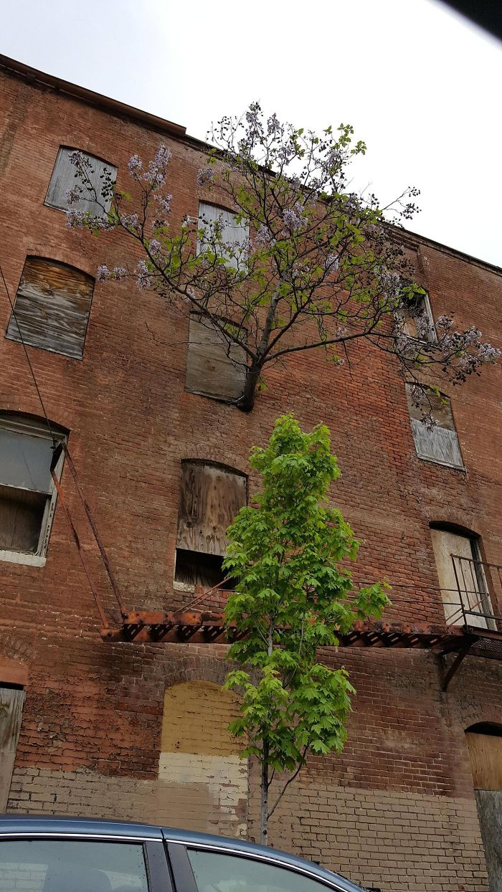
#21 Life Finds A Way

#22 I Spent Ages Staring At This Tree Before Taking This Pic. I Hope You Find It As Fascinating As I Did
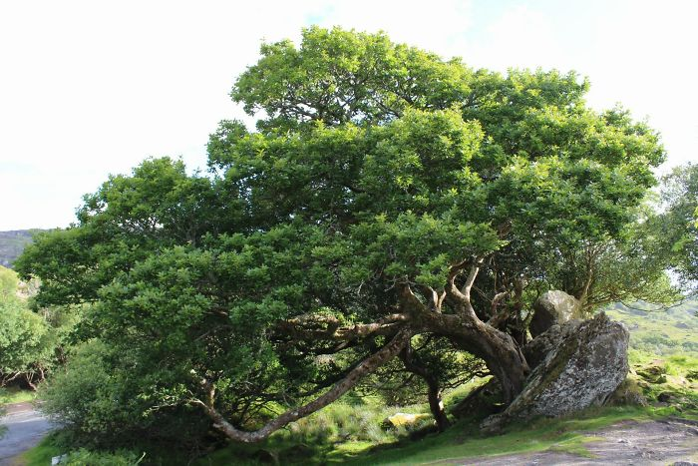
#23 This Floating Island That Grew At The End Of A Partially Sunken Tree
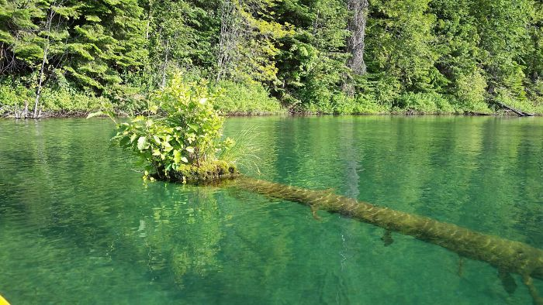
#24 This Wooden Chair My Parents Bought Started Sprouting Leaves
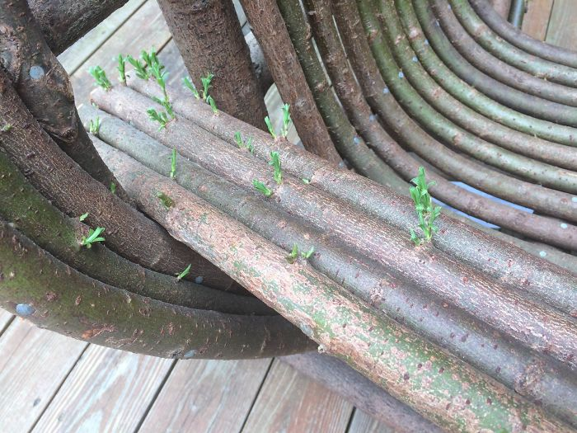
#25 The Old Piano Tree
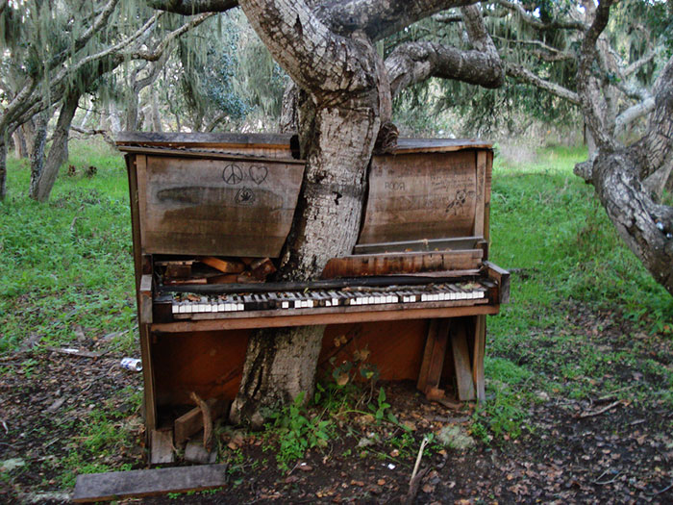
#27 One Tree On My Street Refused To Accept Winter
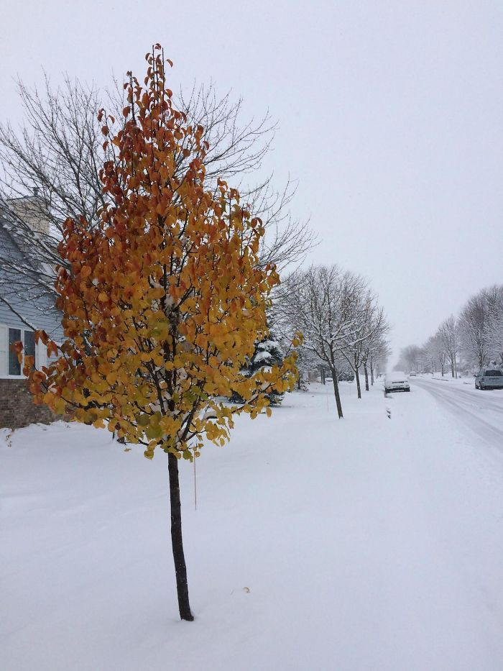
#28 My Sister's Tree Is Eating Her Fence
